**Job Recommendation Platform**



BSc in Computing

Department of Computing, Coventry University

**买家自己填写**

Student ID:

Supervisor:

Date Submitted: 20th April 2023

# Abstract

For decades, science, technology, engineering and mathematics (STEM) have been perceived as ‘male’ subjects; a stereotype that is still very much alive today as explained by Professor Bernhard Ertl (2017). It is a recurring problem through many influential countries in the world and this view is reflected by the under-representation of women in STEM industries and educational institutions.

This report explores reasons as to why these opinions exist and looks at ways they can be eradicated from society by tackling the views of young students with the use of mobile technologies and techniques. Literature is reviewed to gain an understanding of the reasons why academia believe there to be a gender gap in STEM fields. Both primary and secondary school surveys are analysed to consolidate some of these reasonings and to clarify any relationships between influential factors in students’ lives and STEM. An application development has been completed before seeing its demonstration to a focus group illustrating how such a technique **can/will** inspire young females to explore a future in science, technology, engineering and/or mathematics.

“To the women in my engineering classes:

While it is my intention in every other interaction I share with you to treat you as my peer, let me deviate from that to say that you and I are in fact unequal. Sure, we are in the same school program, and you are quite possibly getting the same GPA as I, but does that make us equal?

I did not, for example, grow up in a world that discouraged me from focusing on hard science. Nor did I live in a society that told me not to get dirty, or said I was bossy for exhibiting leadership skills. In grade school I never had to fear being rejected by my peers because of my interests. I was not bombarded by images and slogans telling me that my true with was in how I look, and that I should abstain from certain activities because I might be thought too masculine. I was not overlooked by teachers who assumed that the reason I did not understand a tough math or science concept was, after all, because of my gender. I have no difficulty whatsoever with a boys club mentality, and I will not face added scrutiny or remarks of being the ‘diversity hire’. When I experience success the assumption of others will be that I earnt it.

So, you and I cannot be equal. You have already conquered far more to be in this field than I will ever face.” By Jared Mauldin, Senior in Mechanical Engineering (The Easterner, 2015)

Contents

Abstract 2

1. Introduction 10

1.1. What is STEM? 10

1.2. Background and Motivation 10

1.3. Thesis Structure and Summary 10

2. Literature Review 11

2.1. Is There A Gender Gap? 11

2.1.1. Gender Gap in Different Cultures Around the World 11

2.2. Why Is There A Gender Gap? 11

2.2.1. Misconceptions and Gender Stereotypes 11

2.2.2. Fewer Female Role Models 12

2.2.3. Gender Response Teacher Training Lacking 12

2.2.4. Lack of Encouragement from Parents and Teachers 12

2.2.5. Not Choosing to Study STEM Subjects Post 16 13

2.3. Does the Gender Gap Need to Be Narrowed? 13

2.4. How Can the Gender Gap Be Narrowed? 13

2.4.1. Change Mindsets by Challenging Gender Stereotypes and Misconceptions 13

2.4.2. More Female Role Models 14

2.4.3. Parent Encouragement 14

2.4.4. Education Within the Industries 15

2.4.5. Sponsor Female and Male Talent Equally 15

2.5. Summary 15

2.6. Gaps in Current Knowledge 15

2.7. Research Question 15

2.7.1. Research Question Search Terms 16

2.8. Contribution of this Thesis 16

3. Research Methodology 17

3.1. Research Philosophy and Strategy 17

3.2. Data Collection, Participants, and Ethics 17

3.3. Operationalisation of the Experiment’s Constructs 18

4. Development 19

4.1. Wireframes 19

4.2. Front – End Development 20

4.2.1. Norman’s Design Principles 20

4.3. Back – End Development 21

4.4. Application Hosting 21

4.5. Summary 22

5. Project Management 23

5.1. Methodology 23

5.2. Planning 23

5.2.1. Time Management 23

5.2.2. Dependencies 23

5.2.3. Risk management 24

5.3. Communications 25

5.4. Social, Ethical, Legal and Professional Issues 25

5.5. Presentation Feedback 25

5.6. End Point 27

5.7. Reflection 27

6. Analysis of Results 28

6.1. Analysis of Primary School Data 28

6.1.1. Background Analysis of Primary School Data 28

6.1.2. Analysis of Primary School Data Looking into Gender Gaps 31

6.2. Analysis of Secondary School Data 34

6.2.1. Background Analysis of Secondary School Data 34

6.2.2. Analysis of Secondary School Data Looking into Gender Gaps 36

6.2.3. Analysis of Secondary School Data Identifying Reasons for a Gender Gap in STEM 40

6.3. Analysis of Focus Group 65

6.3.1. Interest in STEM 65

6.3.2. Inspirational Women in STEM 66

6.3.3. Careers and Support in STEM 66

6.3.4. Smartphones, Apps and Their Purpose 66

6.3.5. Identification of Benefits with the Developed Application 66

6.3.6. Interest in Application 66

6.3.7. Techniques to Help Spark an Interest in STEM 66

6.4. Data Analysis Summary 66

7. Conclusions 67

7.1. Summary of Results 67

7.1.1. Why a Gender Gap Exists 67

7.1.2. Development Decisions 67

7.2. How the Gender Gap Can Be Narrowed 68

7.3. Study Contribution 68

7.4. Study Limitations 68

7.5. Areas of Future Research 69

8. References 70

7.1. Application Content References 72

9. Appendices 74

9.1. List of Tables 74

9.2. List of Figures 76

9.3. List of Appendices 77

# 1. Introduction

## 1.1. What is STEM?

Importance of STEM in the curriculum is growing significantly both nationally and globally possessing the intention of increasing student interest in science, technology, engineering and mathematical fields for higher education and career perusal. Hom (2014) highlights how it adopts an interdisciplinary and practical approach to each of the listed subjects, combining classroom, online and hands-on teaching to tackle different ways of problem solving and learning.

Mohtadi (2016) states that the role of STEM for society and in life is becoming more prominent with the tackling of issues such as sustainability and future economic growth. Companies need a qualified workforce who have intensive knowledge in such subjects and so inspiring young people into the world of STEM is of high importance.

## 1.2. Background and Motivation

The WISE Campaign is a government-backed campaign which sets out trying to inspire more young women to consider and join the world of STEM (n.d.). The existence and increased popularity of such a charity highlights the disparities in gender within STEM domains. The growing awareness of the lack of women in STEM proves how society needs to be educated in a way where people understand and appreciate the important role women play in STEM. This report explores a range of sources and studies with the intention of discovering the reasons why the gender gap exists before coming to conclusions as to frameworks and approaches that should be adopted if the gap is to ever be closed.

As a young woman, I took an interest in what are commonly seen as ‘male’ subjects and have experienced working in a male-dominated industry where I felt the pressures and lack of support in STEM. At the age of 12, I experienced a male maths teacher expressing his views that I was not good enough to be within the top-ability group which lead to a massive knock in my confidence - it was only when another teacher expressed their faith in me and supported me that I really began to thrive. I have become motivated to see if other females within the industry have been made to feel this way and this sparked an interest into understanding why gender gaps and such stereotypical views exist.

## 1.3. Thesis Structure and Summary

An initial literature review is conducted to gain a background understanding of STEM and its limitations in schools and career choices. The review will then examine reasons for a gender gap along with the importance of this gap being diminished before exploring ways it can be narrowed. Following, research methodologies are discussed, providing explanations as to why selected primary research methods have been adopted for this research report. The software development approaches are then deliberated in detail defining key features and functionality of the application as well as explaining different usability design principles which were adhered to achieve an effective design and usable product. Alongside development, project management is discussed – it describes the time management, planning, risk management and feedback integration approaches carried out to generate such a research project.

The analysis of both questionnaires and the focus group is then carried out to form conclusions and to decipher if the project’s research question has been answered. The analysis of these results will also aid the validation and verification of the reasoning expressed in the literature as to why a gender gap exists and how it can be minimised. Conclusions are then summarised and explained in line with the research question. The study’s contribution is defined as well as the identification of any of its limitations before providing future recommendations as to further research opportunities and approaches that could be assessed and implemented by companies and educational organisations to bridge the gender gap and to explore the topic further.

References and appendices can be found hereafter.

# 2. Literature Review

The purpose of this literature review is to gain an understanding of the culture within science, technology, engineering and mathematics, ranging from school years to career employment. It aims at exploring whether a gender gap exists in such fields whilst exploring reasons for its existence and how society can adapt and use methods to combat this potential gender issue.

## 2.1. Is There A Gender Gap?

Gender inequality has long been a topical area of discussion amongst countries in the world throughout history and is still an issue for STEM industries today, with research undeniably showing a large gender gap. A 2017 study conducted by WISE concluded that women make up only 24% of the workforce in STEM industries in the United Kingdom. UNESCO Institute for Statistics (2016) enhances this fact by estimating that women make up 28% of scientific researchers worldwide.

Stepping away from careers, according to Gurney-Read (2014), a STEM gender gap has been found to originate at a secondary school age in England whereby only 13% of students opt to advance in maths and such subjects whereas countries such as Japan and Taiwan see a huge proportion of their student population advancing such subjects (85% and 70% respectively).

### 2.1.1. Gender Gap in Different Cultures Around the World

It can be argued that this gap is a direct result of countries having a gender gap in general. The World Economic Forum (2016) provides gender gap rating by countries and the analysis of such data has proven that the gender gap in STEM still exists and is a recurring issue. For instance, Iceland ranks first in the gender gap index with a score of 0.874 (out of 1) yet its proportion of female to male STEM graduates is still 10% to 27% respectively. Likewise, Finland (ranking 2nd), has a STEM graduate proportion of 13% female to 51% male; Rwanda (ranking 5th) with 16% female to 27% male and the United Kingdom (ranking 20th) with 16% to 37%.

This variation of results proves that it is not necessarily down to a country’s culture as to why this gender gap exists in STEM - it is to do with other reasons in general as explored in the following section.

## 2.2. Why Is There A Gender Gap?

### 2.2.1. Misconceptions and Gender Stereotypes

A study conducted by the Department of Education (Gurney-Read, 2014) found that teenagers still perceive STEM subjects to be ‘male and boring’. These conceptions can be traced back through the history and through the influential role media coverage plays. Cheryan (2013) asked US university students to simply describe a computer science graduate - the results highlighted them to be ‘nerdy’, intelligent people who lack social skills whilst enjoying science fiction and playing computer games regularly. They also indicated that the graduates were more likely to be male. Interestingly, students who studied a form of computing in the past were less likely to mention a gender characteristic. The consistent views on stereotypes for computer science graduates are only strengthened when you look at the characters from the TV show ‘The Big Bang Theory’ whereby these stereotypes still subtly exist. Media, in all its forms, is now extremely accessible and if girls and young women are constantly exposed to these negative stereotypes of STEM, it is understandable as to why they would be discouraged from pursuing a career in either of the fields, feeling as though STEM is not the right place for a woman to be.

Tversky (1992) states the status quo effect is inevitable in decision-making processes and it is often what holds individuals back as people think it is more beneficial to take the ‘safe’ option, simply because it is seen as the norm. From a young age, children feel the desire to ‘fit in’ with their peers and so these ‘gender-associated subjects’ could discourage them from wanting to broaden their knowledge in STEM areas as they see this as going against the ‘status quo’.

A study conducted by Cheryan (2013) saw both male and female students reading two newspaper articles which spoke about computer science graduates fitting and not fitting gender stereotypes. The results found that men were unaffected by how computer science graduates were represented and would still consider a career in such a field whereas women were less likely to want to pursue a future in STEM when they believed the gender stereotypes still existed.

### 2.2.2. Fewer Female Role Models

Many influential women within STEM, including Black, the founder and first chair of BCSWomen: The Chartered Institute for IT (2015), and Pugh (2016), a high ranked data scientist in the US defence and Federal community, have acknowledged the lack of female role model representation within the industries and how this can impact upon girls pursuing degrees and careers in STEM. UNESCO (2016) highlights how this absence can even be traced back to the lack of female teachers in science, technology, mathematics and engineering within schools. This point was strengthened by a personal comment made by a secondary school teacher (2018) whereby she stated that *‘in 10 years of being here [St. Thomas More Secondary School, Nuneaton], we’ve never had a female IT teacher’.* Having few female STEM teachers can have a detrimental impact on the opinions of STEM subjects by young individuals as they may not be able to associate themselves with the potential STEM can bring.

Young girls experience a lack of appropriate career counselling and mentoring opportunities which will allow them to understand STEM industries further and discover their potential. The Wise Campaign (2017) has proven that girls tend to need/want to know that their work has value and they need an understanding that STEM subjects will not be limiting their future and progression. Having female role models more accessible to younger women will only create inspiration and a sense of understanding of the true potential of careers in STEM.

### 2.2.3. Gender Response Teacher Training Lacking

The lack of appropriate gender-responsive training in the field can be identified as a failing factor in our education system which leads to girls not seeing their true potential in STEM. High levels of anxiety and lack of confidence amongst girls and woman around STEM has proven to be the dominant reason as to why there is such a gender gap within the industries. A study by sociologist Correll (2004) found that within a group of students with the equivalent achievement history, girls perceived themselves to be a lower mathematical ability than the boys. The study found that this self-assessment of students hindered and controlled the individual’s actual ability and in turn would make it less likely for said individual to choose to study a degree in science, maths or engineering.

A *mindset* is defined as the theory in which an individual regards the nature of intelligent behaviour. Dweck (2014) highlights the two mindsets being ‘fixed’ and ‘growth’. With a fixed mindset, individuals see intelligence traits as being fixed and rigid whereas a growth mindset allows for individual’s traits to be explored and enhanced through the use of learning, effort, training and practice.

Negative gender stereotypes combined with fixed mindsets contribute to these high levels of self-belief within women. A 2009 study conducted by Good, Rattan and Dweck, which tracked several hundred women studying mathematics for a semester at university, concluded that women who found their studies to be taught with a fixed mindset approach which portrayed these negative stereotypes were less likely to pursue further education or a career in the given industry as they were quick to lose interest and ‘give in’ when challenges were tough. The study found that within growth mindset promoting classrooms, women were found to be less susceptible to any negative stereotyping meaning that they were more likely to develop in this chosen area with a sense of determination and interest.

Hill, Corbett and Rose (2010) strengthens this point and highlights that, as parents, educational representatives and a society, we should aim at developing growth mindsets whereby we praise children’s efforts and struggles, promoting that they can achieve and acquire any intellectual skills they require.

### 2.2.4. Lack of Encouragement from Parents and Teachers

As Primary Facts (2014) identifies, Ada Lovelace is remembered as being the person to write the first software program for Charles Babbage’s Analytic Machine in the 19th century. Welsh (2013) states how it was the influence and encouragement of Lovelace’s mother who led her to challenging the female stereotype of STEM to pursue mathematics. This alone shows the strong impact a parent’s encouragement can have upon their child. Accenture (2017) carried out a study of 8,500 young people, parents and teachers whereby the results came back stating that 54% of teachers have personally seen girls dropping STEM subjects due to pressure and discouragement from their parents. Children and young people look up to their parents and believe everything they say is helping them to make the right decisions. Due to this, this is a worrying statistic as it highlights how a lack of parental encouragement could lead to girls dismissing their future in STEM fields.

The study also found that both parents (52%) and teachers (57%) admit they have made having subconscious stereotypes about gender in relation to STEM too. This lack of knowledge (from parents and teachers) of STEM subjects and their potential could have a detrimental effect on how they portray such subjects to their children, providing a bias opinion before their child has even had chance to experience such fields.

### 2.2.5. Not Choosing to Study STEM Subjects Post 16

Most STEM university degrees require either maths, IT, computing or science A Levels (or equivalent) as a basic requirement onto the course thus meaning that students must have chosen to study such subjects at the end of secondary school. If not, they are limiting themselves to the type of degree they can study and potentially they are minimising their chances and options of working in STEM fields. The WISE Campaign (2017) analysed the gender balance at every stage of the STEM education ‘pipeline’ and it found that 94% of the boys continued to study STEM-related subjects post-16 whereas, for girls, it was only 35%. These figures go a long way to show why there is such a gender gap in STEM industries by male numbers almost tripling the numbers of females.

Attitudes and education towards STEM subjects and careers needs to be addressed during the schooling years so that young adults are aware of the options they can take in life. For this to be achieved, we need to explore the different strategies and techniques in which the gender gap can be narrowed.

## 2.3. Does the Gender Gap Need to Be Narrowed?

Winfrey (2016) stated how STEM industries are amongst the fastest growing industries worldwide so why is it gender gap a problem? Does it really need to be narrowed if it is already becoming so successful? Williams (2014) identifies how the integration of women in the development of new processes and designs brings with it different perceptions that haven’t ever really been considered before so there is huge potential for great advancements within the fields of science, technology, maths and engineering. Additionally, Islam (2013) highlights how the closing of the STEM gender gap will bring about beneficial economic factors with the narrowing of the gender pay gap too (high-tech STEM roles are shown to be extremely high-paying). Microsoft (2016) highlights how diversity is key to the future of STEM to provide initiative and higher-quality products and services - the bridging of the gender gap is key to this potential.

## 2.4. How Can the Gender Gap Be Narrowed?

Bromley (2015) describes how there are many avenues that can be explored which will help to narrow the gender gap with STEM fields - most revolving around changing mindsets, challenging stereotypes and gender-neutralising education throughout life.

### 2.4.1. Change Mindsets by Challenging Gender Stereotypes and Misconceptions

Changing mindsets of gender stereotypes and misconceptions of science, technology, engineering and mathematics subjects is the prominent motivating force behind STEM becoming gender-neutral. Society needs to step away from the view that STEM subjects are ‘male’ orientated - simply, this is not true - girls tend to outperform boys throughout school in such subjects. The WISE Campaign (2017) analysed data for GCSE students in the UK and found that 66% of girls achieved A*-C/9-4 grades in STEM subjects compared to 62% of boys. Looking closer, in science 51% of girls achieved A*-C compared to 45% of boys; in technology 73% of girls achieved A*-C compared to 54% of boys; in engineering, 66% of girls achieved A*-C grades compared to 42%; in IT and computing 72% and 66% (respectively) of girls achieved A*-C compared to 64% and 60% of boys.

#### 2.4.1.1. Advertisements - Be Creative in Role Design and Advertisement

O’Neill (2013) states how it is the advertising and marketing of STEM subjects that underpin the associated stereotypes within the industries. Looking at the GCSE statistics, it clearly shows that girls outperform boys and these facts should be made clear to society, especially young girls. It has the power to change perceptions and open minds of the young to consider their future in STEM, at least progressing with such subjects to a higher education level.

O’Neill (2013) continues to state that is important to expose students to the variation of work in STEM subjects and to make it vital that students understand the interesting things they can achieve. After the research study conducted by Cheryan (2013), it was proven that it doesn’t take a huge effort for stereotypes to begin to be dissolved - the small article case study began to shift the thinking of the participants about computer science and this idea can be transposed for all STEM subjects; society needs to develop these techniques which appeal to the young, female generation.

The WISE Campaign (2015) have created their ‘People Like Me’ scheme which is deployed within schools with a goal of creating that sense of belonging and passion which Hill, Corbett and Rose (2010) identify as lacking in the industries currently. It is full of activities and presentations aimed at enabling girls to understand their importance and explore roles within STEM, suggesting how personalities traits can be reflected in certain job roles which they may have never considered before.

Being serious about change needs to be consistent throughout school and work life. National curriculums need to be planned and developed in a gender-neutral way which tackle the traditional, yet ongoing stereotypes. When job advertisement and descriptions are generated, they need to be creative and open-minded. When job descriptions are designed with a fixed-mindset they have the potential of alienating female talents and discouraging them from applying for such roles.

### 2.4.2. More Female Role Models

Human nature finds that people follow leaders and their example. The Wise Campaign (2017) discovered that out of the STEM companies listed within the FTSE 100, 28% of the executive board in 2017 were female. Thinking about this, if there is a lack of female role models for girls to look up to then there is inevitably going to be a lack of females within STEM industries. Gender opposites tend to find it harder to identify themselves with each other and so this fuels the lack of women in STEM industries. A study by Tulane University (2016) found that girls felt a ‘sense of belonging’ after working with influential role models in science and were more likely to pursue science in the future as the roles appeared more identifiable and relatable.

The visibility and accessibility of female role models can be achieved through the holding of events and workshops such as Girls in STEM (GiST) by Tulane University; ‘People Like Me’ by WISE Campaign and the publication of reports such as the ‘100 Women to Watch’ list generated by Cranfield University. As Davis (2017) highlights, the more female role models there are in the public eye, the more of a normality ‘women in STEM’ will seem and in turn STEM will lose its ‘male’ stigma.

### 2.4.3. Parent Encouragement

Parents and teachers are extremely influential figures in children’s lives and it is important for them to understand just how influential they are and how their ideas and opinions can be inflicted onto their own children or they children they teach. A PISA study (2012) conducted found that within the 64 countries surveyed, the parents of the students were more likely to expect their sons, rather than daughters to work in STEM-related industries. This preconception and gender bias is echoed in the thoughts of teachers also and it is imperative that these opinions are not forced on children, so they can go into studying with fresh and open minds.

To combat this issue the Joseph Rowntree Foundation (2014) identifies how schools should be encouraged to have parental involvement programmes in place which focus on helping parents to support their child’s learning at home rather than pushing their children into certain subject areas based on their own views. The programmes should be aimed at teaching parents techniques which will help to inspire children to be the greatest they can be, in any field they enjoy.

### 2.4.4. Education Within the Industries

It is equally as important that STEM industries understand the importance of having a gender-neutral workforce and taking the right approaches to step away from the gender stereotypes. For many, it is ignorance to the career challenges for women and a lack of understanding of female potential which make STEM fields traditionally ‘male’-oriented. Education is key to the mindset changing process within these industries: mentoring programs can be set up and executives made accountable for the company’s diversity progression. The WISE Campaign (n.d.) identifies how people are led by example and so it is vital that leaders start at basic level and do not tolerate sexist or inappropriate remarks which could show a lack of respect to women or any other group. They must represent and address how having a diverse range of talent makes company’s stronger and is extremely beneficial and collaborative.

### 2.4.5. Sponsor Female and Male Talent Equally

The empowering of women in STEM industries has the power to achieve female equality in such fields as it will allow women to be perceived as of being on the same ‘level’ as men in whatever career path they choose. This empowerment can be achieved by the same exposure of opportunities being granted to both genders to achieve greatness. The WISE Campaign (n.d.) shows how sponsors, mentors and coaches can be incorporated into schools and workplaces with the intention of encouraging people to talk about their experiences and inspiring others within the world of STEM; showcasing their achievements and how problematic obstacles have been resolved along the way.

#### 2.4.5.1. Increase Transparency of Opportunities for Progression

The Wise Campaign (n.d.) has spoken of how women are often lacking this visibility, exposure and profile throughout their careers and so they find that their career progression loses momentum. It is crucial that everyone working or studying in STEM is knowledgeable about their potential training and development opportunities at each stage of their life and career. Schools and organisations should invite women and other talented individuals from under-represented groups to take part in such opportunities for the purpose of self-development and self-promotion to see how far they can potentially go in a chosen field.

## 2.5. Summary

What is prominent from the research is the lack of support and encouragement for young women. It consequently means that they do not realise their potential within STEM to want to carry on with such subjects post-16, meaning that they are limiting themselves and abilities for their lives ahead. Even with the new ‘People Like Me’ scheme, UNESCO Bangkok (2016) identified that there is still a lack of stimulating resources and equipment for girls in STEM. This is the influencing factor as to why a mobile application will be generated with the intention of contributing to the ‘closing of the gender gap’. The intenyion is to create a resource which is both educational and professional and can allow for the networking, inspiration and guidance of women through different stages of their STEM lives before going onto assess its impact.

## 2.6. Gaps in Current Knowledge

After the exploration of the STEM gender gap, this report aims to set out ways in which a STEM gender gap can be narrowed by providing advice, general guidance and networking opportunities using a mobile application as a potential key solution. The application’s goal is to provide a support network for women throughout their educational and professional lives within STEM subjects, enabling them to identify their potential and strive towards it.

## 2.7. Research Question

Can an application influence young female school students to consider studying STEM subjects where they had previously not considered a STEM subject as a career path?

### 2.7.1. Research Question Search Terms

To carry out the initial research for this report, terms like the following were explored: STEM; networking and support; gender inequality; gender gap; education; careers; application.

## 2.8. Contribution of this Thesis

Through the exploration of science, technology, maths and engineering subjects, this dissertation contributes to STEM fields by the highlighting the underlying causes of its prominent gender divide before continuing to identify techniques and methods that need to be adopted to combat such an issue.

This report explores the importance of women in STEM and discusses the reasoning behind a lack of women in such subjects and careers. Following extensive research, this project sees the development of an application which provides support, inspiration and knowledge for young women (predominately young women in latter primary and lower secondary school years) to consider and choose a career in STEM as a technique to try and endeavour to bridge the gender gap.

For younger girls, the application provides advice on potential careers and opportunities to interact with female role models in the STEM field. For those in higher and further education, the project’s application will be used as a networking and support resource whereby women can communicate to help find solutions to their problems or worries and create a social networking tool, in general, for women looking into STEM subjects and careers.

Enhancing this, the application holds a calendar and links to useful networking events, as well as providing a forum platform by which females can communicate and be inspired by other females within the field. All in all, the project’s application sets out to provide a support network for existing and potential females in the STEM field. This could then help to inspire future masters of the science, technology, engineering and mathematics field and help to fill the roles in-demand within these sectors.

# 3. Research Methodology

Considering a research methodology allows for research structure to be considered in advance rather than researching being conducted ‘on the fly’. The following section explains the research methods executed within this project.

## 3.1. Research Philosophy and Strategy

For this research report, three primary research methodologies were practiced. The first being a questionnaire being sent out to school children to gain popular opinions on school subjects and STEM in general. McLeod (2018) states that questionnaires are a quick and efficient way to gather a large amount of data in a relatively short space of time, relatively cheaply. These factors coincided with my need of quick and large data results to support my research question and understanding as to the origins of a lack of women in STEM.

Schade (2015) highlights how pilot testing helps to indicate any usability issues or potential problems that could occur when primary research is being conducted. Due to this, before the questionnaires were distributed to desired students, pilot tests were conducted with the Director of St. Thomas More Sixth Form and a teacher at Moat House Primary School to ensure that the questions pitched were appropriate for the targeted audience (two questionnaires were developed for the two different age groups targeted). These tests were successful, and feedback was encouraging and so an agreed date was arranged for the circulation of the questionnaires. The design the questionnaires made it possible for students to express their honest opinions and have allowed for detailed analysis to support the opinions set out in the literature review.

Statista (2017) conducted a study which found that 96% of the surveyed 16-24-year-old population had ownership of smartphone. Likewise, from the small primary research questionnaires completed, it was found that 50% of 7-10 year olds and 95% of 11-18 year olds owned a smartphone. This aided the decision to develop an application which would inspire, support and encourage young women into considering to study and work in a STEM career. With the resource being a piece of mobile technology, it has the potential to be extremely influential and accessible to a huge audience, thus achieving a potentially huge impact on opinions for STEM.

The final research methodology used was the conducting of a focus group to, again, gain an understanding of opinions for school subjects and future careers. Copley Focus (2012) demonstrates how focus groups can capture participants’ feelings in a lot more detail and depth than what a questionnaire can achieve. This reasoning aided the decision to carry out a focus group as opinions of the software development and its potential were vital for this study. Within the focus group, the developed mobile application was shown to the students with the intention of discussing the use of such a support and development resource, determining whether it could potentially help to narrow the gender gap in STEM.

## 3.2. Data Collection, Participants, and Ethics

This dissertation saw the collection of primary data using questionnaires and a focus group evaluating the use of a developed application.

Questionnaires were distributed to both primary and secondary schools (Moat House Primary School and St. Thomas More Secondary School) in order to gather information on student’s opinions on school subjects, parental and teacher encouragement and technologies used in their life.

After the development of the application, a focus group was conducted with female students from St. Thomas More Secondary School. The focus group allowed for popular opinions of STEM to be explored as well as evaluating a specific technique which has been expressed as a way of narrowing the STEM gender gap (the application).

Resnik (2015) states how ethics is commonly defined as the distinguishing of acceptable and unacceptable behaviour through the normality of conduct. As this project is targeted at exploring the opinions and mindsets of children, ensuring ethics and safeguarding is achieve was of huge importance. To ensure that ethics were sustained and consensual, a simple process was carried out. Prior to questionnaires being released to the schools, the schools were contacted with the dissertation idea and proposal of questionnaire deployment before asking if they were interested in participating. Upon approval, initial meetings were conducted with the relevant teachers with the intention of explaining why the questionnaires were to be circulated - what they were trying to achieve and how the students would be helping.

For the focus group, upon approval and after an initial meeting with the relevant teacher, a participation leaflet and consent form were sent out to the participating students to ensure they understood the activity they were about to embark on. These documents allowed the students and parents to understand the purpose of the study for this dissertation and it also allowed for them to opt out of participating at any point they wanted; allowing them to understand they did not have to consent to take part.

## 3.3. Operationalisation of the Experiment’s Constructs

Within the questionnaires and focus group, a range of question types were used in order to extract honest opinions from students. Symoneaux and Galmarini (2014) informs how open-ended questions are used to extract meaningful and honest opinions from the students whereas closed-ended questions were used to extract more factual opinions with the use of multiple choice questions to test how much the students agreed with provided statements. The use of both question types ensured that optimum feedback and results were gathered whilst not being too monotonous for the students to fill out. The understanding of the different question types available allowed for both qualitative and quantitative data to be gathered from the participants. Quantitive data could then be statistically analysed to test for relationships and correlations whilst qualitative data analysed for opinions and understanding.

As opinions of students of all ages needed to be gathered, two questionnaires were designed appropriately for the age ranges. An example of such design is with the closed question whereby the students ranked how far they agreed with a statement - in the secondary school questionnaire, the response chosen was on a ‘strongly agree’ to ‘strongly disagree’ rank whereas the primary school questionnaire had a rating depending on the following icons: 😊😐☹ (a rating system which younger students are more familiar with using).

After response gathering, the primary school questionnaire sample size was 160 students with 150 students responding from the secondary school. In all, a sample size of 310 was recorded for students from the school years of 3 to 11 over a 2-week period. In terms of the focus group, it consisted of 10 females students (2 from each of the secondary years) and lasted an hour. The mentioned questionnaires and focus group questions can be found in Appendix A and B.

# 4. Development

A decision was made for the creation of an application which possessed a paramount importance for inspiration and encouragement for young girls illustrating to them what they can achieve in STEM. To achieve this, several feature requirements were set:

1. Event calendar
2. Types of STEM roles section, along with an interactive quiz
3. ‘Inspiring women’ section
4. Forum

The application needed to include an ’inspiration’ section by which females could explore the incredible things women have achieved now, and in the past. As well as this, the application was to hold a small quiz where the user selects 15 of the most relevant personality traits for them. These traits are then assessed before feedback is given, identifying which job role suits them best, based on their input. The feedback shows them the personality traits of such role and what potential jobs are present within STEM fields. A summary of each of the role types were meant to be found within the application too, allowing the users to explore different avenues they may be interested in.

For encouragement and support to be provided, the application was to possess features such as an ‘Events’ calendar and ‘Forum’ by which communication could be established with like-minded people and role models within STEM. Whether this be by booking onto a networking event or by advice being given on a problem.

## 4.1. Wireframes

Wireframing was the technique adopted for the planning stage of the software development. McLoughlin (2017) explains how wireframing allows the developer to consider the arrangement of content and user experience before going on to properly develop the product. The developer will have a clear understanding of how the end-point product should look, rather than ‘making it up as they go along’.

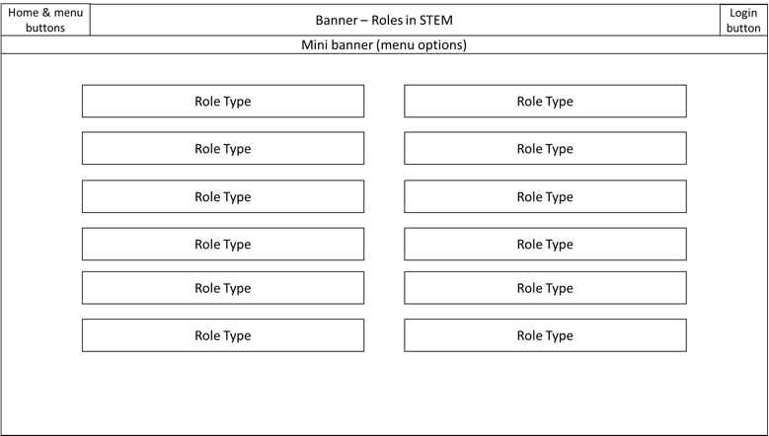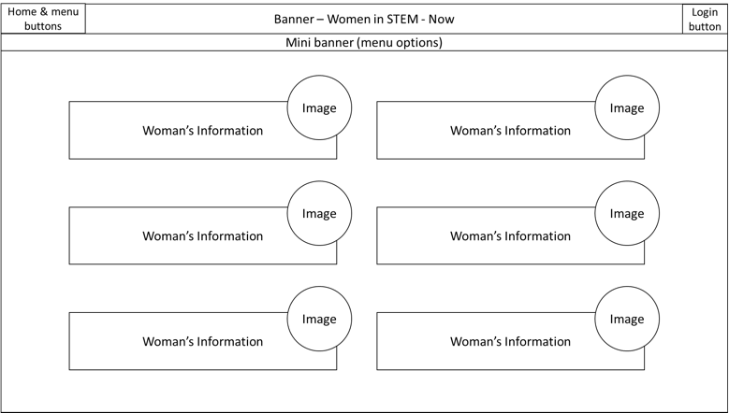Figures 1 – 4 show examples of the wireframes used within this development, see Appendix G for all the wireframes.

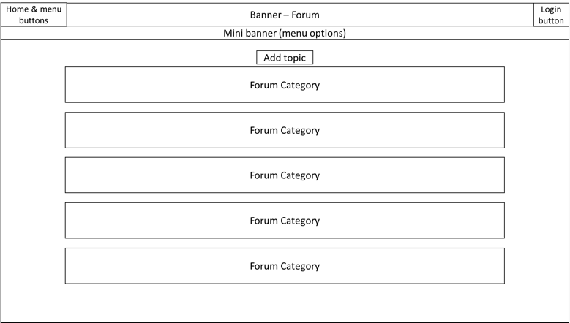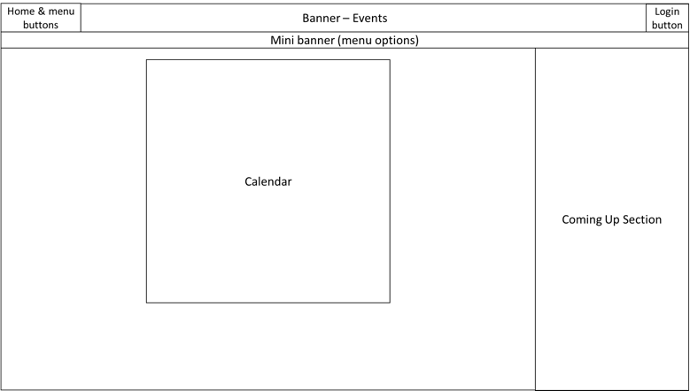 **Fig. 1 – Role Page Wireframe**  **Fig. 2 – Inspiring Women Wireframe**

**Fig. 3 – Events Wireframe**  **Fig. 4 – Forum Wireframe**

## 4.2. Front – End Development

The application was developed from scratch as an initial web application and used a range of API technologies. HTML, CSS, JavaScript and jQuery were the languages adopted for the front-end development. HTML allowed for the definition and organisation of content and its layout whilst CSS defined the style and look of the application. JavaScript and jQuery defined the functions and features of the application which gave it substance and made it behave in a user-friendly, expectant way. The combination of these 4 languages allowed for the creation of an aesthetically-pleasing, interactive and responsive application that could be deployed and rendered on different hardware platforms and web browsers.

### 4.2.1. Norman’s Design Principles

It is vital that any content of an interface is set out in a logical manner to ensure easy-of-use for the users - it must be aesthetically pleasing and usable enough for the maximum number of users be enticed by the application as well as ensuring they return to make full use of the services offered by such an application. A device or application will simply be avoided by users if it is not learnable and hard to use. To avoid this, the decision was made to follow Norman’s Design Principles for Usability (Preece, Rogers, Sharp, 2002).

#### 4.2.1.1. Visibility

The first principle tackled was visibility – it was ensured that the functions within the application were obvious for the user to see, rather than having them hidden from view where users would not take full advantage of them. Examples of this principle being met include: the visible menu and login icons as well as having clear signposts which allowed users to know that they were able to add topics and comments within the forum section of the application.

#### 4.2.1.2. Feedback

Feedback from the system/user interface is of extreme importance in designing for usability as it allows users to know when their tasks/actions have accomplished something. Within this app, this has been achieved in many ways: when a user first registers to the app feedback is delivered in the form of a modal explaining how a user has been created. Likewise, this is true when a new topic or comment has been added, or a password changed. Within the form elements of the application, validation feedback has been integrated by which input boxes turn red to inform the user that there are mistakes within said input fields. Feedback is key to users understanding the system.

#### 4.2.1.3. Mapping

Preece, Rogers and Sharp (2002) explain how mapping refers to the relationship between controls and the real world. It is important that mappings are as normal as possible within applications – this project sees the how mappings can be achieved by placing the home and menu buttons in the top left-hand corner, with the login/account icons in the top right-hand corner. This follows the standard design of most apps and webpages.

#### 4.2.1.4. Constraints

Constraints are placed upon elements to limit the range of possibilities a user can choose in a process. This principle has been implemented within the application using limited dropdown menus in the topic creation form as well as limiting certain input fields to only accepting email address formatted inputs.

#### 4.2.1.5. Affordance

The idea of affordance is the giving of ‘hints’ to users or allowing them to carry out an action. The design aim of ‘itgirls’ was for it to be naturally intuitive, learnable and useable, meaning that only a few elements of affordance were actually needed such as the text buttons of ‘Add Topic’, ‘Add Comment’ and ‘Sign Up’, hinting to users of the added functionality.

#### 4.2.1.6. Consistency

Consistency is the final, key principle of good design which contributed to a sense of unification, professionalism and completeness of systems and solutions. It has been achieved continuously through this application from a consistent colour scheme, text font, modal animation and shape.

##### 4.2.1.6.1. Colour Scheme Consistency

A key consideration with the design of this application was the main colour scheme. It was important to understand the psychology behind colours and how they affect people emotionally. For instance, originally the colour scheme was grey and pink as it was target at females – it soon became apparent how gender stereotypical the scheme could be and how it was hypocritical to the point being made in this dissertation. After Wright’s colour psychology report (2008), the decision was then made to create green and purple colour scheme which appeared gender neutral and balanced. Green is said to be the colour of balance and reassurance whilst purple is the colour of spirituality and brings with it a higher level of thought and values. The colours compliment each other whilst psychologically encouraging and calming its users.

## 4.3. Back – End Development

The application required both the use of a database and log in functionality with user authentication techniques. To achieve this, node.js was the language used to develop the back-end elements whilst MySQL was the database type chosen to hold the data for the application, including the storing of the login details.

Node.js allowed for validation and testing to occur on within the application, making it more secure, efficient and reliable whilst allowing the connection to the database (which held a lot of the content for the application). After passing the defined tests, the application was populated with the associated data.

MySQL was the database language chosen purely down to the type of data to be held and this disregarded the need to use other, more complicated database structures such as MongoDB. MySQL also provided the effective storage space which was required.

The decision to use these technologies was made due to the developer’s current knowledge of such technologies meaning that the most effective application could be generated in the small space of allocated project time.

## 4.4. Application Hosting

The development and hosting of the application was achieved using the online cloud service: Cloud9. The reasoning behind this decision was that all the development work would be accessed and modified at any location and the developer also had previous knowledge of the platform and its benefits. For instance, Cloud9 is Git integrated which helped with the element of version control and always keeping the code secure and of a high quality. Due to the nature of this application, it is currently just a prototype and its aim is to be deployed and demonstrated to a focus group (no user testing periods were required). The need to setup its own domain and external host seemed a bit unnecessary when Cloud9 was fit for purpose, allowing the application to be locally hosted and viewed.

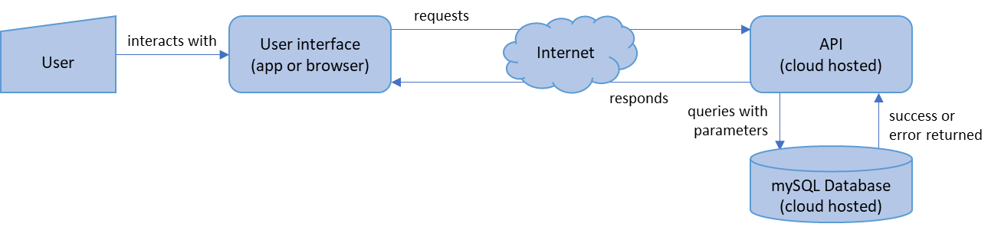Figure 4.1. below shows the basic architectural diagram for the application to give an overview of the communications and interactions between services and inputs.

**Fig. 4.1 – System Architecture**

## 4.5. Summary

All in all, the development process was completed in a timely fashion, ready to be deployed and demonstrated within the planned focus group. Figures 5 – 8 show screenshots of the completed application – the rest can be found in Appendix H. To see the entire code, it can be found at:

<https://github.com/RayannTedds/individualproject>

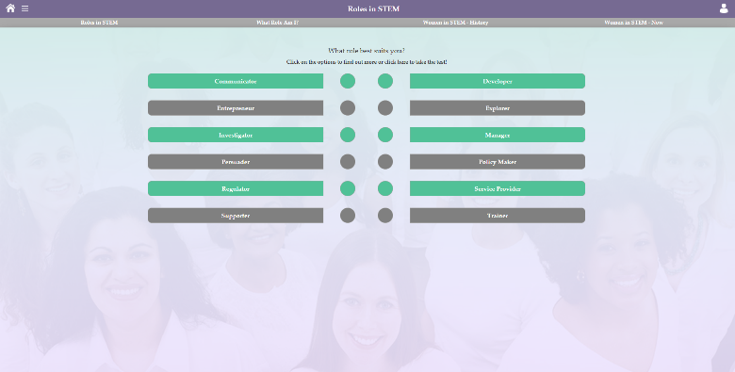

**Fig. 5 – itgirls Homepage**  **Fig. 6 – itgirls Role Page**

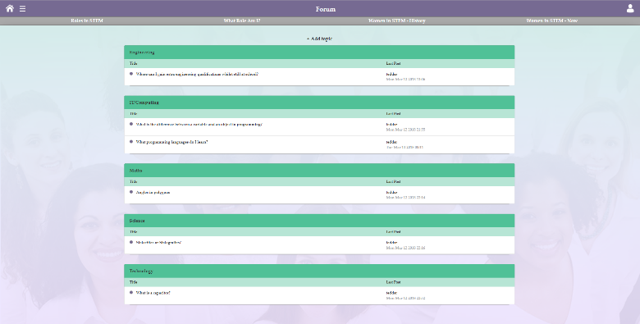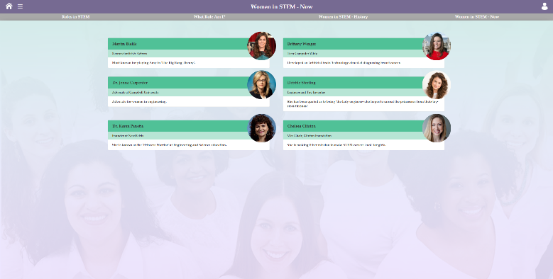

**Fig. 7 – itgirls Inspiring Women Page**  **Fig. 8 – itgirls Forum Page**

# 5. Project Management

Having a project management plan enables projects to have a sense of direction and focus to produce a high-quality product. The following section explains the project management approaches adopted within this project.

## 5.1. Methodology

Within this project’s development process, an agile development process was adopted. Agile development, as defined by Highsmith (2002), is the ability of creating and responding to change to succeed in uncertain and ever-changing environments. This approach fitted perfectly with a project such as this as a literature review and primary research analysis and software development were being conducted simultaneously. The sufficient planning process associated with agile ensured that any new and relevant data and information received could be integrated into the report and application without hesitation or many problems, ensuring that the application was always fit for purpose, could reach its potential and goal.

With agile development, the main task is broken down into smaller, more manageable chunks – this approach was taken when developing ‘itgirls’: each day, new goals and tasks were set. The following day, the daily checklist was analysed to determine if all the tasks from the previous day had been completed or if any problems were encountered – new tasks for the remaining day were then defined. This method gave structure to the application’s development and enabled the deliverable (a satisfiable product) to be completed ahead of time, ready for its deployment within the focus group.

## 5.2. Planning

A key principle in Agile development is effective planning which allows for the tracking of time and the allowance of flexibility for the product to be generated.

### 5.2.1. Time Management

Time organisation played a vital role in this project. Mind Tools (2017) explains how time management consists of organising allotted time for tasks to be completed - good time management enables ‘smart’ working where tasks are completed efficiently and effectively whereas poor time management can lead to missed deadlines and unsatisfied goals.

The time within this project was managed using the project planning tool of a Gantt chart (see Appendix J) which set ideal deadlines and milestones for elements of the project, providing structure and goals. The Gantt chart was planned in the range of weeks and this allowed for weekly scrum meetings with the project’s supervisor to ensure that the project was on track and work was being completed at a sufficient rate. The meetings highlighted any action points that needed addressing for the following week and they gave encouragement when delivering results week-by-week.

### 5.2.2. Dependencies

The Gantt chart planning also allowed for the identification of dependencies within the project. M (n.d.) states that a dependency is a constraint-based or relationship between two or more activities by which their completion is reliant on the completion of the other. In short, before one element of the project can be completed, the previous element needs to be completed first.

There were 3 key dependencies within this project:

1. **The completion and sign-off of the ethics report.**

The longer this took to pass, the more time would be stalled before primary research could be conducted.

1. **The application development.**

This needed to be completed before any focus group could take place as a demonstration was required.

1. **Questionnaire completion.**

The questionnaire data can only be generated and analysed if the questionnaires are completed and submitted by the school.

These dependencies produced a time constraint for development work to commence straightaway. They also brought risk factors in terms of completion by a specified date – if dependencies weren’t completed by such a time, they could jeopardise any data being collected, and it could lead to the project aims not being achieved.

As well as highlighting dependencies, the planning process allowed parallel activities to be identified (what tasks can be completed simultaneously). Combined, the Gantt chart then allowed timeframes to be defined and visualised accordingly.

### 5.2.3. Risk management

The Oxford Dictionary (2018) defines risk as *“the possibility that something unpleasant or unwelcome will happen”*. In terms of this project, risk is associated with any element which could cause problems with its completion. It is for this reason that projects such as this need to be able to respond to change and risk as requirements are constantly changing and it is imperative that projects get completed. With a development process such as agile, risks can be managed from the start and dealt with accordingly – part of the planning stage is the generation of a risk table, as shown below:

|  |  |  |
| --- | --- | --- |
| Risk | Project Affect | Response |
| School doesn’t want to take part with questionnaires and/or focus group. | This would mean that primary research could not be collected for the project. | * The primary research methods would have to be proposed to another school until a consensual school was found (back up schools considered and approached). |
| Sample size of questionnaires are not as big as expected. | This could affect the reliability of the results from the data which had been collected. | * Having to settle with the maximum number of responses from the students and running reliability tests along with the data analysis tools and tests. * As well, more than 1 school could be approached for data collection. |
| Focus group consent numbers not achieved. | This could affect the reliability of the results from the data which had been collected. | * Having to settle for less than 10 people’s responses reliability tests should be carried out along with the data analysis tools and tests. * Potentially, have back up school ready if the focus group results are not sufficient enough. |
| Ethics approval late | Only after the ethics form has been approved can any form of primary research can be conducted – being late would mean that the school holidays may coincide and so the project could be stalled for a couple of weeks meaning the project could have a risk of not being completed. | * Communication with the school and project supervisor should be of high importance to discuss further action and possible deadline extension dates. |
| Application hosting service down | Focus group cannot be conducted as the application demonstration cannot occur. | * The focus group will need to be rearranged for another date. * Potentially, an application demonstration can be videoed as a backup feature for the focus group. |

**Tab. 1** – **Risk Planning**

Pinpointing risks at the beginning of the project enables for project continuation and ensures that projects stay and track and don’t stray far from time deadlines, stalling the project’s progress.

## 5.3. Communications

Skillsyouneed (2017) defines communication as *“the act of transferring information from one place to another”*. Within this project, communication and relationships were extremely important as it allowed for data to be gathered and it ensured that the project came to a successful end-point using analysed data. The communication structure within this project depended upon face-to-face meetings and email communications. There were 3 key relationships which needed to be upheld within this project:

1. **Project supervisor**

Weekly face-to-face meetings took place with the project supervisor every Wednesday to discuss progress updates and action points (see Appendix I). Email correspondents were also used for more informal communications and answering of simple queries.

1. **Primary school representative**

A face-to-face meeting took place with the primary school representative to explain what the questionnaire consisted of and why it was needed for this project. Phone communications were then used to inform each other of questionnaire completion updates and to arrange pickup/drop-off dates.

1. **Secondary school representative**

A face-to-face meeting took place with the secondary school representative to explain what the questionnaire and focus group consisted of and why they were needed for this project. Email communications were then used to inform each other of questionnaire completion updates and to arrange further meeting dates and focus group number clarifications.

## 5.4. Social, Ethical, Legal and Professional Issues

BCS (2017) played a huge role in the understanding social, ethical, legal and professional issues that needed to be addressed and adhered to throughout the project (see 3.2. Data Collection, Participants, and Ethics for more depth). Legally and professionally, a duty of care towards participants and their data was required as well as having the responsibility to reduce any risk involved. Included in this was the adherence to the Data Protection Act (1998); keeping any data collected secure and anonymous. Ethically, it was of vital importance that any data collected for primary research purposes was consensual by the participants as well as being checked and approved by the participating educational institutions. Socially, the project remained neutral throughout free from slander and any stigma found within society. Culturally, it was ensured that no pitched question or application feature had a damaging or negative impact on different cultures. To achieve a diverse range of results, random students from different cultures and backgrounds completed the surveys and focus group.

## 5.5. Presentation Feedback

Half way through the project, a presentation was conducted where the project’s progress and structure were explored in detail to the project supervisor. Feedback is defined as a technique where helpful information/criticism on topics or works are communicated to the author. DeFranzo (2015) highlights how effective feedback is extremely beneficial as it allows for projects to expand and better themselves by improving performance and allowing for continuous learning. The project’s supervisor provided a range of feedback points after the presentation was delivered (see table 2). The feedback highlighted weaker areas of the project and how they could be strengthened to help produce a more solid research project.

|  |  |  |
| --- | --- | --- |
| Feedback Point | Feedback Point Explanation | Action Point |
| Restructuring of introduction sections | The sections within the main introduction did not originally flow properly or make sense to be grouped in the way they were. | It was decided that the ‘Gaps in Current Knowledge’, ‘Research Question’ and ‘Contribution of Thesis’ should be relocated to the summary of the literature review. This ensures that the content flows and is more logical. |
| Literature review reasoning behind category selections | When it came to the literature report and the reasons behind the gender gap, there were 5 main categories (reasons) selected as to the overall explanation of the problem. It was then important that the reader of the report understood why these 5 categories were identified and chosen. This is the same for the section about how the gender gap could be narrowed. | An introductory paragraph within the literature review was added to explain how these reasons were chosen – in this case it was the use of a spreadsheet as a source database with checklists, identifying the most frequent reasons identified by each source. The spreadsheet was then added to the appendix also (Appendix K). |
| Search terms | It was highlighted that search terms and journals should be identified so the reader understands where the references and information were gained. | Within the introductory paragraph of the literature review, an overview of the search terms have been added to fulfil this aim. |
| Is a gender gap required to be narrowed? | Within the literature review, ways that the STEM gender gap can be narrowed have been identified. The review lacked reasoning as to why the gender gap should be narrowed and if there were any identified benefits of having a smaller gap at all. | An introductory paragraph within the specific literature review section was added which highlighted the benefits of having more women in STEM. Sources have been referenced and given the report more justification for the development of an application to bridge the gap. |
| Analysis techniques and explanation | At the point of the presentation, primary research data had only been inputted and needed analysis. It is important that analysis techniques are selected and understood. | I had always been planned that IBM’s SPSS Software (2018) would be used as the data analysis tool. It was highlighted in the presentation feedback that each technique used should be fully justified – this has been incorporated into the results. |
| Development section needs developing | A large part of this report and primary research is based upon the development of an application. Up until this point, the development section had been skipped altogether and the project supervisor advised on including this section as it was of high importance. | As the feedback was given, it became apparent how important this section was. It has been included in the report with the following elements included:   * Technologies used * The use and importance of Git and version control * User interface design and explanations * Wireframes, screenshots and the link to the application’s code in Git. |
| Future development addition | In the presentation, it was highlighted how the lateness of the ethics form approval causes problems for my primary research gathering – it was advised that these problems could be incorporated into the future development section of the report. | As well as looking at other techniques that would entice more women to study and have a career in STEM, the future development section also highlights how issues impacted the project and how it could be changed in the future. An example of this is with the late approval of the ethics form which stalled the data collection period and meant that the focus group and application demonstration and deployment could not be as thorough as desired. |

**Tab. 2 – Presentation Feedback**

The action points were implemented into the report and it was understood how important such elements were and how they benefited the project but also other research in the future.

Positive feedback was also provided by the supervisor including: the good structure that the report has in general, how the summaries help with the flow of report and how all the development work needs to be documented as it is a huge part of hardwork which needs to be expressed and shown.

## 5.6. End Point

The primary research has been proved successful in showing that a STEM gender divide does exist, and it is present from a young primary school age. In addition to this, defined at the start of the project was its aim to investigate whether an application could help to influence young women into considering studying STEM, this project has set out to indicate that such a technique can indeed make fulfil its aim and goal.

## 5.7. Reflection

In reflection, the fact that the acceptance of this project’s ethics was stalled meant that the primary research methods were conducted a few weeks after the desired date, stalling the entire project and causing frustration as results could not be analysed until much later in the development process.

# 6. Analysis of Results

The following section sees the analysis of the primary research conducted to coincide with this report. It sees a series of analysis tools and tests being conducted.

Pie charts have been used as clear visual aids to show proportions and distribution of nominal and ordinal data. Whereas bar charts have been used as a clear visual representation of discrete/scale data. Both chart types have been included the analysis as a large amount of data and information can be extracted at a glance and easily interpreted.

Looking more deeply into analysis, associations between variables have been tested using both Chi-Square and Spearman’s Rank Correlation Coefficient hypothesis tests have been conducted. Chi-Square tests have been used to test association between categorical responses whereas Spearman’s Rank Correlation Coefficient has been used to test associations between ordinal responses.

## 6.1. Analysis of Primary School Data

### 6.1.1. Background Analysis of Primary School Data

To begin the primary school data analysis, it is important to understand the basic distribution of the children surveyed. This survey found 158 people were surveyed from both genders and ranging in the years 3 – 6, as you can see following:

|  |  |  |  |
| --- | --- | --- | --- |
| **Gender Distribution** | | | |
|  | | Frequency | Percent |
| Valid | Male | 68 | 43.0 |
| Female | 90 | 57.0 |
| Total | 158 | 100.0 |

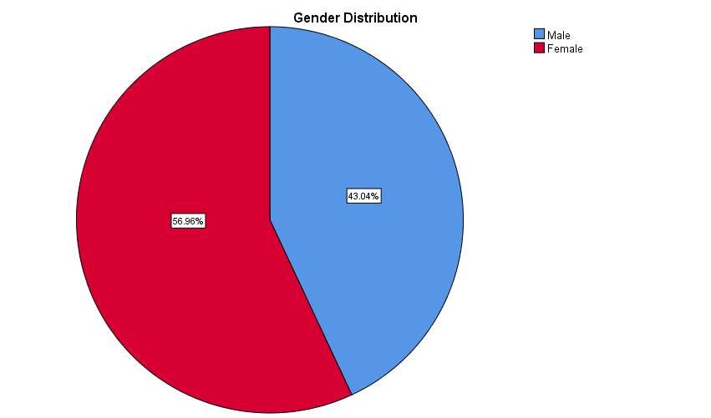

**Tab. 3 – Primary Gender Distribution Table**

**Fig. 9 – Primary Gender Distribution Chart**

Figure 9 shows that 43% of the surveyed people were male whilst 57% were female. Knowing this statistic is important as gender is an important testing variable amongst this project.

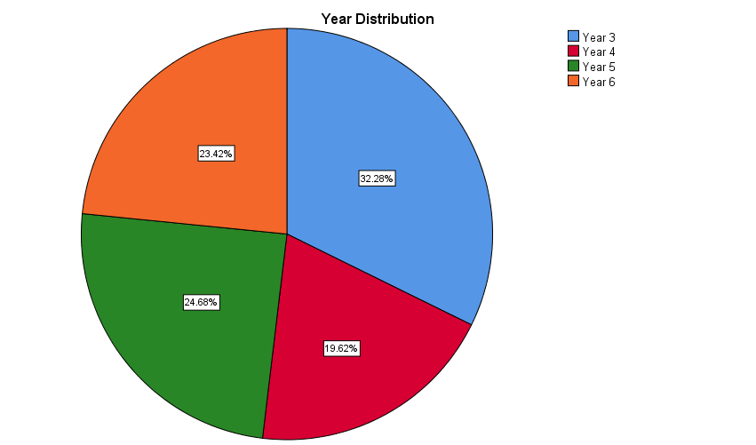

|  |  |  |  |
| --- | --- | --- | --- |
| **Year Group Distribution** | | | |
|  | | Frequency | Percent |
| Valid | Year 3 | 51 | 32.3 |
| Year 4 | 31 | 19.6 |
| Year 5 | 39 | 24.7 |
| Year 6 | 37 | 23.4 |
| Total | 158 | 100.0 |

**Tab. 4 – Primary Year Distribution Table**

**Fig. 10 – Primary Year Distribution Chart**

Table 4 and Figure 10 highlights the distribution of the age groups the children surveyed were in – showing that the years 3 – 6 were all represented in this survey.

Figure 11 show the results as to what technology the primary school pupils owned can be found.

**Fig. 11 – Primary Technology Owned Chart**

This bar chart shows that a range of technologies are owned by the primary school pupils, tablets and computers being the most popular devices.

The survey then went on to investigate the activities pupils use their technological devices for, the results are presented in Figure 12:

**Fig. 12 – Primary Technology Activity Used Chart**

The bar chart shows a range of activities conducted by the pupils, gaming and education being the most popular. Following on from this, the survey asked the pupil specifically what activity they conducted the most with their technical device – Figure 13 below shows the distribution of their answers.

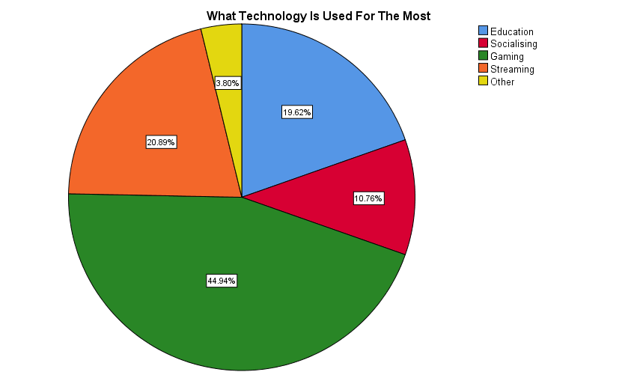

|  |  |  |  |
| --- | --- | --- | --- |
| **Purpose Technology is Used for Most** | | | |
|  | | Frequency | Percent |
| Valid | Education | 31 | 19.6 |
| Socialising | 17 | 10.8 |
| Gaming | 71 | 44.9 |
| Streaming | 33 | 20.9 |
| Other | 6 | 3.8 |
| Total | 158 | 100.0 |

**Tab. 5 – Primary Technology Activity Used Most Table**

**Fig. 13 – Primary Technology Activity Used Most Chart**

This frequency table and pie chart shows how gaming is the most popular activity overall to be conducted (44.9%) with streaming (20.9%) and education (19.6%) following.

### 6.1.2. Analysis of Primary School Data Looking into Gender Gaps

Within the literature review, it was shown how there is a gender gap with STEM subjects and careers. In the primary school survey, pupils were asked to identify how they felt about several subjects, from this we can interpret the pupil’s most and least favourite subjects – the results are presented in Figure 14:

**Fig. 14 – Primary Subject Favouritism Chart**

From the pie chart, it can be seen that PE, ICT and Maths are the most favoured subjects (with percentages of 13% respectively) within the surveyed primary school pupils overall with Geography, History and English being the least favoured subjects (with percentages of 8%, 9%, 10% respectively). To investigate whether an overall gender gap exists for STEM subjects, it is important to look gender-specifically:

**Fig. 15 – Primary Subject Favouritism** **Chart for Males**

**Fig. 16 – Primary Subject Favouritism Chart for Females**

Figures 15 and 16 show how the distribution of male and female favoured subjects are similarly distributed. PE is the favoured subject for both males and females (14% and 13% respectively), with Geography and History being the least favoured subjects (both 8% and 9% respectively). Contrastingly, 1% more girls before Science and Music than boys and 1% less girls prefer PE and ICT compared to boys. These numbers do not identify a clear STEM gender gap within primary school subjects – due to this more tests need to be completed to investigate this theory more closely.

#### 6.1.2.1 Analysing Relationships Between Gender and STEM Subjects in Primary School Survey

Following are hypothesis tests completed with Chi Square tests which analyse whether there is an association between primary school STEM subjects and gender.

IT and Gender Hypothesis Test

H0: There is no association between enjoying computer work and gender.

|  |  |  |  |  |
| --- | --- | --- | --- | --- |
| **Crosstabulation** | | | | |
|  | | Gender | | Total |
| Male | Female |
| I enjoy working with computers. | Strongly Agree | 81.5% | 88.4% | 85.4% |
| Neither Agree or Disagree | 15.4% | 9.3% | 11.9% |
| Strongly Disagree | 3.1% | 2.3% | 2.6% |
| Total | | 100.0% | 100.0% | 100.0% |

H1: There is no association between enjoying computer work and gender

|  |  |  |  |
| --- | --- | --- | --- |
| **Chi-Square Tests** | | | |
|  | Value | df | Asymptotic Significance (2-sided) |
| Pearson Chi-Square | 1.430a | 2 | .489 |
| Likelihood Ratio | 1.415 | 2 | .493 |
| Linear-by-Linear Association | 1.082 | 1 | .298 |
| N of Valid Cases | 151 |  |  |
| a. 2 cells (33.3%) have expected count less than 5. The minimum expected count is 1.72. | | | |

**Tab. 6 – IT and Gender Crosstabulation Table** **Tab. 7 – IT and Gender Chi-Square Test**

Within this test the p value = 0.489

p > 0.05 so we keep the null hypothesis meaning that this survey showed there to be **no** association between enjoying computer work and gender. This is shown as 81.5% of males agreed with liking computer work with females agreeing at 88.4%.

Maths and Gender Hypothesis Test

H0: There is no association between enjoying maths and gender.

|  |  |  |  |  |
| --- | --- | --- | --- | --- |
| **Crosstabulation** | | | | |
|  | | Gender | | Total |
| Male | Female |
| I enjoy maths. | Strongly Agree | 70.8% | 77.2% | 74.3% |
| Neither Agree or Disagree | 20.0% | 12.7% | 16.0% |
| Strongly Disagree | 9.2% | 10.1% | 9.7% |
| Total | | 100.0% | 100.0% | 100.0% |

|  |  |  |  |
| --- | --- | --- | --- |
| **Chi-Square Tests** | | | |
|  | Value | df | Asymptotic Significance (2-sided) |
| Pearson Chi-Square | 1.432a | 2 | .489 |
| Likelihood Ratio | 1.426 | 2 | .490 |
| Linear-by-Linear Association | .258 | 1 | .612 |
| N of Valid Cases | 144 |  |  |
| a. 0 cells (0.0%) have expected count less than 5. The minimum expected count is 6.32. | | | |

H1: There is no association between enjoying maths and gender.

**Tab. 8 – Maths and Gender Crosstabulation Table** **Tab. 9 – Maths and Gender Chi-Square Test**

Within this test the p value = 0.489

p > 0.05 so we keep the null hypothesis meaning that this survey showed there to be **no** association between enjoying maths and gender. This is shown as 70.8% of males agreed with liking maths with females agreeing at 77.2%.

Science and Gender Hypothesis Test

H0: There is no association between enjoying science and gender.

H1: There is no association between enjoying science and gender.

|  |  |  |  |  |
| --- | --- | --- | --- | --- |
| **Crosstabulation** | | | | |
|  | | Gender | | Total |
| Male | Female |
| I enjoy science. | Strongly Agree | 66.1% | 71.4% | 69.1% |
| Neither Agree or Disagree | 21.0% | 18.2% | 19.4% |
| Strongly Disagree | 12.9% | 10.4% | 11.5% |
| Total | | 100.0% | 100.0% | 100.0% |

|  |  |  |  |
| --- | --- | --- | --- |
| **Chi-Square Tests** | | | |
|  | Value | df | Asymptotic Significance (2-sided) |
| Pearson Chi-Square | .465a | 2 | .792 |
| Likelihood Ratio | .464 | 2 | .793 |
| Linear-by-Linear Association | .439 | 1 | .508 |
| N of Valid Cases | 139 |  |  |
| a. 0 cells (0.0%) have expected count less than 5. The minimum expected count is 7.14. | | | |

**Tab. 10 – Science and Gender Crosstabulation Table** **Tab. 11 – Science and Gender Chi-Square Test**

Within this test the p value = 0.792

p > 0.05 so we keep the null hypothesis meaning that this survey showed there to be **no** association between enjoying maths and gender. This is shown as 66.1% of males agreed with liking science with females agreeing at 71.4%.

Summary of Hypothesis Tests

From the results of these Chi-Square tests, we can imply that a STEM gender gap does not exist in a primary school setting as no associations have been proven. Due to this fact, the remaining analysis will focus on the secondary school data to identify a potential gap and contributing factors.

## 6.2. Analysis of Secondary School Data

### 6.2.1. Background Analysis of Secondary School Data

To begin the analysis of the secondary school data, it is important to understand the basic distribution of the children surveyed. This survey found 147 people were surveyed from both genders and ranging in the years 7 – 13, as you can see below:

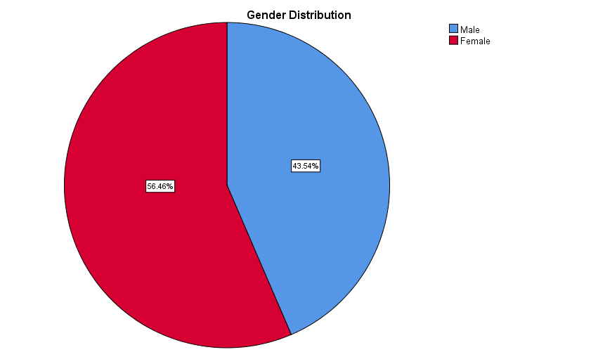

|  |  |  |  |
| --- | --- | --- | --- |
| **Gender Distribution** | | | |
|  | | Frequency | Percent |
| Valid | Male | 64 | 43.5 |
| Female | 83 | 56.5 |
| Total | 147 | 100.0 |

**Tab. 12 – Secondary Gender Distribution Table**

**Fig. 17 – Secondary Gender Distribution Chart**

Figure 17 found that 43.5% of the surveyed people were male whilst 56.5% were female. Knowing this statistic is important as gender is an important testing variable amongst this project.

|  |  |  |  |
| --- | --- | --- | --- |
| **Year Group Distribution** | | | |
|  | | Frequency | Percent |
| Valid | Year 7 | 25 | 17.0 |
| Year 8 | 27 | 18.4 |
| Year 9 | 26 | 17.7 |
| Year 10 | 27 | 18.4 |
| Year 11 | 22 | 15.0 |
| Year 12 | 13 | 8.8 |
| Year 13 | 7 | 4.8 |
| Total | 147 | 100.0 |

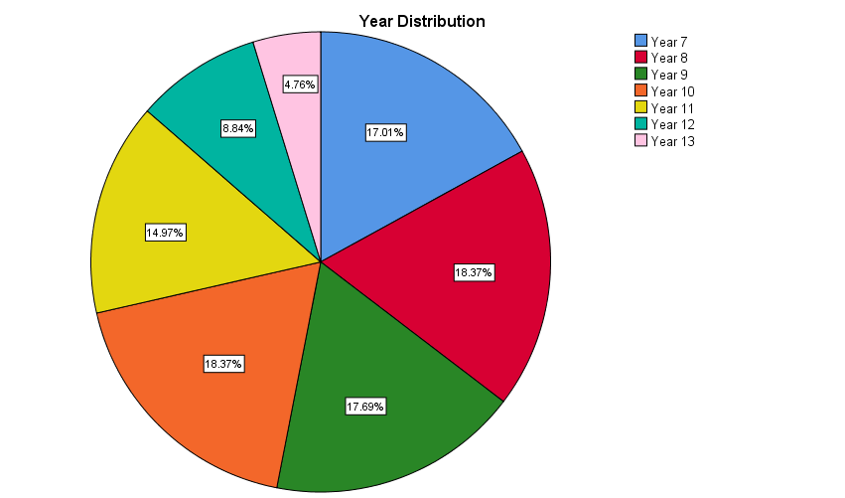

**Fig. 18 – Secondary Year Distribution Chart** **Tab. 13 – Secondary Year Distribution Table**

This frequency table and Figure 18 highlights the distribution of the age groups the children surveyed were in – showing that the years 7 – 13 were all represented in this survey.

Figure 19’s bar chart shows that a range of technologies are owned by the secondary school pupils - smartphones and computers being the most popular devices.

**Fig. 19 – Primary Technology Owned Chart**

The survey then went on to investigate the activities pupils use their technological devices for, the results are presented in Figure 20:

**Fig. 20 – Secondary Technology Activity Used Chart**

|  |  |  |  |
| --- | --- | --- | --- |
| **What Technology Is Used for The Most** | | | |
|  | | Frequency | Percent |
| Valid | Education | 12 | 8.2 |
| Socialising | 83 | 56.5 |
| Gaming | 36 | 24.5 |
| Streaming | 16 | 10.9 |
| Total | 147 | 100.0 |

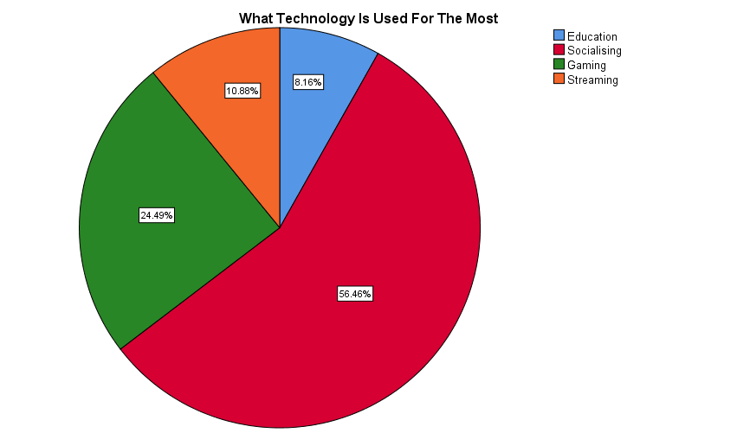Figure 20 shows a range of activities conducted by the pupils, socialising and education being the most popular. Following on from this, the survey asked the pupil specifically what activity they conducted the most with their technical device – Figure 21 shows the distribution of their answers.

**Tab. 14 – Secondary Technology Activity Used Most Table**

**Fig. 21 – Secondary Technology Activity Used Most Chart**

This frequency table and Figure 21 show how socialising is the most popular activity overall to be conducted (56.5%) by secondary school pupils with gaming (24.5%) following.

### 6.2.2. Analysis of Secondary School Data Looking into Gender Gaps

Similarly, to the primary school survey, the secondary school survey asked pupils to identify their top and bottom 3 school subjects – the results are presented below:

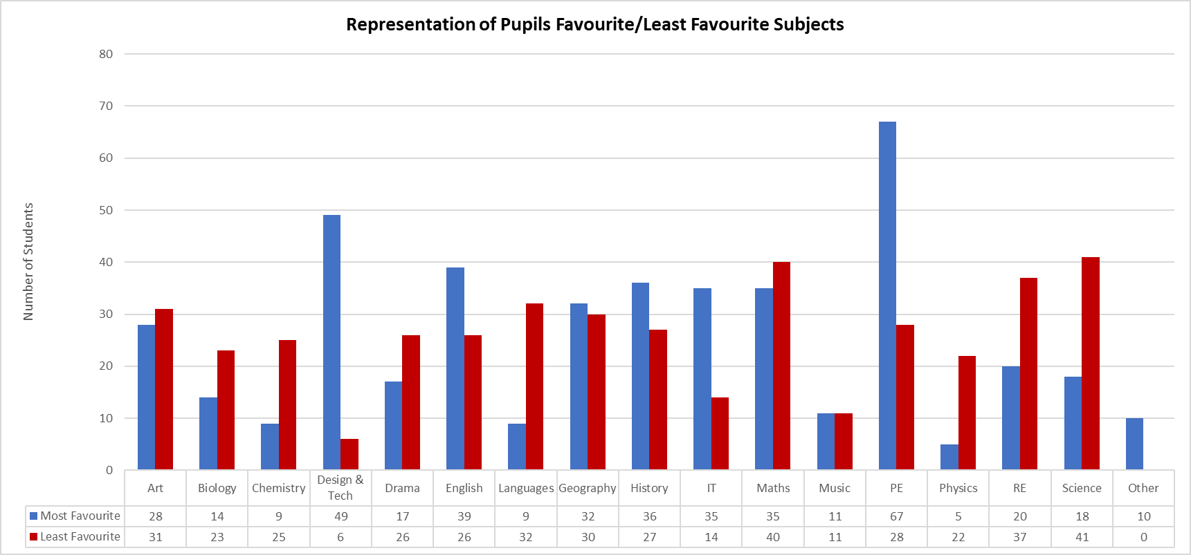

**Fig. 22 – Secondary Subject Favouritism Chart**

From Figure 22, it can be seen that PE, Design & Technology and English are the most favoured subjects (with frequencies of 67, 49 and 39 respectively) within the surveyed secondary school pupils overall. Science, Maths and RE were the least favoured subjects with Geography, History and English being the least favoured subjects (with frequencies 41, 40 and 37 respectively). To investigate whether an overall gender gap exists for STEM subjects, it is important to look gender-specifically:

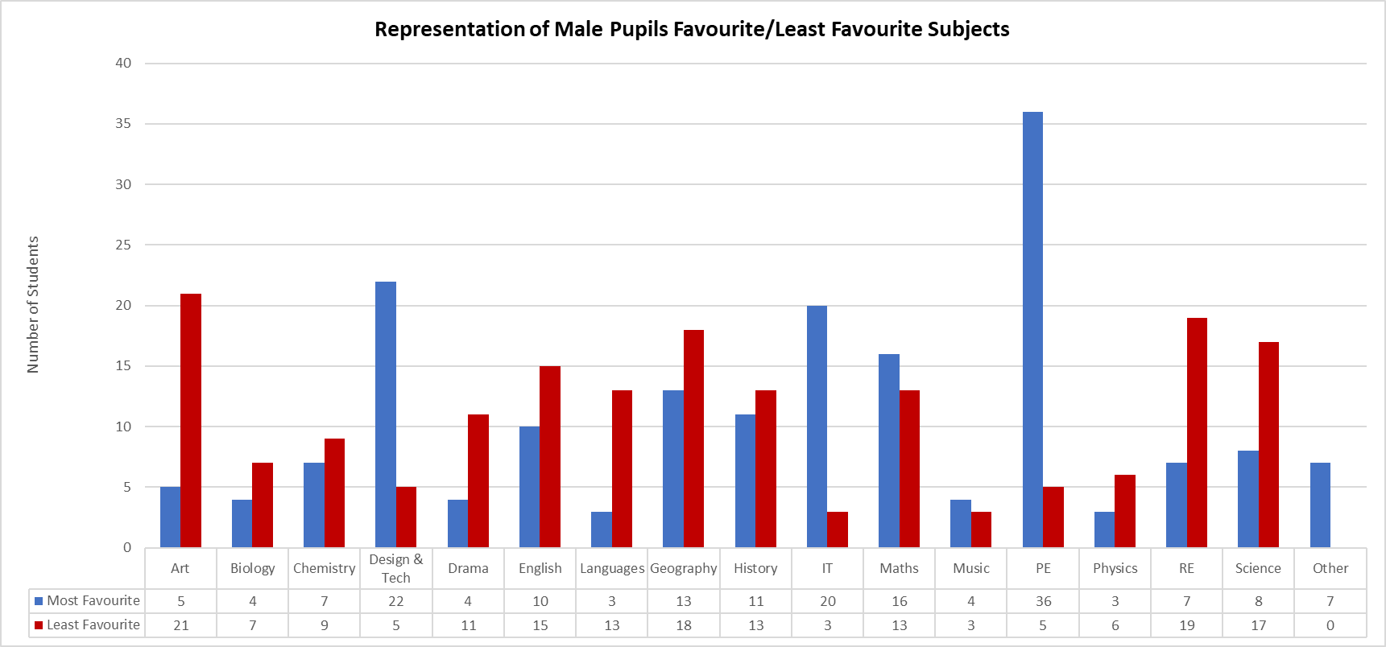

**Fig. 23 – Secondary Subject Favouritism Chart for Males**

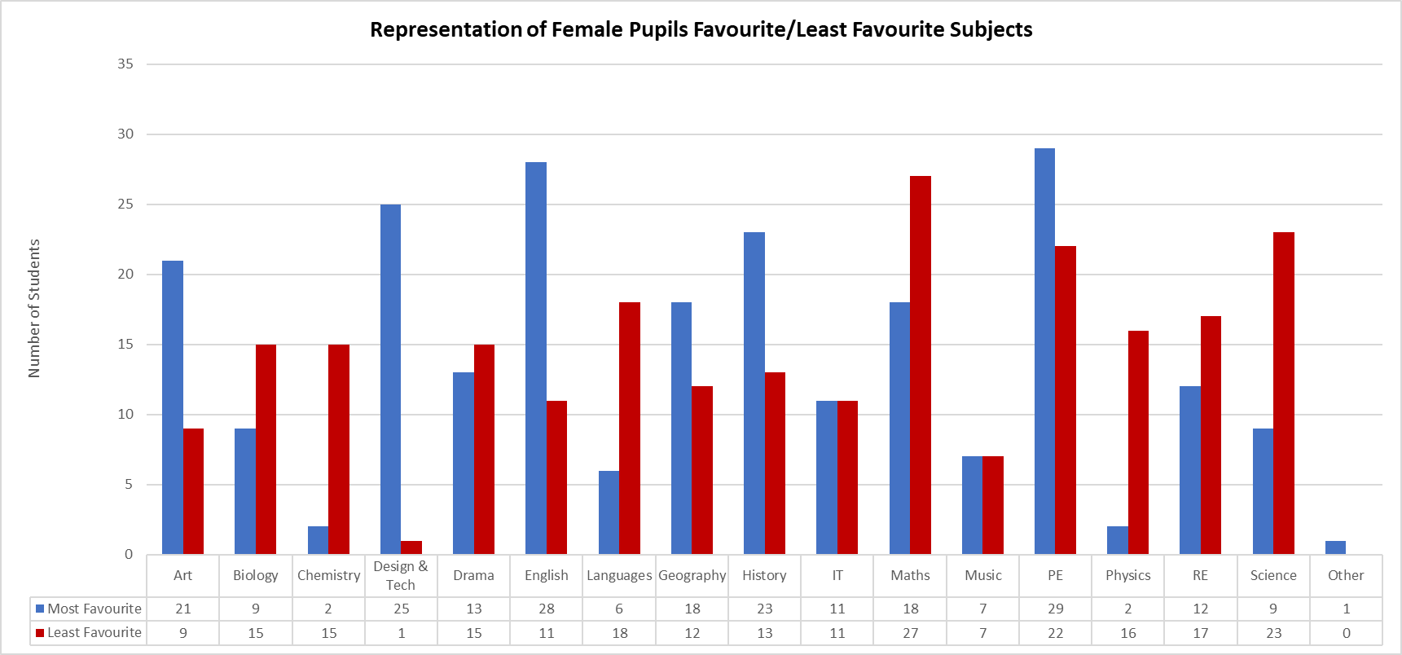

**Fig. 24 – Secondary Subject Favouritism Chart for Females**

Figures 23 and 24 show how the distribution of male and female favoured subjects are distributed. PE is the favoured subject for both males and females (frequencies of 36 and 29 respectively), males then prefer Design & Technology and IT (frequencies of 22 and 20 respectively) whereas females next prefer English and then Design & Technology (frequencies of 28 and 25 respectively).

In terms of the least favoured secondary school subjects, it has been found that males like Art, RE and Geography the least (with frequencies of 21, 19 and 18 respectively) whereas females like Maths, Science and PE the least (with frequencies of 27, 23 and 22 respectively). with Geography and History being the least favoured subjects (both 8% and 9% respectively).

Compared to the primary school statistics, the secondary school results show a shift in the opinions of STEM subjects in general, hinting that females enjoy maths and science the least (starting to identify a gender gap). Again, it is now important to explore the STEM subjects in more depth to come to further conclusions as to whether a gender gap exists.

#### 6.2.2.1 Analysing Relationships Between Gender and STEM Subjects in Secondary School Survey

Following are hypothesis tests completed with Spearman’s Rank Correlation tests which analyse whether there is an association between secondary school STEM subjects and gender.

IT and Gender Hypothesis Test

H0: Population rank correlation coefficient = 0.

H1: Population rank correlation coefficient ≠ 0.

|  |  |  |  |  |
| --- | --- | --- | --- | --- |
| **Crosstabulation** | | | | |
|  | | Gender | | Total |
| Male | Female |
| I enjoy IT | Strongly Agree | 33.3% | 12.7% | 21.9% |
| Agree | 33.3% | 30.2% | 31.6% |
| Neither Agree or Disagree | 17.6% | 27.0% | 22.8% |
| Disagree | 9.8% | 22.2% | 16.7% |
| Mostly Disagree | 5.9% | 7.9% | 7.0% |
| Total | | 100.0% | 100.0% | 100.0% |

|  |  |  |  |  |
| --- | --- | --- | --- | --- |
| **Correlations** | | | | |
|  | | | I enjoy IT. | Gender |
| Spearman | I enjoy IT | Correlation Coefficient | 1.000 | .268** |
| Sig. (2-tailed) | . | .004 |
| N | 114 | 114 |
| Gender | Correlation Coefficient | .268** | 1.000 |
| Sig. (2-tailed) | .004 | . |
| N | 114 | 114 |
| **. Correlation is significant at the 0.01 level (2-tailed). | | | | |

**Tab. 15 – IT and Gender Crosstabulation Table** **Tab. 16 – IT and Gender** **Spearman Test**

Within this test the rank correlation coefficient = 0.268 with the p value = 0.004

p < 0.05 so we reject the null hypothesis meaning that within this survey there is significant evidence of an association between enjoying IT and gender. This is shown as 66.6% of males agreed with liking IT with females agreeing at 42.9%.

Technology and Gender Hypothesis Test

H0: Population rank correlation coefficient = 0.

H1: Population rank correlation coefficient ≠ 0.

|  |  |  |  |  |
| --- | --- | --- | --- | --- |
| **Crosstabulation** | | | | |
|  | | Gender | | Total |
| Male | Female |
| I enjoy technology | Strongly Agree | 44.2% | 47.5% | 46.1% |
| Agree | 34.9% | 37.3% | 36.3% |
| Neither Agree or Disagree | 9.3% | 10.2% | 9.8% |
| Disagree | 9.3% | 5.1% | 6.9% |
| Mostly Disagree | 2.3% |  | 1.0% |
| Total | | 100.0% | 100.0% | 100.0% |

**Tab. 17 – Technology and Gender Crosstabulation Table**

|  |  |  |  |  |  |
| --- | --- | --- | --- | --- | --- |
| **Correlations** | | | | | |
|  | | | I enjoy technology | Gender |
| Spearman | Gender | Correlation Coefficient | 1.000 | -.061 |
| Sig. (2-tailed) | . | .543 |
| N | 102 | 102 |
| I enjoy technology | Correlation Coefficient | -.061 | 1.000 |
| Sig. (2-tailed) | .543 | . |
| N | 102 | 102 |

**Tab. 18 – Technology and Gender Spearman Test**

Within this test the rank correlation coefficient = -0.61 with the p value = 0.543

p > 0.05 so we keep the null hypothesis meaning that within this survey there is **no** significant evidence of an association between enjoying technology and gender. This is shown as 79.1% of males agreed with liking technology with females agreeing at 84.8%.

Maths and Gender Hypothesis Test

H0: Population rank correlation coefficient = 0.

H1: Population rank correlation coefficient ≠ 0.

|  |  |  |  |  |
| --- | --- | --- | --- | --- |
| **Crosstabulation** | | | | |
|  | | Gender | | Total |
| Male | Female |
| I enjoy maths | Strongly Agree | 29.8% | 12.3% | 19.2% |
| Agree | 31.9% | 52.1% | 44.2% |
| Neither Agree or Disagree | 10.6% | 12.3% | 11.7% |
| Disagree | 14.9% | 12.3% | 13.3% |
| Mostly Disagree | 12.8% | 11.0% | 11.7% |
| Total | | 100.0% | 100.0% | 100.0% |

|  |  |  |  |  |
| --- | --- | --- | --- | --- |
| **Correlations** | | | | |
|  | | | I enjoy maths | Gender |
| Spearman | I enjoy maths | Correlation Coefficient | 1.000 | .029 |
| Sig. (2-tailed) | . | .899 |
| N | 21 | 21 |
| Gender | Correlation Coefficient | .029 | 1.000 |
| Sig. (2-tailed) | .899 | . |
| N | 21 | 21 |

**Tab. 19 – Maths and Gender Crosstabulation Table** **Tab. 20 – Maths and Gender Spearman Test**

Within this test the rank correlation coefficient = 0.029 with the p value = 0.899

p > 0.05 so we keep the null hypothesis meaning that within this survey there is **no** significant evidence of an association between enjoying maths and gender. This is shown as 61.7% of males agreed with liking maths with females agreeing at 64.4%.

Science and Gender Hypothesis Test

H0: Population rank correlation coefficient = 0.

H1: Population rank correlation coefficient ≠ 0.

|  |  |  |  |  |
| --- | --- | --- | --- | --- |
| **Crosstabulation** | | | | |
|  | | Gender | | Total |
| Male | Female |
| I enjoy science | Strongly Agree | 23.7% | 21.2% | 22.1% |
| Agree | 42.1% | 31.8% | 35.6% |
| Neither Agree or Disagree | 10.5% | 18.2% | 15.4% |
| Disagree | 10.5% | 21.2% | 17.3% |
| Mostly Disagree | 13.2% | 7.6% | 9.6% |
| Total | | 100.0% | 100.0% | 100.0% |

|  |  |  |  |  |
| --- | --- | --- | --- | --- |
| **Correlations** | | | | |
|  | | | I enjoy science | Gender |
| Spearman | I enjoy science | Correlation Coefficient | 1.000 | .070 |
| Sig. (2-tailed) | . | .481 |
| N | 104 | 104 |
| Gender | Correlation Coefficient | .070 | 1.000 |
| Sig. (2-tailed) | .481 | . |
| N | 104 | 104 |

**Tab. 21 – Science and Gender Crosstabulation Table** **Tab. 22 – Science and Gender Spearman Test**

Within this test the rank correlation coefficient = 0.07 with the p value = 0.481

p > 0.05 so we keep the null hypothesis meaning that within this survey there is **no** significant evidence of an association between enjoying science and gender. This is shown as 65.8% of males agreed with liking science with females agreeing at 53%.

Summary of Hypothesis Tests

The results of the Spearman rank correlation tests start to hint at a gender gap with IT as a STEM subject yet they rival a clear gender divide amongst the other subjects. The results begin to show signs that a gender gap begins at a secondary school level.

### 6.2.3. Analysis of Secondary School Data Identifying Reasons for a Gender Gap in STEM

To identify the reasons why females do not like STEM subjects, pie charts have been generated to represent the findings.

|  |  |  |  |
| --- | --- | --- | --- |
| **Why Females Did Not Enjoy IT** | | | |
|  | | Frequency | % |
| Valid | Hard To Remember | 1 | 4% |
| Make Mistakes | 1 | 4% |
| Difficult | 1 | 4% |
| Repetitive | 2 | 8% |
| Boring | 5 | 20% |
| The Given Work | 10 | 40% |
| Confusing | 2 | 8% |
| No Interest For My Future | 1 | 4% |
| Teacher | 2 | 8% |
| Total | 25 | 100% |

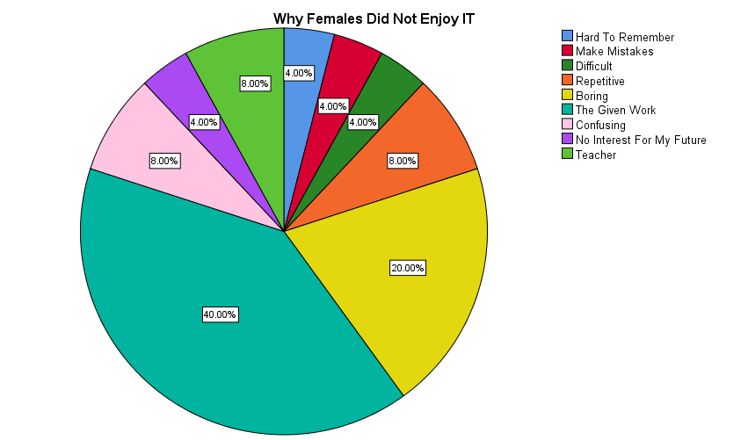

**Fig. 25 – Females Not Enjoying IT Reasoning Chart**

**Tab. 23 – Females Not Enjoying IT Reasoning Table**

Figure 25 has identified that those females who did not like IT, mainly felt this way due to the work given (40%) and because they find the subject boring (20%).

|  |  |  |  |
| --- | --- | --- | --- |
| **Why Females Did Not Enjoy Technology** | | | |
|  | | Frequency | % |
| Valid | Make Mistakes | 1 | 14.3% |
| Difficult | 2 | 28.6% |
| Time Consuming | 1 | 14.3% |
| The Given Work | 3 | 42.9% |
| Total | 7 | 100% |

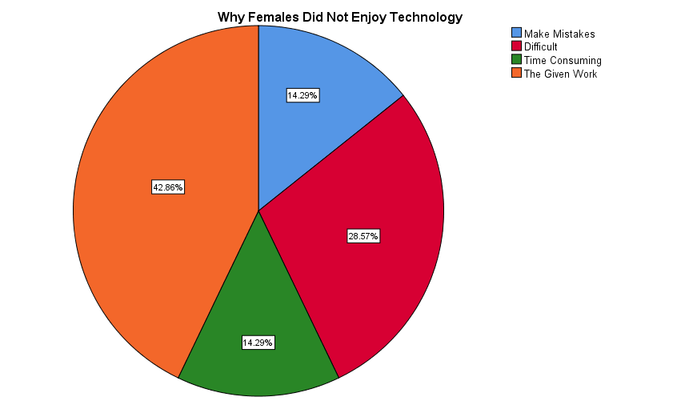

**Tab. 24 – Females Not Enjoying Tech Reasoning Table**

**Fig. 26 – Females Not Enjoying Technology Reasoning Chart**

Figure 26 has identified that those females who did not like technology, mainly felt this way due to the work given (42.86%) and because they find the subject difficult (28.6%).

|  |  |  |  |
| --- | --- | --- | --- |
| **Why Females Did Not Enjoy Maths** | | | |
|  | | Frequency | % |
| Valid | Hard To Remember | 4 | 25% |
| Difficult | 3 | 18.8% |
| Boring | 1 | 6.3% |
| The Given Work | 6 | 37.5% |
| Lack of Help | 1 | 6.3% |
| The Class | 1 | 6.3% |
| Total | 16 | 100% |

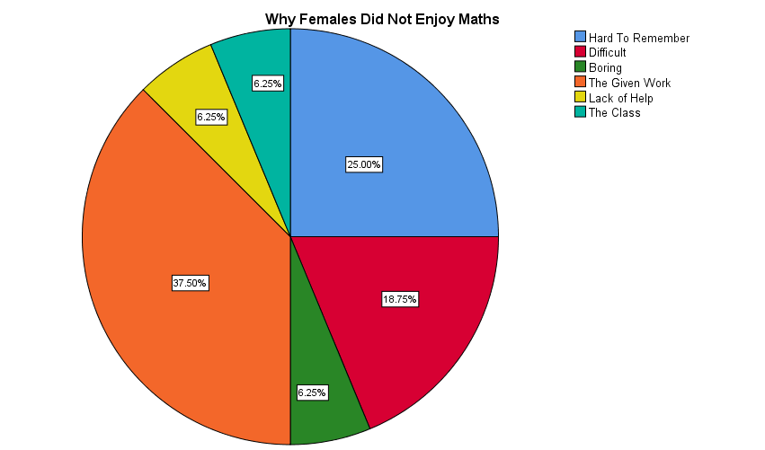

**Fig. 27 – Females Not Enjoying Maths Reasoning Chart** **Tab. 25 – Females Not Enjoying Maths Reasoning Table**

Figure 27 has identified that those females who did not like maths, mainly felt this way due to the work given (37.5%) and the subject being hard to remember (25%).

|  |  |  |  |
| --- | --- | --- | --- |
| **Why Females Did Not Enjoy Science** | | | |
|  | | Frequency | % |
| Valid | Make Mistakes | 1 | 4.5% |
| Difficult | 3 | 13.6% |
| Boring | 3 | 13.6% |
| The Given Work | 7 | 31.8% |
| Too Fast Paced | 1 | 4.5% |
| Teacher | 5 | 22.7% |
| The Class | 2 | 9.1% |
| Total | 22 | 100% |

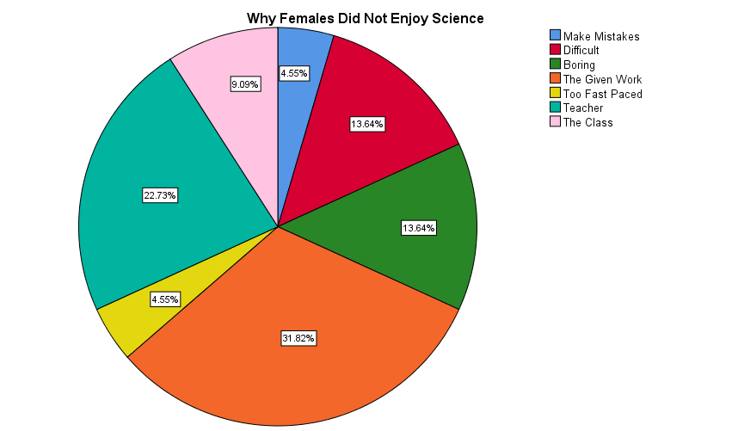

**Fig. 28 – Females Not Enjoying Science Reasoning Chart** **Tab. 26 – Females Not Enjoying Science Reasoning Table**

Figure 28 has identified that those females who did not like science, mainly felt this way due to the work given (31.8%) and because of the subject teacher (22.7%).

The literature review suggests reasons as to why a gender gap exists worldwide, the following analysis takes some of reasons and tests them against the opinions provided by the secondary school survey.

#### 6.2.3.1. STEM Gender Gap Reasoning - Fewer Female Role Models

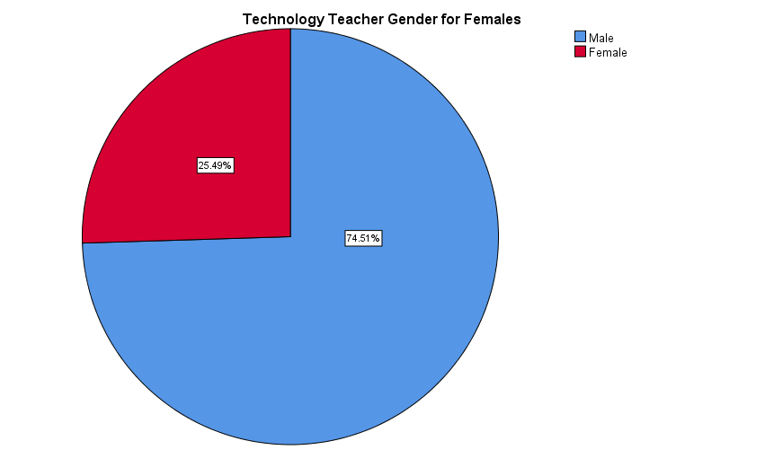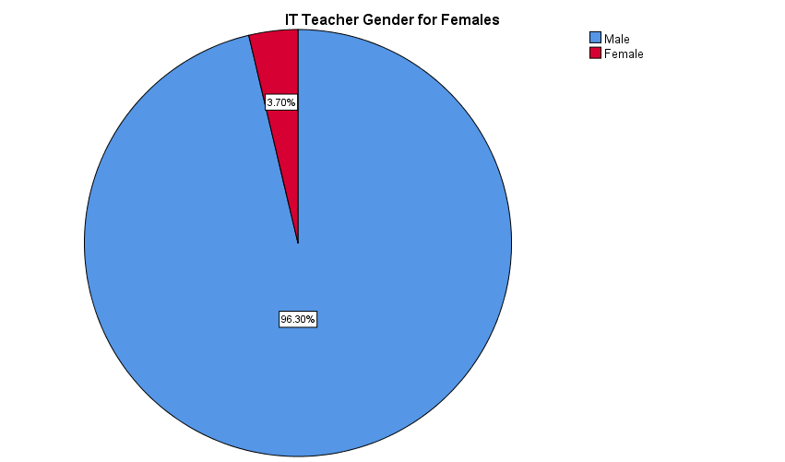To begin, exploring the idea of having fewer female role models for females in STEM is analysed. Figures 29 - 32 and corresponding frequencies tables showing the distribution of teacher’s genders in this survey.

**Fig. 29 – Female’s IT Teacher Gender Chart Fig. 30 – Female’s Technology Teacher Gender Chart**

|  |  |  |  |
| --- | --- | --- | --- |
| **IT Teacher Gender for Females** | | | |
|  | | Frequency | % |
| Valid | Male | 52 | 96.3% |
| Female | 2 | 3.7% |
| Total | 54 | 100% |

|  |  |  |  |
| --- | --- | --- | --- |
| **Technology Teacher Gender for Females** | | | |
|  | | Frequency | % |
| Valid | Male | 38 | 74.5% |
| Female | 13 | 25.5% |
| Total | 51 | 100% |

**Tab. 27 – Female’s IT Teacher Gender Table** **Tab. 28 – Female’s Technology Teacher Gender Table**

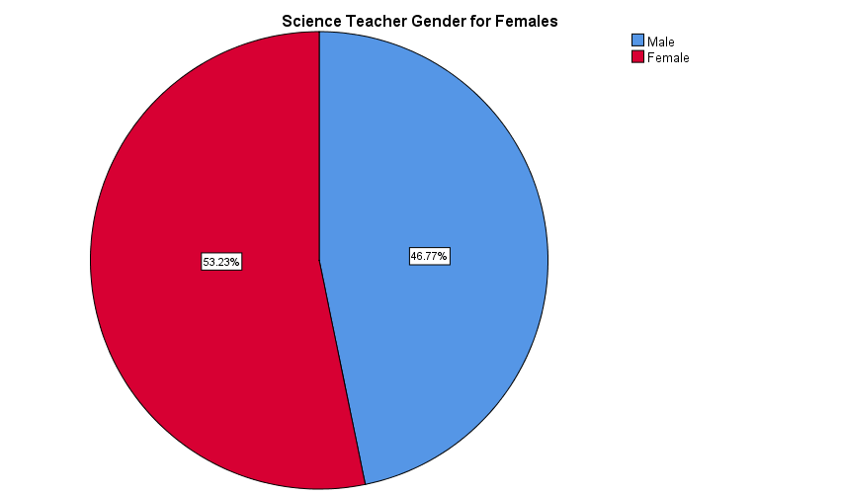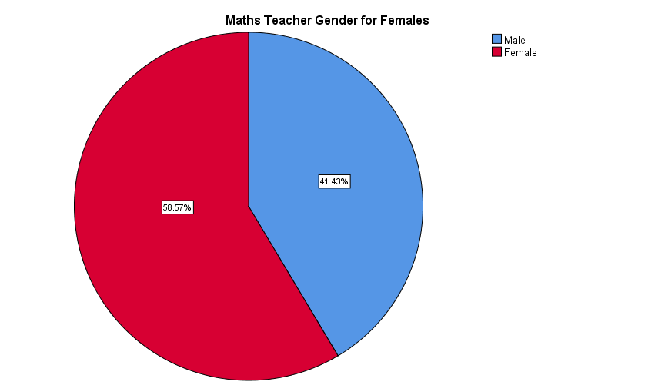

**Fig. 31 – Female’s Maths Teacher Gender Chart Fig. 32 – Female’s Science Teacher Gender Chart**

|  |  |  |  |
| --- | --- | --- | --- |
| **Maths Teacher Gender for Females** | | | |
|  | | Frequency | % |
| Valid | Male | 29 | 41.4% |
| Female | 41 | 58.6% |
| Total | 70 | 100% |

|  |  |  |  |
| --- | --- | --- | --- |
| **Science Teacher Gender for Females** | | | |
|  | | Frequency | % |
| Valid | Male | 29 | 46.8% |
| Female | 33 | 53.2% |
| Total | 62 | 100% |

**Tab. 29 – Female’s Maths Teacher Gender Table** **Tab. 30 – Female’s Science Teacher Gender Table**

Figures 29 - 32 show how the male to female teacher ratio for technology and IT is biased towards male teachers whereas maths and science teacher ratio is more equal - if anything they are more suede towards female teachers.

Following are hypothesis tests completed with Chi Square tests which analyse whether there is an association between having an influential teacher and liking the STEM subject.

IT and Influential Teacher Hypothesis Test

H0: There is no association between enjoying IT and having an influential teacher.

H1: There is no association between enjoying IT and having an influential teacher.

|  |  |  |  |  |  |  |  |
| --- | --- | --- | --- | --- | --- | --- | --- |
| **Crosstabulation** | | | | | | | |
|  | | My teacher influences how well I do in IT. | | | | | Total |
| Strongly Agree | Agree | Neither Agree or Disagree | Disagree | Mostly Disagree |
| I enjoy IT | Strongly Agree | 40% | 6.2% | 22.2% |  |  | 14.6% |
| Agree | 40% | 50% | 33.3% |  |  | 33.3% |
| Neither Agree or Disagree | 20% | 25% | 33.3% | 57.1% |  | 31.3% |
| Disagree |  | 18.8% | 5.6% | 14.3% |  | 10.4% |
| Mostly Disagree |  |  | 5.6% | 28.6% | 100% | 10.4% |
| Total | | 100% | 100% | 100% | 100% | 100% | 100% |

**Tab. 31 – IT & Influential Teacher Crosstabulation Table**

|  |  |  |  |
| --- | --- | --- | --- |
| **Chi-Square Tests** | | | |
|  | Value | df | Asymptotic Significance (2-sided) |
| Pearson Chi-Square | 34.488a | 16 | .005 |
| Likelihood Ratio | 30.580 | 16 | .015 |
| Linear-by-Linear Association | 11.771 | 1 | .001 |
| N of Valid Cases | 48 |  |  |
| a. 21 cells (84.0%) have expected count less than 5. The minimum expected count is .21. | | | |

**Tab. 32 – IT & Influential Teacher Chi-Square Test**

Within this test the p value = 0.005

p < 0.05 so we reject the null hypothesis meaning that there **is** significant evidence of an association between enjoying IT and having an influential teacher. This is shown as 80% of females agreed with liking IT and having an influential teacher.

Technology and Influential Teacher Hypothesis Test

H0: There is no association between enjoying technology and having an influential teacher.

H1: There is no association between enjoying technology and having an influential teacher.

|  |  |  |  |  |  |  |  |
| --- | --- | --- | --- | --- | --- | --- | --- |
| **Crosstabulation** | | | | | | | |
|  | | My teacher influences how well I do in technology | | | | | Total |
| Strongly Agree | Agree | Neither Agree or Disagree | Disagree | Mostly Disagree |
| I enjoy technology | Strongly Agree | 78.6% | 40% | 25.0% | 33.3% |  | 46.8% |
| Agree | 21.4% | 50% | 50.0% |  | 50% | 38.3% |
| Neither Agree or Disagree |  | 10% |  | 33.3% | 50% | 8.5% |
| Disagree |  |  | 25.0% | 33.3% |  | 6.4% |
| Total | | 100% | 100% | 100% | 100% | 100% | 100% |

**Tab. 33 – Technology & Influential Teacher Crosstabulation Table**

|  |  |  |  |
| --- | --- | --- | --- |
| **Chi-Square Tests** | | | |
|  | Value | df | Asymptotic Significance (2-sided) |
| Pearson Chi-Square | 26.540a | 12 | .009 |
| Likelihood Ratio | 25.891 | 12 | .011 |
| Linear-by-Linear Association | 11.915 | 1 | .001 |
| N of Valid Cases | 47 |  |  |
| |  | | --- | | a. 16 cells (80.0%) have expected count less than 5. The minimum expected count is .13. | | | | |

**Tab. 34 – Technology & Influential Teacher Chi-Square Test**

Within this test the p value = 0.009

p < 0.05 so we reject the null hypothesis meaning that there **is** significant evidence of an association between enjoying technology and having an influential teacher. This is shown as 100% of females agreed with liking IT and having an influential teacher.

Maths and Influential Teacher Hypothesis Test

H0: There is no association between enjoying maths and having an influential teacher.

H1: There is no association between enjoying maths and having an influential teacher.

|  |  |  |  |  |  |  |  |
| --- | --- | --- | --- | --- | --- | --- | --- |
| **Crosstabulation** | | | | | | | |
|  | | My teacher influences how well I do in maths. | | | | | Total |
| Strongly Agree | Agree | Neither Agree or Disagree | Disagree | Mostly Disagree |
| I enjoy maths | Strongly Agree | 26.3% |  | 12.5% |  | 50% | 10.8% |
| Agree | 57.9% | 65.6% | 12.5% | 25% | 50% | 53.8% |
| Neither Agree or Disagree | 5.3% | 15.6% | 37.5% |  |  | 13.8% |
| Disagree |  | 6.3% | 37.5% | 25% |  | 9.2% |
| Mostly Disagree | 10.5% | 12.5% |  | 50% |  | 12.3% |
| Total | | 100% | 100% | 100% | 100% | 100% | 100% |

**Tab. 35 – Maths & Influential Teacher Crosstabulation Table**

|  |  |  |  |
| --- | --- | --- | --- |
| **Chi-Square Tests** | | | |
|  | Value | df | Asymptotic Significance (2-sided) |
| Pearson Chi-Square | 36.363a | 16 | .003 |
| Likelihood Ratio | 36.805 | 16 | .002 |
| Linear-by-Linear Association | 3.484 | 1 | .062 |
| N of Valid Cases | 65 |  |  |
| a. 23 cells (92.0%) have expected count less than 5. The minimum expected count is .18. | | | |

**Tab. 36 – Maths & Influential Teacher Chi-Square Test**

Within this test the p value = 0.003

p < 0.05 so we reject the null hypothesis meaning that there **is** significant evidence of an association between enjoying IT and having an influential teacher. This is shown as 84.2% of females agreed with liking maths and having an influential teacher.

Science and Influential Teacher Hypothesis Test

H0: There is no association between enjoying science and having an influential teacher.

H1: There is no association between enjoying science and having an influential teacher.

|  |  |  |  |  |  |  |  |
| --- | --- | --- | --- | --- | --- | --- | --- |
| **Crosstabulation** | | | | | | | |
|  | | My teacher influences how well I do in science. | | | | | Total |
| Strongly Agree | Agree | Neither Agree or Disagree | Disagree | Mostly Disagree |
| I enjoy science | Strongly Agree | 60% | 6.9% |  | 40% |  | 22% |
| Agree | 20% | 48.3% |  | 20% | 66.7% | 33.9% |
| Neither Agree or Disagree | 6.7% | 20.7% | 28.6% | 20% |  | 16.9% |
| Disagree | 6.7% | 17.2% | 57.1% | 20% | 33.3% | 20.3% |
| Mostly Disagree | 6.7% | 6.9% | 14.3% |  |  | 6.8% |
| Total | | 100% | 100% | 100% | 100% | 100% | 100% |

**Tab. 37 – Science & Influential Teacher Crosstabulation Table**

|  |  |  |  |
| --- | --- | --- | --- |
| **Chi-Square Tests** | | | |
|  | Value | df | Asymptotic Significance (2-sided) |
| Pearson Chi-Square | 31.816a | 16 | .011 |
| Likelihood Ratio | 33.962 | 16 | .005 |
| Linear-by-Linear Association | 3.117 | 1 | .077 |
| N of Valid Cases | 59 |  |  |
| a. 21 cells (84.0%) have expected count less than 5. The minimum expected count is .20. | | | |

**Tab. 38 – Science & Influential Teacher Chi-Square Test**

Within this test the p value = 0.011

p < 0.05 so we reject the null hypothesis meaning that there **is** significant evidence of an association between enjoying IT and having an influential teacher. This is shown as 80% of females agreed with liking maths and having an influential teacher.

Next are hypothesis tests completed with Chi Square tests which analyse whether there is an association between liking the STEM subject and the gender of the subject teacher.

IT and Teacher Gender Hypothesis Test

H0: There is no association between enjoying IT and teacher gender.

H1: There is no association between enjoying IT and teacher gender.

|  |  |  |  |
| --- | --- | --- | --- |
| **Chi-Square Tests** | | | |
|  | Value | df | Asymptotic Significance (2-sided) |
| Pearson Chi-Square | 4.282a | 4 | .369 |
| Likelihood Ratio | 4.639 | 4 | .326 |
| Linear-by-Linear Association | .806 | 1 | .369 |
| N of Valid Cases | 52 |  |  |
| a. 6 cells (60.0%) have expected count less than 5. The minimum expected count is .15. | | | |

**Tab. 39 – IT & Teacher Gender Chi-Square Test**

Within this test the p value = 0.369

p > 0.05 so we keep the null hypothesis meaning that there is **no** evidence of an association between enjoying IT and the teacher’s gender.

Technology and Teacher Gender Hypothesis Test

H0: There is no association between enjoying technology and teacher gender.

H1: There is no association between enjoying technology and teacher gender.

|  |  |  |  |
| --- | --- | --- | --- |
| **Chi-Square Tests** | | | |
|  | Value | df | Asymptotic Significance (2-sided) |
| Pearson Chi-Square | 2.713a | 3 | .438 |
| Likelihood Ratio | 3.875 | 3 | .275 |
| Linear-by-Linear Association | 2.534 | 1 | .111 |
| N of Valid Cases | 48 |  |  |
| a. 5 cells (62.5%) have expected count less than 5. The minimum expected count is .50. | | | |

**Tab. 40 – Technology & Teacher Gender Chi-Square Test**

Within this test the p value = 0.438

p > 0.05 so we keep the null hypothesis meaning that there is **no** evidence of an association between enjoying technology and the teacher’s gender.

Maths and Teacher Gender Hypothesis Test

H0: There is no association between enjoying maths and teacher gender.

H1: There is no association between enjoying maths and teacher gender.

|  |  |  |  |
| --- | --- | --- | --- |
| **Chi-Square Tests** | | | |
|  | Value | df | Asymptotic Significance (2-sided) |
| Pearson Chi-Square | .729a | 4 | .948 |
| Likelihood Ratio | .728 | 4 | .948 |
| Linear-by-Linear Association | .335 | 1 | .563 |
| N of Valid Cases | 68 |  |  |
| a. 7 cells (70.0%) have expected count less than 5. The minimum expected count is 2.47. | | | |

**Tab. 41 – Maths & Teacher Gender Chi-Square Test**

Within this test the p value = 0.948

p > 0.05 so we keep the null hypothesis meaning that there is **no** evidence of an association between enjoying maths and the teacher’s gender.

Science and Teacher Gender Hypothesis Test

H0: There is no association between enjoying science and teacher gender.

H1: There is no association between enjoying science and teacher gender.

|  |  |  |  |
| --- | --- | --- | --- |
| **Chi-Square Tests** | | | |
|  | Value | df | Asymptotic Significance (2-sided) |
| Pearson Chi-Square | 2.859a | 4 | .582 |
| Likelihood Ratio | 2.991 | 4 | .559 |
| Linear-by-Linear Association | .160 | 1 | .689 |
| N of Valid Cases | 61 |  |  |
| a. 2 cells (20.0%) have expected count less than 5. The minimum expected count is 2.38. | | | |

**Tab. 42 – Technology & Teacher Gender Chi-Square Test**

Within this test the p value = 0.582

p > 0.05 so we keep the null hypothesis meaning that there is **no** evidence of an association between enjoying science and the teacher’s gender.

Summary of Hypothesis Tests

The original pie charts show the distribution of teacher gender throughout the STEM subjects with the results of the Chi-Square tests showing how the gender of the teacher does not impact whether a student enjoys the subject but having an influential teacher (of any gender) is the most important and impacting factor.

#### 6.2.3.2. STEM Gender Gap Reasoning – Gender Responsive Teacher Training Lacking

Another reason identified by the literature review as to the gender gap is because of a lack of gender responsive training. Following are hypothesis tests completed with Spearman’s rank correlation to test teacher training and approaches towards different genders. To begin is a test which analyses whether there is an association between having female students feeling confident in the given STEM subject and having a teacher who encourages them.

IT and Encouraging Teacher Hypothesis Test

H0: Population rank correlation coefficient = 0.

H1: Population rank correlation coefficient ≠ 0.

|  |  |  |  |  |  |  |
| --- | --- | --- | --- | --- | --- | --- |
| **Crosstabulation** | | | | | | |
|  | | My teacher encourages me in IT. | | | |  |
| Strongly Agree | Agree | Neither Agree or Disagree | Disagree | Total |
| I feel confident about my abilities in IT. | Strongly Agree | 30.8% | 14.3% |  |  | 14.6% |
| Agree | 38.5% | 28.6% | 33.3% | 80% | 37.5% |
| Neither Agree or Disagree | 7.7% | 42.9% | 11.1% |  | 22.9% |
| Disagree | 23.1% | 9.5% | 44.4% | 20% | 20.8% |
| Mostly Disagree |  | 4.8% | 11.1% |  | 4.2% |
| Total | | 100% | 100% | 100% | 100% | 100% |

**Tab. 43 – IT & Encouraging Teacher Crosstabulation Table**

|  |  |  |  |  |
| --- | --- | --- | --- | --- |
| **Correlations** | | | | |
|  | | | I feel confident about my abilities in IT. | My teacher encourages me in IT. |
| Spearman | I feel confident about my abilities in IT. | Correlation Coefficient | 1.000 | .484** |
| Sig. (2-tailed) | . | .000 |
| N | 48 | 48 |
| My teacher encourages me in IT. | Correlation Coefficient | .484** | 1.000 |
| Sig. (2-tailed) | .000 | . |
| N | 48 | 48 |
| **. Correlation is significant at the 0.01 level (2-tailed). | | | | |

**Tab. 44 – IT & Encouraging Teacher Spearman Test**

Within this test the rank correlation coefficient = 0.484 with the p value = 0.000

P < 0.05 so we reject the null hypothesis meaning that within this survey there **is** significant evidence of an association between a student being confident in IT and having a teacher who encourages them in the subject. This is shown as 69.3% of females agreed with feeling confident in IT when they had an encouraging teacher.

Technology and Encouraging Teacher Hypothesis Test

H0: Population rank correlation coefficient = 0.

H1: Population rank correlation coefficient ≠ 0.

|  |  |  |  |  |  |  |
| --- | --- | --- | --- | --- | --- | --- |
| **Crosstabulation** | | | | | | |
|  | | I feel confident about my abilities in technology | | | | Total |
| Strongly Agree | Agree | Neither Agree or Disagree | Disagree |
| My teacher encourages me in technology. | Strongly Agree | 81.3% | 25% |  |  | 38.3% |
| Agree | 18.8% | 75% | 66.7% | 50.0% | 53.2% |
| Neither Agree or Disagree |  |  | 22.2% | 50.0% | 6.4% |
| Mostly Disagree |  |  | 11.1% |  | 2.1% |
| Total | | 100% | 100% | 100% | 100% | 100% |

**Tab. 45 – Technology & Encouraging Teacher Crosstabulation Table**

|  |  |  |  |  |
| --- | --- | --- | --- | --- |
| **Correlations** | | | | |
|  | | | I feel confident about my abilities in technology. | My parents make me feel enthusiastic about technology. |
| Spearman | I feel confident about my abilities in technology. | Correlation Coefficient | 1.000 | .711** |
| Sig. (2-tailed) | . | .000 |
| N | 47 | 47 |
| My parents make me feel enthusiastic about technology. | Correlation Coefficient | .711** | 1.000 |
| Sig. (2-tailed) | .000 | . |
| N | 47 | 47 |
| **. Correlation is significant at the 0.01 level (2-tailed). | | | | |

**Tab. 46 – Technology & Encouraging Teacher Spearman Test**

Within this test the rank correlation coefficient = 0.711 with the p value = 0.000

p < 0.05 so we reject the null hypothesis meaning that within this survey there **is** significant evidence of an association between a student being confident in technology and having a teacher who encourages them in the subject. This is shown as 92.5% of females agreed with feeling confident in technology when they had an encouraging teacher.

Maths and Encouraging Teacher Hypothesis Test

H0: Population rank correlation coefficient = 0.

H1: Population rank correlation coefficient ≠ 0.

|  |  |  |  |  |  |  |  |
| --- | --- | --- | --- | --- | --- | --- | --- |
| **Crosstabulation** | | | | | | | |
|  | | I feel confident about my abilities in maths | | | | | Total |
| Strongly Agree | Agree | Neither Agree or Disagree | Disagree | Mostly Disagree |
| My teacher encourages me in maths | Strongly Agree | 71.4% | 42.4% | 20% | 30% | 50% | 40.9% |
| Agree | 28.6% | 51.5% | 50% | 60% | 33.3% | 48.5% |
| Neither Agree or Disagree |  | 6.1% | 20% | 10% | 16.7% | 9.1% |
| Disagree |  |  | 10% |  |  | 1.5% |
| Total | | 100% | 100% | 100% | 100% | 100% | 100% |

**Tab. 47 – Maths & Encouraging Teacher Crosstabulation Table**

|  |  |  |  |  |
| --- | --- | --- | --- | --- |
| **Correlations** | | | | |
|  | | | I feel confident about my abilities in maths. | My teacher encourages me in maths. |
| Spearman | I feel confident about my abilities in maths. | Correlation Coefficient | 1.000 | .214 |
| Sig. (2-tailed) | . | .084 |
| N | 66 | 66 |
| My teacher encourages me in maths. | Correlation Coefficient | .214 | 1.000 |
| Sig. (2-tailed) | .084 | . |
| N | 66 | 66 |
| **. Correlation is significant at the 0.01 level (2-tailed). | | | | |

**Tab. 48 – Maths & Encouraging Teacher Spearman Test**

Within this test the rank correlation coefficient = 0.214 with the p value = 0.084

P > 0.05 so we keep the null hypothesis meaning that within this survey there is **no** significant evidence of an association between a student being confident in maths and having a teacher who encourages them in the subject. This is shown as 89.4% of females agreed with feeling confident in maths when they had an encouraging teacher.

Science and Encouraging Teacher Hypothesis Test

H0: Population rank correlation coefficient = 0.

H1: Population rank correlation coefficient ≠ 0.

|  |  |  |  |  |  |  |  |
| --- | --- | --- | --- | --- | --- | --- | --- |
| **Crosstabulation** | | | | | | | |
|  | | I feel confident about my abilities in science | | | | | Total |
| Strongly Agree | Agree | Neither Agree or Disagree | Disagree | Mostly Disagree |
| My teacher encourages me in science | Strongly Agree | 81.8% | 30.4% | 7.7% |  | 25% | 30.5% |
| Agree | 9.1% | 39.1% | 46.2% | 37.5% | 25% | 33.9% |
| Neither Agree or Disagree | 9.1% | 17.4% | 15.4% | 12.5% |  | 13.6% |
| Disagree |  | 4.3% | 7.7% | 50% | 50% | 13.6% |
| Mostly Disagree |  | 8.7% | 23.1% |  |  | 8.5% |
| Total | | 100% | 100% | 100% | 100% | 100% | 100% |

**Tab. 49 – Science & Encouraging Teacher Crosstabulation Table**

|  |  |  |  |  |
| --- | --- | --- | --- | --- |
| **Correlations** | | | | |
|  | | | I feel confident about my abilities in science. | My parents make me feel enthusiastic about science. |
| Spearman | I feel confident about my abilities in science. | Correlation Coefficient | 1.000 | .501** |
| Sig. (2-tailed) | . | .000 |
| N | 59 | 59 |
| My parents make me feel enthusiastic about science. | Correlation Coefficient | .501** | 1.000 |
| Sig. (2-tailed) | .000 | . |
| N | 59 | 59 |
| **. Correlation is significant at the 0.01 level (2-tailed). | | | | |

**Tab. 50 – Science & Encouraging Teacher Spearman Test**

Within this test the rank correlation coefficient = 0.501 with the p value = 0.000

p < 0.05 so we reject the null hypothesis meaning that within this survey there **is** significant evidence of an association between a student being confident in science and having a teacher who encourages them in the subject. This is shown as 64.4% of females agreed with feeling confident in science when they had an encouraging teacher.

The next set of tests analyse whether there is an association between having female students feeling confident in the given STEM subject and having a teacher who helps them when they ask for it.

IT and Helpful Teacher Hypothesis Test

H0: Population rank correlation coefficient = 0.

H1: Population rank correlation coefficient ≠ 0.

|  |  |  |  |  |  |  |
| --- | --- | --- | --- | --- | --- | --- |
| **Crosstabulation** | | | | | | |
|  | | My teacher encourages me in IT. | | | | Total |
| Strongly Agree | Agree | Neither Agree or Disagree | Disagree |
| If I ask my teacher for help in IT, he/she will try to help me. | Strongly Agree | 66.7% | 26.3% | 36.4% | 20% |  |
| Agree | 16.7% | 57.9% | 45.5% | 30% | 50% |
| Neither Agree or Disagree |  | 10.5% | 18.2% | 40% |  |
| Disagree |  | 5.3% |  | 10% | 50% |
| Mostly Disagree | 16.7% |  |  |  |  |
| Total | | 100% | 100% | 100% | 100% | 100% |

**Tab. 51 – IT & Helpful Teacher Crosstabulation Table**

|  |  |  |  |  |
| --- | --- | --- | --- | --- |
| **Correlations** | | | | |
|  | | | I feel confident about my abilities in IT. | If I ask my teacher for help in IT, he/she will try to help me. |
| Spearman | I feel confident about my abilities in IT. | Correlation Coefficient | 1.000 | .277 |
| Sig. (2-tailed) | . | .057 |
| N | 48 | 48 |
| If I ask my teacher for help in IT, he/she will try to help me. | Correlation Coefficient | .277 | 1.000 |
| Sig. (2-tailed) | .057 | . |
| N | 48 | 48 |
| **. Correlation is significant at the 0.01 level (2-tailed). | | | | |

**Tab. 52 – IT & Helpful Teacher Spearman Test**

Within this test the rank correlation coefficient = 0.277 with the p value = 0.057

p > 0.05 so we keep the null hypothesis meaning that within this survey there is **no** significant evidence of an association between a student being confident in IT and having a teacher who helps them when they ask for it. This is shown as 50% of females agreed with feeling confident in IT when they had a helpful teacher.

Technology and Encouraging Teacher Hypothesis Test

H0: Population rank correlation coefficient = 0.

H1: Population rank correlation coefficient ≠ 0.

|  |  |  |  |  |  |  |
| --- | --- | --- | --- | --- | --- | --- |
| **Crosstabulation** | | | | | | |
|  | | I feel confident about my abilities in technology | | | | Total |
| Strongly Agree | Agree | Neither Agree or Disagree | Disagree |
| If I ask my teacher for help in technology, he/she will try to help me. | Strongly Agree | 53.3% | 20% | 11.1% |  | 28.9% |
| Agree | 40% | 50% | 55.6% | 100% | 48.9% |
| Neither Agree or Disagree |  | 30% | 22.2% |  | 17.8% |
| Mostly Disagree | 6.7% |  | 11.1% |  | 4.4% |
| Total | | 100% | 100% | 100% | 100% | 100% |

**Tab. 53 – Technology & Helpful Teacher Crosstabulation Table**

|  |  |  |  |  |
| --- | --- | --- | --- | --- |
| **Correlations** | | | | |
|  | | | I feel confident about my abilities in technology. | If I ask my teacher for help in technology, he/she will try to help me. |
| Spearman | I feel confident about my abilities in technology. | Correlation Coefficient | 1.000 | .368* |
| Sig. (2-tailed) | . | .013 |
| N | 45 | 45 |
| If I ask my teacher for help in technology, he/she will try to help me. | Correlation Coefficient | .368* | 1.000 |
| Sig. (2-tailed) | .013 | . |
| N | 45 | 45 |
| **. Correlation is significant at the 0.05 level (2-tailed). | | | | |

**Tab. 54 – Technology & Helpful Teacher Spearman Test**

Within this test the rank correlation coefficient = 0.368 with the p value = 0.013

p < 0.05 so we reject the null hypothesis meaning that within this survey there **is** significant evidence of an association between a student being confident in technology and having a teacher who helps them when they ask for it. This is shown as 77.8% of females agreed with feeling confident in technology when they had a helpful teacher.

Maths and Helpful Teacher Hypothesis Test

H0: Population rank correlation coefficient = 0.

H1: Population rank correlation coefficient ≠ 0.

|  |  |  |  |  |  |  |  |
| --- | --- | --- | --- | --- | --- | --- | --- |
| **Crosstabulation** | | | | | | | |
|  | | I feel confident about my abilities in maths | | | | | Total |
| Strongly Agree | Agree | Neither Agree or Disagree | Disagree | Mostly Disagree |
| If I ask my teacher for help in maths, he/she will try to help me. | Strongly Agree | 57.1% | 53.1% | 10% | 30% | 16.7% | 40% |
| Agree | 42.9% | 37.5% | 60% | 50% | 50.0% | 44.6% |
| Neither Agree or Disagree |  | 9.4% | 10% | 20% | 16.7% | 10.8% |
| Disagree |  |  | 10% |  | 16.7% | 3.1% |
| Mostly Disagree |  |  | 10% |  |  | 1.5% |
| Total | | 100% | 100% | 100% | 100% | 100% | 100% |

**Tab. 55 – Maths & Helpful Teacher Crosstabulation Table**

|  |  |  |  |  |
| --- | --- | --- | --- | --- |
| **Correlations** | | | | |
|  | | | I feel confident about my abilities in maths. | If I ask my teacher for help in maths, he/she will try to help me. |
| Spearman | I feel confident about my abilities in maths. | Correlation Coefficient | 1.000 | .353** |
| Sig. (2-tailed) | . | .004 |
| N | 65 | 65 |
| If I ask my teacher for help in maths, he/she will try to help me. | Correlation Coefficient | .353** | 1.000 |
| Sig. (2-tailed) | .004 | . |
| N | 65 | 65 |
| **. Correlation is significant at the 0.01 level (2-tailed). | | | | |

**Tab. 56 – Maths & Helpful Teacher Spearman Test**

Within this test the rank correlation coefficient = 0.353 with the p value = 0.004

p < 0.05 so we reject the null hypothesis meaning that within this survey there **is** significant evidence of an association between a student being confident in maths and having a teacher who helps them when they ask for it. This is shown as 84.6% of females agreed with feeling confident in maths when they had a helpful teacher.

Science and Helpful Teacher Hypothesis Test

H0: Population rank correlation coefficient = 0.

H1: Population rank correlation coefficient ≠ 0.

|  |  |  |  |  |  |  |  |
| --- | --- | --- | --- | --- | --- | --- | --- |
| **Crosstabulation** | | | | | | | |
|  | | I feel confident about my abilities in science | | | | | Total |
| Strongly Agree | Agree | Neither Agree or Disagree | Disagree | Mostly Disagree |
| If I ask my teacher for help in science, he/she will try to help me. | Strongly Agree | 63.6% | 34.8% | 7.7% |  | 33.3% | 29.3% |
| Agree | 27.3% | 47.8% | 46.2% | 50% | 33.3% | 43.1% |
| Neither Agree or Disagree | 9.1% | 8.7% | 7.7% | 12.5% |  | 8.6% |
| Disagree |  | 4.3% | 23.1% | 25% |  | 10.3% |
| Mostly Disagree |  | 4.3% | 15.4% | 12.5% | 33.3% | 8.6% |
| Total | | 100% | 100% | 100% | 100% | 100% | 100% |

**Tab. 57 – Science & Helpful Teacher Crosstabulation Table**

|  |  |  |  |  |
| --- | --- | --- | --- | --- |
| **Correlations** | | | | |
|  | | | I feel confident about my abilities in science. | If I ask my teacher for help in science, he/she will try to help me. |
| Spearman | I feel confident about my abilities in science. | Correlation Coefficient | 1.000 | .467** |
| Sig. (2-tailed) | . | .000 |
| N | 58 | 58 |
| If I ask my teacher for help in science, he/she will try to help me. | Correlation Coefficient | .467** | 1.000 |
| Sig. (2-tailed) | .000 | . |
| N | 58 | 58 |
| **. Correlation is significant at the 0.01 level (2-tailed). | | | | |

**Tab. 58 – Science & Helpful Teacher Spearman Test**

Within this test the rank correlation coefficient = 0.467 with the p value = 0.000

p < 0.05 so we reject the null hypothesis meaning that within this survey there **is** significant evidence of an association between a student being confident in science and having a teacher who helps them when they ask for it. This is shown as 72.4% of females agreed with feeling confident in maths when they had a helpful teacher.

Finally, following, the enjoyment of the given STEM subject is analysed against how well the teacher is prepared and confident with their given subject.

IT and Prepared Teacher Hypothesis Test

H0: Population rank correlation coefficient = 0.

H1: Population rank correlation coefficient ≠ 0.

|  |  |  |  |  |  |  |
| --- | --- | --- | --- | --- | --- | --- |
| **Crosstabulation** | | | | | | |
|  | | My teacher is prepared and confident when teaching IT. | | | | Total |
| Strongly Agree | Agree | Neither Agree or Disagree | Disagree |
| I enjoy IT. | Strongly Agree | 31.6% | 5% |  |  |  |
| Agree | 42.1% | 20% | 42.9% |  | 100% |
| Neither Agree or Disagree | 26.3% | 45% | 28.6% |  |  |
| Disagree |  | 15% | 14.3% | 50% |  |
| Mostly Disagree |  | 15% | 14.3% | 50% |  |
| Total | | 100% | 100% | 100% | 100% | 100% |

**Tab. 59 – IT & Prepared Teacher Crosstabulation Table**

|  |  |  |  |  |
| --- | --- | --- | --- | --- |
| **Correlations** | | | | |
|  | | | I enjoy IT. | My teacher is prepared and confident when teaching IT. |
| Spearman | I enjoy IT. | Correlation Coefficient | 1.000 | .470** |
| Sig. (2-tailed) | . | .001 |
| N | 49 | 49 |
| My teacher is prepared and confident when teaching IT. | Correlation Coefficient | .470** | 1.000 |
| Sig. (2-tailed) | .001 | . |
| N | 49 | 49 |
| **. Correlation is significant at the 0.01 level (2-tailed). | | | | |

**Tab. 60 – IT & Prepared Teacher Spearman Test**

Within this test the rank correlation coefficient = 0.47 with the p value = 0.001

p < 0.05 so we reject the null hypothesis meaning that within this survey there **is** significant evidence of an association between a student enjoying IT and having a prepared and confident teacher. This is shown as 73.7% of females agreed with enjoying IT when they had a prepared teacher.

Technology and Prepared Teacher Hypothesis Test

H0: Population rank correlation coefficient = 0.

H1: Population rank correlation coefficient ≠ 0.

|  |  |  |  |  |  |  |
| --- | --- | --- | --- | --- | --- | --- |
| **Crosstabulation** | | | | | | |
|  | | My teacher is prepared and confident when teaching technology. | | | | Total |
| Strongly Agree | Agree | Disagree | Mostly Disagree |
| I enjoy technology. | Strongly Agree | 77.3% | 26.1% |  |  | 48.9% |
| Agree | 22.7% | 52.2% | 100% |  | 38.3% |
| Neither Agree or Disagree |  | 8.7% |  | 100% | 6.4% |
| Disagree |  | 13.0% |  |  | 6.4% |
| Total | | 100% | 100% | 100% | 100% | 100% |

**Tab. 61 – Technology & Prepared Teacher Crosstabulation Table**

|  |  |  |  |  |
| --- | --- | --- | --- | --- |
| **Correlations** | | | | |
|  | | | I enjoy technology. | My teacher is prepared and confident when teaching technology. |
| Spearman | I enjoy technology. | Correlation Coefficient | 1.000 | .573** |
| Sig. (2-tailed) | . | .000 |
| N | 47 | 47 |
| My teacher is prepared and confident when teaching technology. | Correlation Coefficient | .573** | 1.000 |
| Sig. (2-tailed) | .000 | . |
| N | 47 | 47 |
| **. Correlation is significant at the 0.01 level (2-tailed). | | | | |

**Tab. 62 – Technology & Prepared Teacher Spearman Test**

Within this test the rank correlation coefficient = 0.573 with the p value = 0.000

p < 0.05 so we reject the null hypothesis meaning that within this survey there **is** significant evidence of an association between a student enjoying technology and having a prepared and confident teacher. This is shown as 100% of females agreed with enjoying technology when they had a prepared teacher.

Maths and Prepared Teacher Hypothesis Test

H0: Population rank correlation coefficient = 0.

H1: Population rank correlation coefficient ≠ 0.

|  |  |  |  |  |  |  |  |
| --- | --- | --- | --- | --- | --- | --- | --- |
| **Crosstabulation** | | | | | | | |
|  | | My teacher is prepared and confident when teaching maths | | | | | Total |
| Strongly Agree | Agree | Neither Agree or Disagree | Disagree | Mostly Disagree |
| I enjoy maths | Strongly Agree | 19.4% | 3.3% |  |  | 10.6% | 19.4% |
| Agree | 51.6% | 53.3% | 75% |  | 53.0% | 51.6% |
| Neither Agree or Disagree | 16.1% | 13.3% |  |  | 13.6% | 16.1% |
| Disagree | 3.2% | 13.3% | 25% | 100% | 10.6% | 3.2% |
| Mostly Disagree | 9.7% | 16.7% |  |  | 12.1% | 9.7% |
| Total | | 100% | 100% | 100% | 100% | 100% | 100% |

**Tab. 63 – Maths & Prepared Teacher Crosstabulation Table**

|  |  |  |  |  |
| --- | --- | --- | --- | --- |
| **Correlations** | | | | |
|  | | | I enjoy maths | My teacher is prepared and confident when teaching maths |
| Spearman | I enjoy maths | Correlation Coefficient | 1.000 | .230 |
| Sig. (2-tailed) | . | .063 |
| N | 66 | 66 |
| My teacher is prepared and confident when teaching maths | Correlation Coefficient | .230 | 1.000 |
| Sig. (2-tailed) | .063 | . |
| N | 66 | 66 |

**Tab. 64 – Maths & Prepared Teacher Spearman Test**

Within this test the rank correlation coefficient = 0.23 with the p value = 0.063

p > 0.05 so we keep the null hypothesis meaning that within this survey there is no significant evidence of an association between a student enjoying maths and having a prepared and confident teacher.

Science and Encouraging Teacher Hypothesis Test

H0: Population rank correlation coefficient = 0.

H1: Population rank correlation coefficient ≠ 0.

|  |  |  |  |  |  |  |  |
| --- | --- | --- | --- | --- | --- | --- | --- |
| **Crosstabulation** | | | | | | | |
|  | | I feel confident about my abilities in science | | | | | Total |
| Strongly Agree | Agree | Neither Agree or Disagree | Disagree | Mostly Disagree |
| I enjoy science. | Strongly Agree | 55% | 4% | 25% |  |  | 21.7% |
| Agree | 20% | 52% |  |  | 60% | 33.3% |
| Neither Agree or Disagree | 5% | 20% | 25% | 33.3% | 20% | 16.7% |
| Disagree | 15% | 16% | 50% | 50% |  | 20% |
| Mostly Disagree | 5% | 8% |  | 16.7% | 20% | 8.3% |
| Total | | 100% | 100% | 100% | 100% | 100% | 100% |

**Tab. 65 – Science & Prepared Teacher Crosstabulation Table**

|  |  |  |  |  |
| --- | --- | --- | --- | --- |
| **Correlations** | | | | |
|  | | | I enjoy science | My teacher is prepared and confident when teaching science |
| Spearman | I enjoy science | Correlation Coefficient | 1.000 | .426** |
| Sig. (2-tailed) | . | .001 |
| N | 60 | 60 |
| My teacher is prepared and confident when teaching science | Correlation Coefficient | .426** | 1.000 |
| Sig. (2-tailed) | .001 | . |
| N | 60 | 60 |
| **. Correlation is significant at the 0.01 level (2-tailed). | | | | |

**Tab. 66 – Science & Prepared Teacher Spearman Test**

Within this test the rank correlation coefficient = 0.426 with the p value = 0.001

p < 0.05 so we reject the null hypothesis meaning that within this survey there **is** significant evidence of an association between a student enjoying science and having a prepared and confident teacher. This is shown as 75% of females agreed with enjoying science when they had a prepared teacher.

Summary of Hypothesis Tests

These 3 hypothesis tests have identified how having a teacher who is encouraging, helpful, confident and well-prepared within STEM really helps with the enjoyment of the subjects by pupils. The tests have also highlighted how maths is the only subject to not match the correlation between having a prepared, confident and encouraging teacher doesn’t the enjoyment of maths, yet having a teacher close to hand when said pupil is stuck does have an impact.

#### 6.2.3.3. STEM Gender Gap Reasoning – Lack of Parent Encouragement

Parent encouragement is seen as a big factor when it comes to students making decisions about their future study and career choices – a lack of such encouragement has been said to be a reason to the STEM gender gap. Following are hypothesis tests which begin to test this theory. To begin, Figures 33 – 36 show the distribution of parents encouraging their children in the given STEM area.

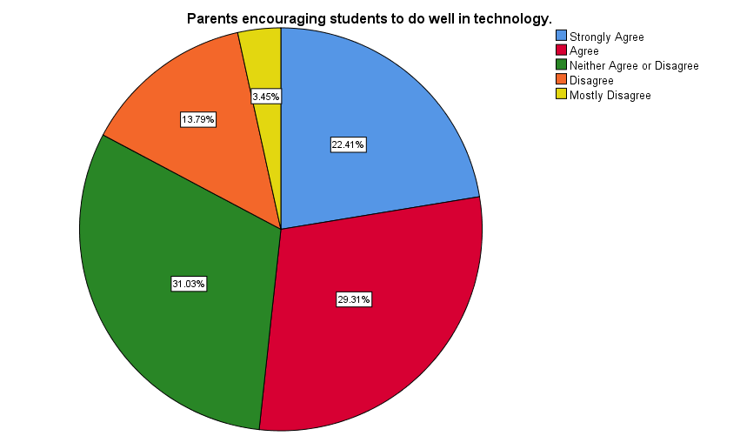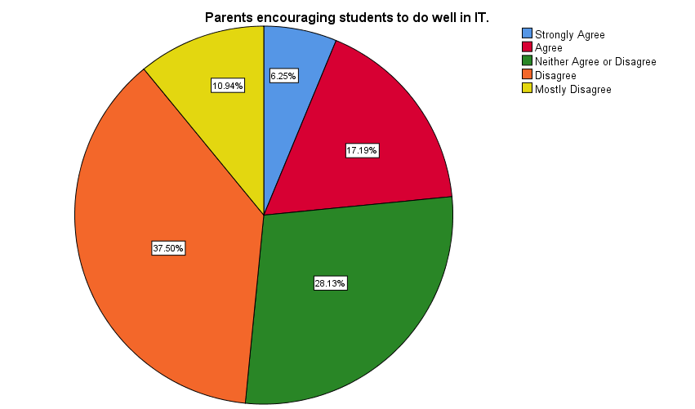

**Fig. 33 – Parent Encouragement for IT Chart Fig. 34 – Parent Encouragement for Technology Chart**

|  |  |  |  |
| --- | --- | --- | --- |
| **Parents encouraging students to do well in IT.** | | | |
|  | | Frequency | % |
| Valid | Strongly Agree | 4 | 6.3% |
| Agree | 11 | 17.2% |
| Neither Agree or Disagree | 18 | 28.1% |
| Disagree | 24 | 37.5% |
| Mostly Disagree | 7 | 10.9% |
| Total | 64 | 100% |

|  |  |  |  |
| --- | --- | --- | --- |
| **Parents encouraging students to do well in technology** | | | |
|  | | Frequency | % |
| Valid | Strongly Agree | 13 | 22.4% |
| Agree | 17 | 29.3% |
| Neither Agree or Disagree | 18 | 31% |
| Disagree | 8 | 13.8% |
| Mostly Disagree | 2 | 3.4% |
| Total | 58 | 100% |

**Tab. 67 – Parent Encouragement for IT Table Tab. 68 – Parent Encouragement for Technology Table**

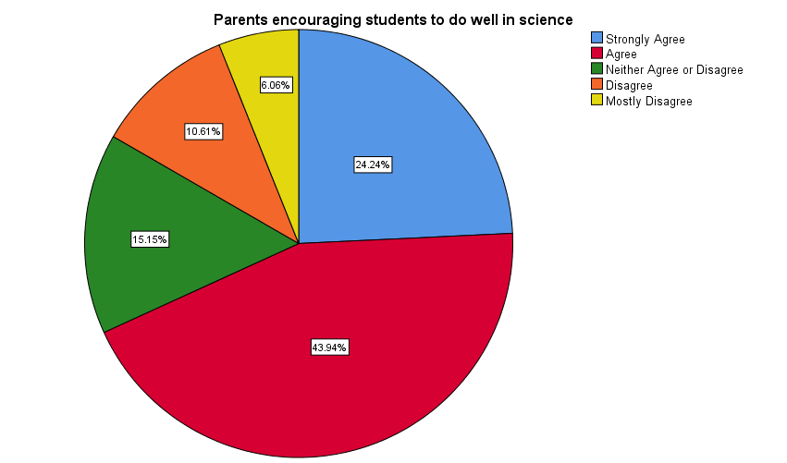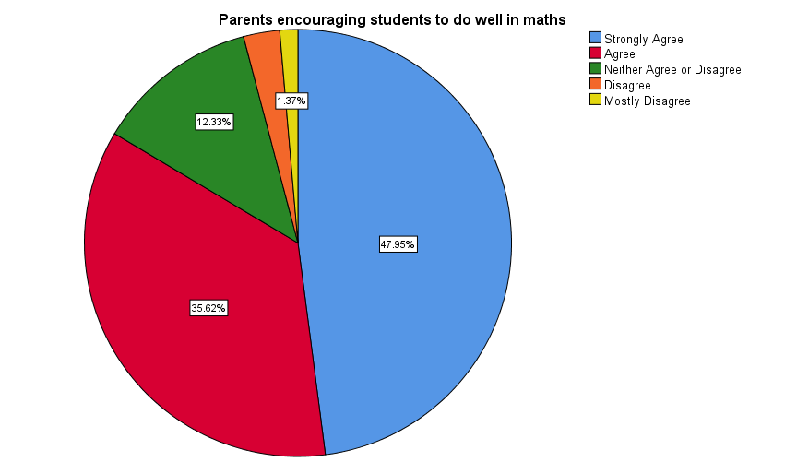

|  |  |  |  |
| --- | --- | --- | --- |
| **Parents encouraging students to do well in science** | | | |
|  | | Frequency | % |
| Valid | Strongly Agree | 16 | 24.2% |
| Agree | 29 | 43.9% |
| Neither Agree or Disagree | 10 | 15.2% |
| Disagree | 7 | 10.6% |
| Mostly Disagree | 4 | 6.1% |
| Total | 66 | 100% |

|  |  |  |  |
| --- | --- | --- | --- |
| **Parents encouraging students to do well in maths** | | | |
|  | | Frequency | % |
| Valid | Strongly Agree | 35 | 47.9% |
| Agree | 26 | 35.6% |
| Neither Agree or Disagree | 9 | 12.3% |
| Disagree | 2 | 2.7% |
| Mostly Disagree | 1 | 1.4% |
| Total | 73 | 100% |

**Fig. 35 – Parent Encouragement for Maths Chart Fig. 36 – Parent Encouragement for Science Chart**

**Tab. 69 – Parent Encouragement for Maths Table Tab. 70 – Parent Encouragement for Science Table**

The pie charts illustrate the rate of encouragement by parents. It can be seen that parents encourage students to do well in it the least, with maths being the most encouraged subject.

Following are the tests which analyse the rate of enjoyment for a STEM subject depending on the rate of encouragement by the student’s parents.

IT and Parent Encouragement Hypothesis Test

H0: Population rank correlation coefficient = 0.

H1: Population rank correlation coefficient ≠ 0.

|  |  |  |  |  |  |  |  |
| --- | --- | --- | --- | --- | --- | --- | --- |
| **Crosstabulation** | | | | | | | |
|  | | My parents encourage me to do well in IT | | | | | Total |
| Strongly Agree | Agree | Neither Agree or Disagree | Disagree | Mostly Disagree |
| I enjoy IT | Strongly Agree |  | 27.3% | 5.6% | 16.7% |  | 12.7% |
| Agree | 66.7% | 36.4% | 50% | 8.3% | 28.6% | 30.2% |
| Neither Agree or Disagree | 33.3% | 18.2% | 22.2% | 29.2% | 42.9% | 27% |
| Disagree |  | 18.2% | 16.7% | 37.5% |  | 22.2% |
| Mostly Disagree |  |  | 5.6% | 8.3% | 28.6% | 7.9% |
| Total | | 100% | 100% | 100% | 100% | 100% | 100% |

**Tab. 71 – IT & Encouraging Parent Crosstabulation Table**

|  |  |  |  |  |
| --- | --- | --- | --- | --- |
| **Correlations** | | | | |
|  | | | I enjoy IT | My parents encourage me to do well in IT |
| Spearman | I enjoy IT | Correlation Coefficient | 1.000 | .309* |
| Sig. (2-tailed) | . | .014 |
| N | 63 | 63 |
| My parents encourage me to do well in IT | Correlation Coefficient | .309* | 1.000 |
| Sig. (2-tailed) | .014 | . |
| N | 63 | 63 |
| **. Correlation is significant at the 0.05 level (2-tailed). | | | | |

**Tab. 72 – IT & Encouraging Parent Spearman Test**

Within this test the rank correlation coefficient = 0.309 with the p value = 0.014

p < 0.05 so we reject the null hypothesis meaning that within this survey there **is** significant evidence of an association between a student enjoying IT and having encouraging parents. This is shown as 66.7% of females agreed with enjoying IT when they had parent encouragement.

Technology and Parent Encouragement Hypothesis Test

H0: Population rank correlation coefficient = 0.

H1: Population rank correlation coefficient ≠ 0.

|  |  |  |  |  |  |  |  |
| --- | --- | --- | --- | --- | --- | --- | --- |
| **Crosstabulation** | | | | | | | |
|  | | My parents encourage me to do well in technology. | | | | | Total |
| Strongly Agree | Agree | Neither Agree or Disagree | Disagree | Mostly Disagree |
| I enjoy technology | Strongly Agree | 92.3% | 41.2% | 27.8% | 25% | 50% | 46.6% |
| Agree | 7.7% | 52.9% | 33.3% | 62.5% | 50% | 37.9% |
| Neither Agree or Disagree |  | 5.9% | 27.8% |  |  | 10.3% |
| Disagree |  |  | 11.1% | 12.5% |  | 5.2% |
| Total | | 100% | 100% | 100% | 100% | 100% | 100% |

**Tab. 73 – Technology & Encouraging Parent Crosstabulation Table**

|  |  |  |  |  |
| --- | --- | --- | --- | --- |
| **Correlations** | | | | |
|  | | | I enjoy technology | My parents encourage me to do well in technology |
| Spearman | I enjoy technology | Correlation Coefficient | 1.000 | .434** |
| Sig. (2-tailed) | . | .001 |
| N | 58 | 58 |
| My parents encourage me to do well in technology | Correlation Coefficient | .434** | 1.000 |
| Sig. (2-tailed) | .001 | . |
| N | 58 | 58 |
| **. Correlation is significant at the 0.01 level (2-tailed). | | | | |

**Tab. 74 – Technology & Encouraging Parent Spearman Test**

Within this test the rank correlation coefficient = 0.434 with the p value = 0.001

p < 0.05 so we reject the null hypothesis meaning that within this survey there **is** significant evidence of an association between a student enjoying technology and having encouraging parents. This is shown as 100% of females agreed with enjoying technology when they had parent encouragement.

Maths and Parent Encouragement Hypothesis Test

H0: Population rank correlation coefficient = 0.

H1: Population rank correlation coefficient ≠ 0.

|  |  |  |  |  |  |  |  |
| --- | --- | --- | --- | --- | --- | --- | --- |
| **Crosstabulation** | | | | | | | |
|  | | My parents encourage me to do well in maths | | | | | Total |
| Strongly Agree | Agree | Neither Agree or Disagree | Disagree | Mostly Disagree |
| I enjoy maths | Strongly Agree | 22.9% | 3.8% |  |  |  | 12.3% |
| Agree | 51.4% | 50% | 55.6% | 100% |  | 52.1% |
| Neither Agree or Disagree | 8.6% | 19.2% | 11.1% |  |  | 12.3% |
| Disagree | 11.4% | 11.5% | 22.2% |  |  | 12.3% |
| Mostly Disagree | 5.7% | 15.4% | 11.1% |  | 100% | 11% |
| Total | | 100% | 100% | 100% | 100% | 100% | 100% |

**Tab. 75 – Maths & Encouraging Parent Crosstabulation Table**

|  |  |  |  |  |
| --- | --- | --- | --- | --- |
| **Correlations** | | | | |
|  | | | I enjoy maths | My parents encourage me to do well in maths |
| Spearman | I enjoy maths | Correlation Coefficient | 1.000 | .274* |
| Sig. (2-tailed) | . | .019 |
| N | 73 | 73 |
| My parents encourage me to do well in maths | Correlation Coefficient | .274* | 1.000 |
| Sig. (2-tailed) | .019 | . |
| N | 73 | 73 |
| **. Correlation is significant at the 0.05 level (2-tailed). | | | | |

**Tab. 76 – Maths & Encouraging Parent Spearman Test**

Within this test the rank correlation coefficient = 0.274 with the p value = 0.019

p < 0.05 so we reject the null hypothesis meaning that within this survey there **is** significant evidence of an association between a student enjoying maths and having encouraging parents. This is shown as 74.3% of females agreed with enjoying maths when they had parent encouragement.

Science and Parent Encouragement Hypothesis Test

H0: Population rank correlation coefficient = 0.

H1: Population rank correlation coefficient ≠ 0.

|  |  |  |  |  |  |  |  |
| --- | --- | --- | --- | --- | --- | --- | --- |
| **Crosstabulation** | | | | | | | |
|  | | My parents encourage me to do well in science | | | | | Total |
| Strongly Agree | Agree | Neither Agree or Disagree | Disagree | Mostly Disagree |
| I enjoy science | Strongly Agree | 50% | 17.2% | 10% |  |  | 21.2% |
| Agree | 31.3% | 34.5% | 40% | 14.3% | 25.0% | 31.8% |
| Neither Agree or Disagree | 6.3% | 24.1% | 40% |  |  | 18.2% |
| Disagree | 12.5% | 17.2% |  | 85.7% | 25.0% | 21.2% |
| Mostly Disagree |  | 6.9% | 10% |  | 50.0% | 7.6% |
| Total | | 100% | 100% | 100% | 100% | 100% | 100% |

**Tab. 77 – Science & Encouraging Parent Crosstabulation Table**

|  |  |  |  |  |
| --- | --- | --- | --- | --- |
| **Correlations** | | | | |
|  | | | I enjoy science | My parents encourage me to do well in science |
| Spearman | I enjoy science | Correlation Coefficient | 1.000 | .468** |
| Sig. (2-tailed) | . | .000 |
| N | 66 | 66 |
| My parents encourage me to do well in science | Correlation Coefficient | .468** | 1.000 |
| Sig. (2-tailed) | .000 | . |
| N | 66 | 66 |
| **. Correlation is significant at the 0.01 level (2-tailed). | | | | |

**Tab. 78 – Science & Encouraging Parent Spearman Test**

Within this test the rank correlation coefficient = 0.468 with the p value = 0.000

p < 0.05 so we reject the null hypothesis meaning that within this survey there **is** significant evidence of an association between a student enjoying science and having encouraging parents. This is shown as 81.3% of females agreed with enjoying science when they had parent encouragement.

Summary of Hypothesis Tests

These hypothesis tests have identified how parental encouragement (when it is provided) does impact their child enjoying that subject.

#### 6.2.3.4. STEM Gender Gap Reasoning – Not Studying Post 16

Finally, a gender gap is widened if less females are choosing to study the topics after secondary school. To identify any reasons as to why students decide to not study STEM post-16, pie charts have been generated to assess how important student’s feel the subjects are for given aspects of their life. To begin, parent emphasis on the important of a particular subject is explored.

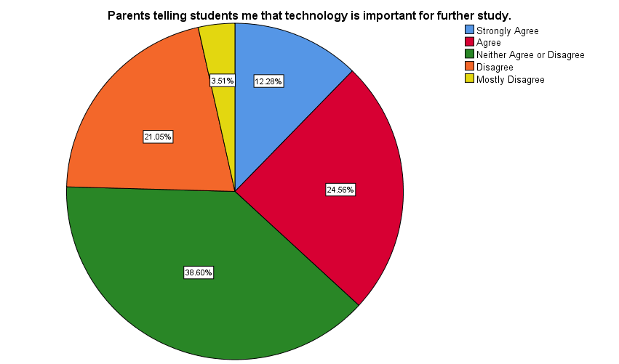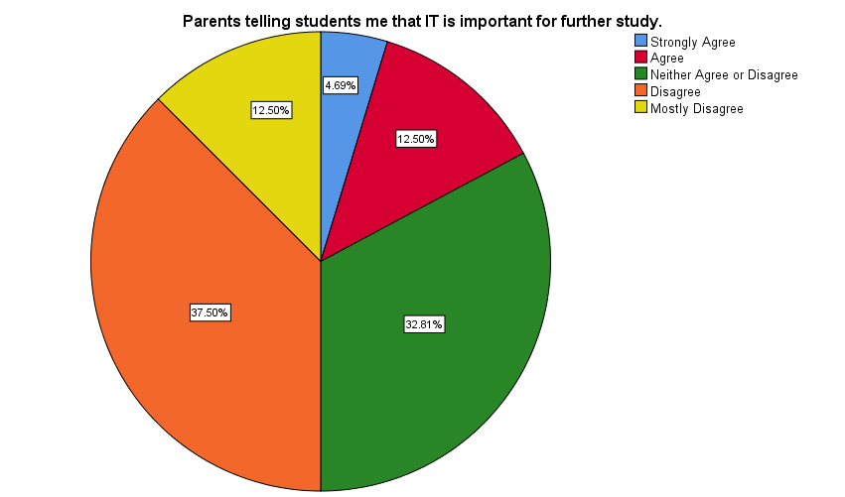

**Fig. 37 – Importance of IT Chart (Parent) Fig. 38 – Importance of Technology Chart (Parent)**

|  |  |  |  |
| --- | --- | --- | --- |
| **Parents telling students that IT is important for further study.** | | | |
|  | | Frequency | % |
| Valid | Strongly Agree | 3 | 4.7% |
| Agree | 8 | 12.5% |
| Neither Agree or Disagree | 21 | 32.8% |
| Disagree | 24 | 37.5% |
| Mostly Disagree | 8 | 12.5% |
| Total | 64 | 100% |

|  |  |  |  |
| --- | --- | --- | --- |
| **Parents telling students that technology is important for further study.** | | | |
|  | | Frequency | % |
| Valid | Strongly Agree | 7 | 12.3% |
| Agree | 14 | 24.6% |
| Neither Agree or Disagree | 22 | 38.6% |
| Disagree | 12 | 21.1% |
| Mostly Disagree | 2 | 3.5% |
| Total | 57 | 100% |

**Tab. 79 – Importance of IT Table (Parent) Tab. 80 – Importance of Technology Table (Parent)**

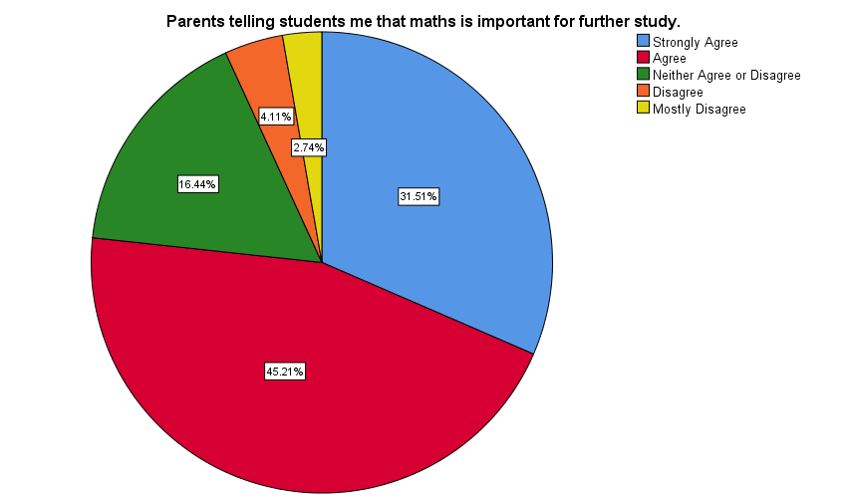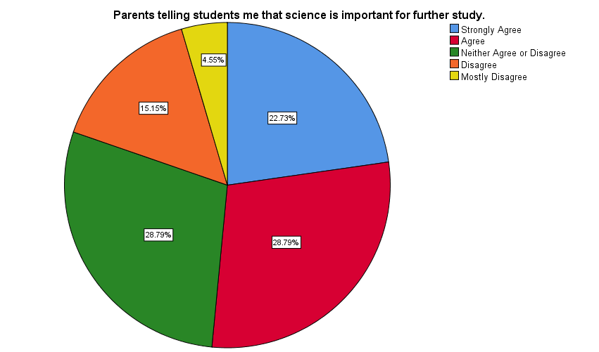

**Fig. 39 – Importance of Maths Chart (Parent) Fig. 40 – Importance of Science Chart**

|  |  |  |  |
| --- | --- | --- | --- |
| **Parents telling students that maths is important for further study.** | | | |
|  | | Frequency | % |
| Valid | Strongly Agree | 23 | 31.5% |
| Agree | 33 | 45.2% |
| Neither Agree or Disagree | 12 | 16.4% |
| Disagree | 3 | 4.1% |
| Mostly Disagree | 2 | 2.7% |
| Total | 73 | 100% |

|  |  |  |  |
| --- | --- | --- | --- |
| **Parents telling students that science is important for further study.** | | | |
|  | | Frequency | % |
| Valid | Strongly Agree | 15 | 22.7% |
| Agree | 19 | 28.8% |
| Neither Agree or Disagree | 19 | 28.8% |
| Disagree | 10 | 15.2% |
| Mostly Disagree | 3 | 4.5% |
| Total | 66 | 100% |

**Tab. 81 – Importance of Maths Table (Parent) Tab. 82 – Importance of Science Table (Parent)**

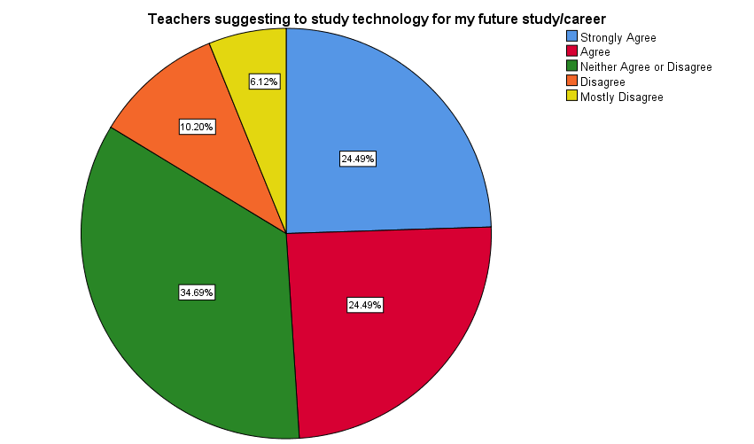Next, teacher suggestiveness on the important of a particular subject is explored.

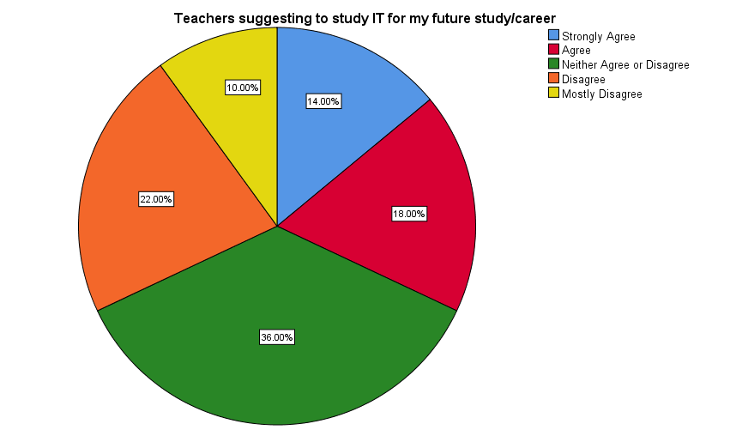

**Fig. 41 – Importance of IT Chart (Teacher) Fig. 42 – Importance of Technology Chart (Teacher)**

|  |  |  |  |
| --- | --- | --- | --- |
| **Teachers suggesting studying IT for my future study/career** | | | |
|  | | Frequency | % |
| Valid | Strongly Agree | 7 | 14% |
| Agree | 9 | 18% |
| Neither Agree or Disagree | 18 | 36% |
| Disagree | 11 | 22% |
| Mostly Disagree | 5 | 10% |
| Total | 50 | 100% |

|  |  |  |  |
| --- | --- | --- | --- |
| **Teachers suggesting studying technology for my future study/career** | | | |
|  | | Frequency | % |
| Valid | Strongly Agree | 12 | 24.5% |
| Agree | 12 | 24.5% |
| Neither Agree or Disagree | 17 | 34.7% |
| Disagree | 5 | 10.2% |
| Mostly Disagree | 3 | 6.1% |
| Total | 49 | 100% |

**Tab. 83 – Importance of IT Table (Teacher) Tab. 84 – Importance of Technology Table (Teacher)** 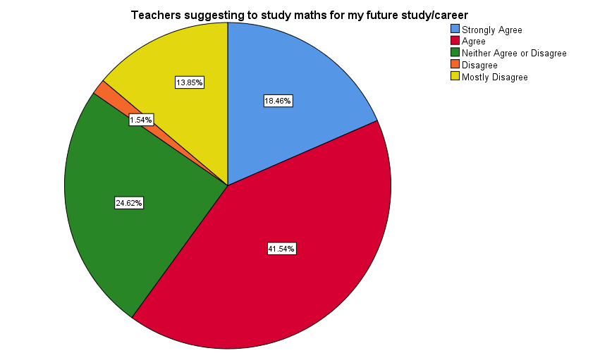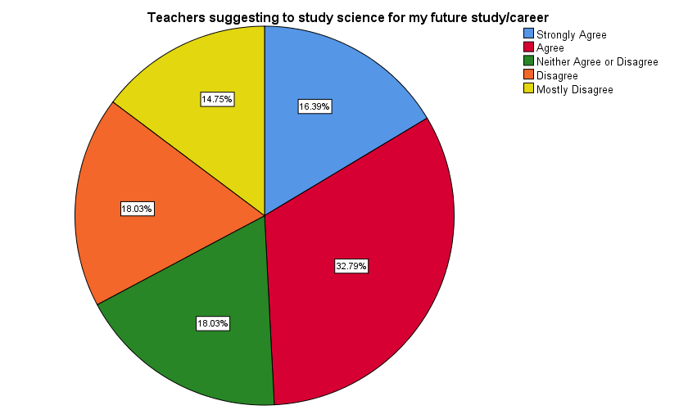

**Fig. 43 – Importance of Maths Chart (Teacher) Fig. 44 – Importance of Science Chart (Teacher)**

|  |  |  |  |
| --- | --- | --- | --- |
| **Teachers suggesting studying maths for my future study/career** | | | |
|  | | Frequency | % |
| Valid | Strongly Agree | 12 | 18.5% |
| Agree | 27 | 41.5% |
| Neither Agree or Disagree | 16 | 24.6% |
| Disagree | 1 | 1.5% |
| Mostly Disagree | 9 | 13.8% |
| Total | 65 | 100% |

|  |  |  |  |
| --- | --- | --- | --- |
| **Teachers suggesting studying science for my future study/career** | | | |
|  | | Frequency | % |
| Valid | Strongly Agree | 10 | 16.4% |
| Agree | 20 | 32.8% |
| Neither Agree or Disagree | 11 | 18.0% |
| Disagree | 11 | 18.0% |
| Mostly Disagree | 9 | 14.8% |
| Total | 61 | 100% |

**Tab. 85 – Importance of Maths Table (Teacher) Tab. 86 – Importance of Science Table (Teacher)**

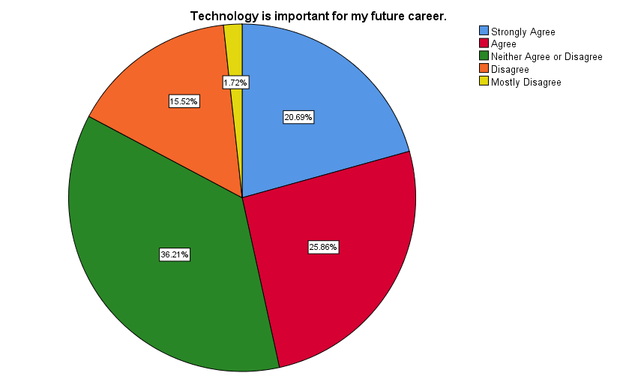Finally, the student’s opinions on whether the STEM subject is important for their future is explored.

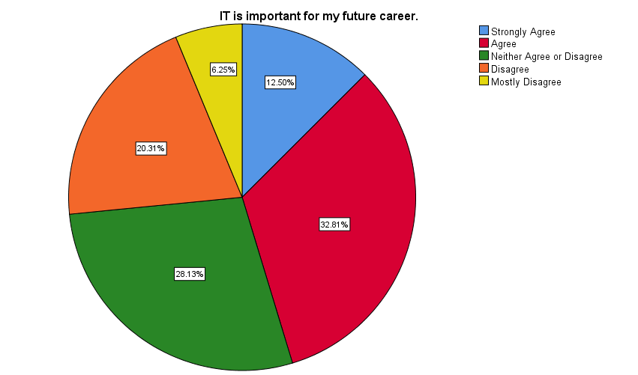

**Fig. 43.1 – Importance of IT Chart (Student) Fig. 44.1 – Importance of Technology Chart (Student)**

|  |  |  |  |
| --- | --- | --- | --- |
| **IT is important for my future career.** | | | |
|  | | Frequency | % |
| Valid | Strongly Agree | 8 | 12.5% |
| Agree | 21 | 32.8% |
| Neither Agree or Disagree | 18 | 28.1% |
| Disagree | 13 | 20.3% |
| Mostly Disagree | 4 | 6.3% |
| Total | 64 | 100% |

|  |  |  |  |
| --- | --- | --- | --- |
| **Technology is important for my future career.** | | | |
|  | | Frequency | % |
| Valid | Strongly Agree | 12 | 20.7% |
| Agree | 15 | 25.9% |
| Neither Agree or Disagree | 21 | 36.2% |
| Disagree | 9 | 15.5% |
| Mostly Disagree | 1 | 1.7% |
| Total | 58 | 100% |

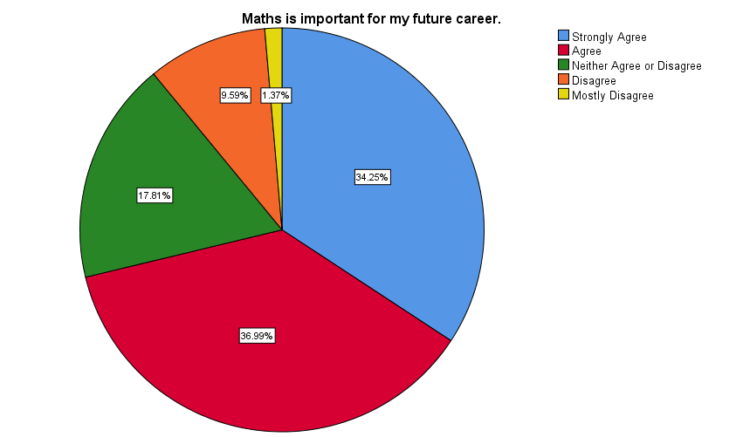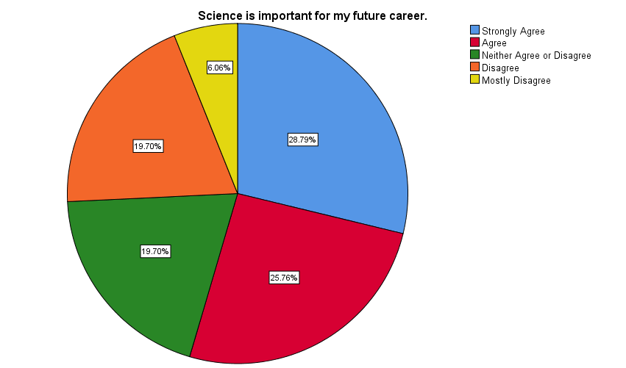 **Tab. 87 – Importance of IT Table (Student) Tab. 88 – Importance of Technology Table (Teacher)**

**Fig. 45 – Importance of Maths Chart (Student) Fig. 46 – Importance of Science Chart (Student)**

|  |  |  |  |
| --- | --- | --- | --- |
| **Maths is important for my future career.** | | | |
|  | | Frequency | % |
| Valid | Strongly Agree | 25 | 34.2% |
| Agree | 27 | 37% |
| Neither Agree or Disagree | 13 | 17.8% |
| Disagree | 7 | 9.6% |
| Mostly Disagree | 1 | 1.4% |
| Total | 73 | 100% |

|  |  |  |  |
| --- | --- | --- | --- |
| **Science is important for my future career.** | | | |
|  | | Frequency | % |
| Valid | Strongly Agree | 19 | 28.8% |
| Agree | 17 | 25.8% |
| Neither Agree or Disagree | 13 | 19.7% |
| Disagree | 13 | 19.7% |
| Mostly Disagree | 4 | 6.1% |
| Total | 66 | 100% |

**Tab. 89 – Importance of Maths Table (Teacher) Tab. 90 – Importance of Science Table (Teacher)**

Summary of Pie Charts

Figures 37 - 46 could help to identify the gender gap since there appears to be gaps in understanding the importance of STEM subjects for future study and for long-term careers. It also hints at a lack of encouragement from teachers and parents and this could stem back to their lack of understanding of the importance of STEM.

## 6.3. Analysis of Focus Group

After the development of the ‘itgirls’ application, a focus group was conducted where it was demonstrated and pitched for the first time. The focus group consisted of 10 girls (2 from each year of Year 7 – Year 11) and it lasted 30 minutes in an informal style and format.

Before heading straight into the app demonstration, it was important to gain background knowledge as to what the group understood about STEM and how they felt about it. To begin, the group was asked to identify what STEM was and what the acronym stood for. Only one member of the group identified knowledge as to the term and even then, it was incorrect by answering ‘Science, Technology, English and Maths’. From this, the term was explained correctly and understood by the girls.

### 6.3.1. Interest in STEM

The first question pitched to the group was to find out who had an interest in STEM. 50% of the girls expressed their interest in STEM subjects and identified that they were interested in Maths and Science or Technology. The reasonings behind their interests were to do with them needing the subjects for their future careers or just because they simply like the practical and creative side to technology.

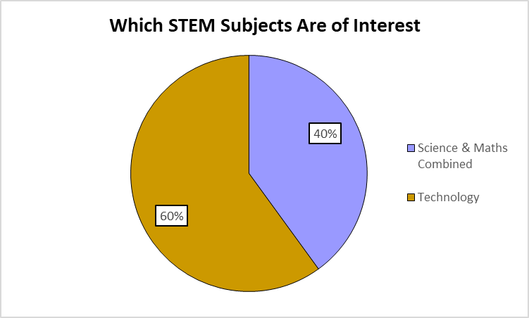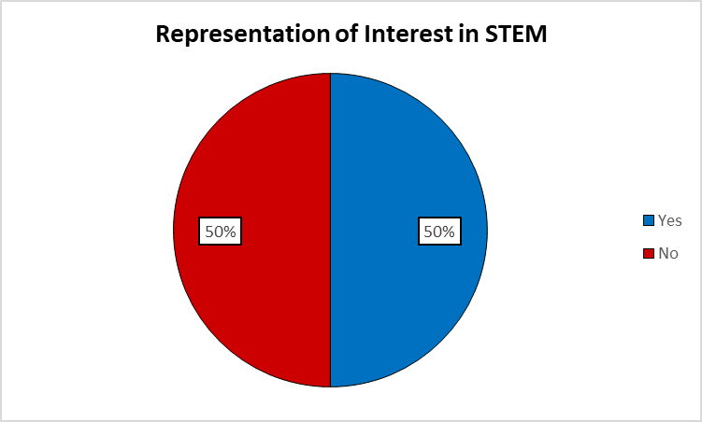

**Fig. 47 – Focus Group STEM Interest Fig. 48 – Focus Group STEM Subject Interest**

To counteract this question, the remaining group members were asked why they did not have an interest in STEM and they fed back reasons such as ‘boring and unmotivating’, ‘they are boys subjects’, ‘I’m not good at them’ and ‘I don’t like the teacher and their teaching style, so I struggle’.

### 6.3.2. Inspirational Women in STEM

Next, the group was asked if they could name any inspirational women in STEM fields to which the response was extremely eye-opening as none of the group could name a single female role model.

### 6.3.3. Careers and Support in STEM

Again, when asked to name some careers within STEM industries, the group only a few careers could be named such as, ‘sound engineer’, ‘teacher’ and ‘zoologist’. What became apparent here was the feeling that the students are kept in the dark when it comes to potential careers – they expressed how they don’t get to see the different roles which are out there and could only visual teachers as a career within Science, Technology and Maths.

This led nicely onto the next question by which 100% of the group agreed that they don’t get enough support or encouragement in STEM and when asked why they believed this, a number of students responded with ‘it is because we are girls’.

### 6.3.4. Smartphones, Apps and Their Purpose

Moving towards the technical side of the project, the group was asked if they had smartphones – the entire group agreed, as well as stating that they used them for the purposes of both socialising and for educational purposes. The response to this question was vital as it ensured that I was pitching to the right target focus group, as the application could have the biggest impact on this relevant group of students.

### 6.3.5. Identification of Benefits with the Developed Application

After the application demonstration, the focus group was questioned on any benefits they could see the deployment of such an application. Some of the responses included how it is beneficial to be interacting with others who are willing to help and encourage you in fields – not being judged or made fun of for wanting support and encouragement. Some of the girls also found the exploration of the different roles within STEM to be useful as they felt ‘in the dark’ about the potential of STEM careers. Overwhelmingly, the group loved the fact that the app is just targeted at girls as they found it more relatable and less intimidating than if it was aimed at males also.

### 6.3.6. Interest in Application

Following on, the group was asked if they would be interested in an application such as this and 100% of the group agreed they would - 2 of the girls even asked if it could be downloaded now. It was important to understand whether the students would only be interested in the application if it was forced upon them at a schooling level, yet they agreed that they would go about downloading and using this technique of their own accord to help their own prospects and understanding of STEM.

### 6.3.7. Techniques to Help Spark an Interest in STEM

To conclude the focus group, students were asked how they believed more females could be inspired to explore STEM and they responded with the following:

* The deployment of this kind of application
* Students being introduced to STEM right from Year 7 – it should be pitched like a careers event but delivered more frequently than a one-off event each year
* Continuous advice should be present, and it should be made visible that this type of help is available
* More role models and inspiring women should speak about their experiences within schools to help inspire.

## 6.4. Data Analysis Summary

The analysis of the surveys and focus group have proven to be very rewarding and eye-opening allowing for the backup and challenge of academia views (within the literature review) on a STEM gender gap and how it can be solved. In all, it has helped to formulate the conclusions to this research project and future developments.

# 7. Conclusions

## 7.1. Summary of Results

Throughout the data analysis stage of this research report, several conclusions have been made which challenge and compliment the views given by the academia within the literature review.

### 7.1.1. Why a Gender Gap Exists

The view on the existence of gender stereotypes within STEM has been enhanced by the focus group where the girls agreed that they were not interested in STEM subjects as they are perceived ‘boy subjects’ and they believed they had a lack of encouragement within the fields because ‘they are girls’.

As to there being a lack of female role models within STEM, the focus group identified how this could be perceived as true as no inspirational women could be identified. The focus group made it clear that this lack of relatability to important figures in STEM made it harder for them to identify themselves in such fields.

In contrast to this, tests have shown there to be an even gender split of teacher in IT and technology, with science and maths possessing more female teachers. This test has challenged the views of academia who state that the gender gap exists due to a lack of female teachers and role models. This is also backed up by the tests which prove there to be no association between a student enjoying a STEM subject and the gender of the teacher. This implies that the enjoyment and confidence of a student studying a STEM subject is not down specifically to the gender of the teacher but rather the teaching style and content of the teacher themselves.

The literature review then highlights how parent and teacher encouragement has an impact upon students wanting to study STEM through school. Tests have proven an association between enjoyment of a subject and having an influential teacher, as well as enjoying a subject depending on parent encouragement. Meaning, if the subject’s teacher is encouraging and parents are encouraging their children, students feel more comfortable and confident in subjects, leading to them feeling more enjoyment for such topics. Tests have also shown that science and maths are encouraged more by parents over IT and technology.

Another reason identified for the STEM gender gap is the lack of gender responsive teacher training. This idea was emphasised and agreed upon the focus group who stated (at a 100% rate) that girls are not given enough support to want to pursue STEM in the future. It has also shown how there is a relationship between having a teacher who is willing to help and liking a subject – this test highlighted how teachers has a huge impact on students’ involvement in STEM.

Not studying past the age of 16 is a downfall for many students who want to enter the STEM world in the future. The study has concluded that students believe maths and science, rather than IT and technology, are perceived as being more beneficial for jobs in the future and so it can interpret that less students are likely to carry on studying IT and technology further. This indicates that students are less likely to want to pursue a career, or future study, in IT and/or technology or they have a lack of understanding its potential. This explanation was emphasised in the focus group where the students expressed how they were ‘kept in the dark over potential careers’.

### 7.1.2. Development Decisions

Having clearly identified the potential reasons for a gender gap in science, technology, engineering and maths, the surveys were used to ensure that the application was developed optimally. The surveys identified how a gender gap starts at secondary school level meaning the application was designed and pitched towards to correct target audience. Additionally, the surveys recognised how most students owned computers, tablets and smartphones meaning that the application needed to be designed in a way which rendered of multiple mobile and web platforms. Finally, the surveyed discovered that students use their technological devices primarily for gaming, streaming and educational purposes. To integrate this understanding to the application, the interactive job role quiz was featured in the application, along with the forum page. The implementation of these features ensured the application to show its potential when demonstrated to a group of potential users.

## 7.2. How the Gender Gap Can Be Narrowed

This report had the intention of solving the question: ‘Can an application influence young female school students to consider studying STEM subjects where they had previously not considered a STEM subject as a career path?’

Conducting the focus group aided in the generation of a solid conclusion to this question – an application **can** influence young, female students into exploring STEM further in the future when they hadn’t previously considered it. At the beginning of the focus group, it was identified that 50% of the students had no interest in STEM whatsoever yet at the end of the app demonstration, 100% of the group felt as though they had been given an insight into the STEM world which brought with it more of an interest and intrigue in its potential.

The students identified many reasons why they found the application to be beneficial, including: having the ability to receive encouragement and interaction with motivated females within STEM as well as having an insight to inspirational women and what they have achieved. Students felt the gender-specific application helped STEM become more relatable and identifiable to themselves, sparking an interest in subjects like never before.

This simple focus group highlighted how misconceptions of gender roles in science, technology, maths and engineering can be easily shifted through the development of techniques such as application development and inspirational awareness. It saw an increase two-fold of the female interest for STEM and it identifies how the gender gap can easily be narrowed when willingness and tools are place in the public eye. As well as this, the focus group recognised how the deployment and usage of such applications from a younger age will strengthen the interest in the four subjects and will become ‘second-nature’ for young females and society, hence degrading the gender stereotypes which currently exist.

## 7.3. Study Contribution

This research project contributes not only to the fields of science, technology, engineering and mathematics, but also to education institutions and parental roles. With the aid of primary and secondary research techniques, the report has clearly identified how a gender gap still plays a huge role in society and explores the reasons why. Following this understanding, techniques and approaches have been described as to how the gender problem can best be solved. An example of an application development has shown how media and mobile technologies can have an influential and lasting impact of young female students and the way they perceive STEM for future study and career decisions. Educational institutions and STEM industries can look at this study with the confidence of understanding how they can impact the future of STEM by introducing techniques such as this. In summary, this research project can be used to aid the inspiration of a new generation of STEM masters, bringing with it new perspectives and outlooks through the integration of more female talents.

## 7.4. Study Limitations

Evaluating this study has highlighted a few limitations that could be expanded upon and improved if the study was to be completed again in the future.

As previously seen in Figures 9 and 17, we can see that for both primary and secondary school surveys, there is an unequal gender divide amongst the respondents (the primary school survey saw 57% female and 43% male respondents, with the secondary school seeing 56.5% female and 43.5% male). This could have introduced a slight bias towards to answers supplied as more of the answers would have been from a female perceptive, even though it is only a slight variance.

Likewise, Figures 10 and 18 identify an unequal split of school year distribution. Figure 10 shows the primary school split being: Year 3 (32.3%), Year 4 (19.6%), Year 5 (24.7%) and Year 6 (23.4%). Figure 18 shows the secondary school split being: Year 7 (17%), Year 8 (18.4%), Year 9 (19.6%), Year 10 (18.4%), Year 11 (15%), Year 12 (8.8 %) and Year 13 (4.8%). This limitation means that all age ranges are not represented equally which would have maximised the statistical power.

Due to the lack of resources and project time, this study only investigates the opinion of students from two schools were surveyed with only one focus group (made up of 10 students) conducted. These small numbers mean that the results cannot be taken as a reflection of the views of the entire country. In total, 315 students were involved in elements of this study – this limited sample size lowers the statistical power of the results concluded and incorrect assumptions as to the entire population could be made.

Additionally, some of the responses to the questionnaires had an even smaller sample size as not all the surveys were completed 100% by the respondents. This reduced the reliability of the answers further hence making them even less reflective of the views of the country’s students.

As with the focus group, the application itself was never actually deployed to potential users due to lack of testing time - the application was simply demonstrated to users. This could have potentially affected some of the responses from the focus group as they lacked a hands-on experience to understand the system fully.

Taking these factors into consideration, areas of future research are now to be explored.

## 7.5. Areas of Future Research

Looking upon this research project’s limitations, future areas of research can be drawn upon by other intellectuals and industry professionals.

In terms of the surveys conducted, bigger sample sizes must be achieved to heighten the reliability and accuracy of any results acquired. This includes enlarging the area of schools surveyed throughout the country, as well as the wider inclusion of multiple focus groups.

Furthermore, research could be conducted from a industry-facing perspective rather than school-facing in order to investigate why STEM gender gaps exist in industries too. This could help identify any other techniques that could be used through STEM fields to maximise the inclusion and enticement of women in STEM. It could also encourage further application development which would be targeted at more of an adult target market.

For the application itself, rather than just having a simple demonstration of the tool, a larger project time would allow for a testing period to which multiple users could download the application and test its features and functionality over a large duration. From this, a more accurate representation of just how beneficial an application such as this could be to STEM.

As well as this, more features and functions could be included in the application such as streaming and gaming techniques – this would help entice more students to use the application as the primary research has identified them as two of the main activities students currently use their technological devices for.

This application technique can simply be seen as the start of the end of the gender gap and can spark inspiration and imagination for schools and industries alike.

# 8. References

BCS (2017) *Legal, Social, Ethical & Professional Issues* [online] available from <https://www.bcs.org/content/ConWebDoc/57831> [11 May 2018]

Black, S. (2015) *How BCSWomen got started* [online] available from <http://bcswomen.bcs.org/how-bcswomen-got-started/> [20 January 2018]

Beyer, S. (2017) *STEM Subjects Still Subject to Gender Stereotype | Education Technology*. [online] 15 February. available from <https://edtechnology.co.uk/Article/stem-subjects-still-subject-to-gender-stereotype> [1 March 2018]

Bromley, M. (201) ‘Narrowing the gender gap: Challenges and solutions’. *SecEd* [online] 4 June. available from < http://www.sec-ed.co.uk/best-practice/narrowing-the-gender-gap-challenges-and-solutions/> [7 March 2018]

Bronston, B. (2016) ‘Female role models make science a better fit for girls’. *Tulane* [online] 18 November. available from <https://tulane.edu/female-role-models-make-science-better-fit-girls> [5 March 2018]

Cheryan, S., Plaut, V.C., Handron, C., and Hudson, L. (2013) ‘The Stereotypical Computer Scientist: Gendered Media Representations as a Barrier to Inclusion for Women’. *Sex Roles* [online] 69 (1–2), 58–71. available from <http://link.springer.com/10.1007/s11199-013-0296-x> [1 March 2018]

Copley Focus (2012) *Why Are Focus Groups Used?* [online] available from <http://www.copleyfocus.com/focus-groups/why-are-focus-groups-used> [27 February 2018]

Correll, S. J. (2004). *Constraints into Preferences: Gender, Status, and Emerging Career Aspirations* [online] 69 (1), 95–110. available from <http://people.uncw.edu/maumem/soc500/Correll2004.pdf> [20 January 2018]

Davis, D. (2017) ‘Girls Need Role Models’. *Code Like A Girl* [online] 2 October. available from <https://code.likeagirl.io/girls-need-role-models-bef0998fd71e> [5 March 2018]

Dweck (2014) *Mindset Theory - Fixed vs. Growth Mindset (Dweck) - Learning Theories* [online] available from <https://www.learning-theories.com/mindset-theory-fixed-vs-growth-mindset-dweck.html> [1 March 2018]

Good, C., Rattan, A., & Dweck, C. (2012) *Why Do Women Opt Out? Sense of Belonging and Women’s Representation in Mathematics’ Journal of Personality and Social Psychology* [online] 102 (4), 701-714. DOI: 10.1037/a0026659 [20 January 2018]

Gurney-Read, J. (2014) ‘Maths and physics seen as 'irrelevant' and too 'male'. *The Telegraph* [online] 21 May. available from <https://www.telegraph.co.uk/education/secondaryeducation/10846321/Maths-and-physics-seen-as-irrelevant-and-too-male.html> [1 March 2018]

Gurría, A. (n.d.) *Key Features of PISA 2012*. [online] available from <https://www.oecd.org/pisa/keyfindings/pisa-2012-results-overview.pdf> [6 March 2018]

Highsmith, J. (2002) *What Is Agile Software Development?* [online] available from <https://www.agilealliance.org/agile101/> [25 March 2018]

Hill, C. Corbett, C. & Rose, A. (2010) *Why So Few? Women in Science, Technology, Engineering, and Mathematics* [online] available from <https://www.aauw.org/aauw_check/pdf_download/show_pdf.php?file=why-so-few-research> [20 January 2018]

Hom, E. J. (2014) *What Is STEM Education?* [online] available from <https://www.livescience.com/43296-what-is-stem-education.html> [22 March 2018]

IBM (2018) *IBM SPSS Software* [online] available from <https://www.ibm.com/analytics/data-science/predictive-analytics/spss-statistical-software> [28 March 2018]

Islam, C. (2013) *Closing the STEM Gender Gap: Why Is It Important and What Can You Do to Help?* [online] available from <https://www.huffingtonpost.com/celia-islam/closing-the-stem-gender-g_b_3779893.html> [2 May 2018]

M, T. (n.d.) *What Are Dependencies in Project Management? A Complete Look* [online] available from <https://www.workzone.com/blog/dependencies-in-project-management/> [27 March 2018]

Mauldin, J. (2015) *Letter to the Editor: STEM | The Easterner*. 5 October. available from <https://easterneronline.com/36007/letters-to-the-editor/letter-to-the-editor-stem/> [23 March 2018]

McLeod, S. (2018) *Questionnaire | Simply Psychology* [online] available from <https://www.simplypsychology.org/questionnaires.html> [27 February 2018]

McLoughlin, A. (2017) *5 Key Reasons Why Wireframing Is Important in Web Design* [online] available from <https://www.tone.co.uk/5-key-reasons-wireframing-important-web-design/> [10 April 2018]

Microsoft (2016) *#InFocus: Why We Need to Bridge the Gender Gap in STEM Sectors* [online] available from <https://blogs.technet.microsoft.com/microsoft_citizenship_asia_pacific/2016/03/15/infocus-why-we-need-to-bridge-the-gender-gap-in-stem-sectors/> [2 May 2018]

Mind Tolls (2017) *What Is Time Management? - Time Management Skills From MindTools.com* [online] available from <https://www.mindtools.com/pages/article/newHTE_00.htm> [27 March 2018]

Mohtadi, C. (2017) *The Importance of Promoting STEM Subjects Across the UK.* 6 January. available from <http://www.huffingtonpost.co.uk/coorous-mohtadi/stem-subjects-uk_b_8917216.html> [22 March 2018]

Oxford Dictionary (2018) *Definition of Infrastructure in English by Oxford Dictionaries* [online] available from <https://en.oxforddictionaries.com/definition/infrastructure> [27 March 2018]

O’Neill, N. (2013) ‘Nerdy Stereotypes Discourage Women From Being Computer Scientists’. *Bustle* [online] 28 June. available from <https://www.bustle.com/articles/1105-nerdy-stereotypes-discourage-women-from-being-computer-scientists> [5 March 2018]

Preece, Rogers, Sharp. (2002) *Interaction Design: Beyond Human-Computer Interaction* [online] available from <https://arl.human.cornell.edu/879Readings/Interaction Design - Beyond Human-Computer Interaction.pdf> [1 May 2018]

Pugh, B. (2016) *Obstacles and Opportunities for Women in Data Science* [online] available from <https://www.elderresearch.com/company/blog/obstacles-and-opportunities-for-women-in-data-science> [20 January 2018]

Resnik, D.B. (2015) *What Is Ethics in Research & Why Is It Important?* [online] available from <https://www.niehs.nih.gov/research/resources/bioethics/whatis/?iframe=true&a> [23 March 2018]

Schade, A. (2015) *Pilot Testing: Getting It Right (Before) the First Time* [online] available from <https://www.nngroup.com/articles/pilot-testing/> [27 February 2018]

Skillsyouneed (2017) *What Is Communication? - Verbal, Nonverbal & Written | SkillsYouNeed* [online] available from <https://www.skillsyouneed.com/ips/what-is-communication.html> [27 March 2018]

Sosu, E. and Ellis, S. (2014) *Closing the Attainment Gap in Scottish Education*. [online] available from <https://www.jrf.org.uk/sites/default/files/jrf/migrated/files/education-attainment-scotland-full.pdf> [6 March 2018]

Statista (2018) *UK: smartphone ownership by age from 2012-2017* [online] available from <https://www.statista.com/statistics/271851/smartphone-owners-in-the-united-kingdom-uk-by-age/> [27 February 2018]

Symoneaux, R., Galmarini, M. V. (2014) *Open-Ended Questions [*online] available from <https://www.mediacollege.com/journalism/interviews/open-ended-questions.html> [24 March 2018]

Tversky, A. and Kahneman, D. (1992) ‘Advances in Prospect Theory: Cumulative Representation of Uncertainty’. *Journal of Risk and Uncertainty* [online] 5 (4), 297–323. available from <http://link.springer.com/10.1007/BF00122574> [1 March 2018]

UNESCO Bangkok. (2016) *Closing the gender gap in STEM: Drawing more girls and women into Science, Technology, Engineering and Mathematics* [online] available from <http://unesdoc.unesco.org/images/0024/002457/245717e.pdf> [19 January 2018]

Welsh, J. (2013) *These Are The 7 Things Keeping Women Out Of Science Careers* [online] available from <http://www.businessinsider.com/7-things-keeping-women-out-of-science-2013-10?IR=T> [1 March 2018]

Williams, S. (2014) *Why We Need Women in STEM* [online] available from <https://www.inc.com/sue-williams/why-we-need-women-in-stem.html> [2 May 2018]

Winfrey, G. (2016) *The 5 Fastest-Growing Industries in the U.S.* [online] available from <https://www.inc.com/graham-winfrey/the-5-fastest-growing-industries-in-the-us.html> [2 May 2018]

WISE Campaign (2015) *People Like Me: Why this revolutionary approach to attract girls into science, technology and engineering will make a difference* [online] available from <https://www.wisecampaign.org.uk/uploads/wise/files/6pp_NFPLM_SUMMARY_v31.pdf> [20 January 2018]

WISE Campaign (2017) *Resources | Analysis of GCSE STEM entries and results* [online] available from <https://www.wisecampaign.org.uk/resources/2017/08/analysis-of-gcse-stem-entries-and-results> [5 March 2018]

WISE Campaign (2017) *Resources | The STEM Education Pipeline 2017* [online] available from <https://www.wisecampaign.org.uk/resources/2017/11/from-classroom-to-boardroom-the-stem-pipeline-2017> [1 March 2018]

WISE Campaign (n.d.) *The History of WISE* [online] available from <https://www.wisecampaign.org.uk/about-us/history> [23 March 2018]

WISE Campaign (n.d.) *The Ten Steps* [online] available from <https://www.wisecampaign.org.uk/consultancy/industry-led-ten-steps/10-steps> [5 March 2018]

WISE Campaign (2017) *Women on Boards 2017* [online] available from <https://www.wisecampaign.org.uk/resources/2017/12/women-on-boards-2017> [5 March 2018]

World Economic Forum (2016) *Global Gender Gap Report 2016 - Reports - World Economic Forum* [online] available from <http://reports.weforum.org/global-gender-gap-report-2016/economies/#economy=ISL> [2 March 2018]

Wright, A. (2008) *Psychological Properties Of Colours* [online] available from <http://www.colour-affects.co.uk/psychological-properties-of-colours> [11 April 2018]

## 7.1. Application Content References

Clinton Foundation (n.d.) *Girls and Women* [online] available from <https://www.clintonfoundation.org/our-work/by-topic/girls-and-women> [7 March 2018]

Dreambox (2015) *Women in STEM who Rock & 8 Cool Websites to Get Girls Psyched About STEM*. 8 October. available from <http://www.dreambox.com/blog/women-in-stem-who-rock-plus-top-10-websites-to-get-girls-psyched-about-stem> [7 March 2018]

Easy Science for Kids (n.d.) *Gertrude B. Elion Facts for Kids* [online] available from <http://easyscienceforkids.com/gertrude-b-elion/> [7 March 2018]

James (2014) *Ada Lovelace: Facts and Information* [online] available from <http://primaryfacts.com/4640/ada-lovelace-facts/> [7 March 2018]

Kiefer, E. (2014) *Brittany Wenger Invented an Artificial Brain to Detect Breast Cancer* [online] available from <https://www.teenvogue.com/story/brittany-wenger-cancer-research> [7 March 2018]

Marie Curie Charity (n.d.) *Marie Curie the scientist.* available from <https://www.mariecurie.org.uk/who/our-history/marie-curie-the-scientist> [7 March 2018]

Nemchonok, S. (2016) *10 Famous Women in Tech History.* 14 March. available from <https://insights.dice.com/2016/03/14/10-famous-women-in-tech-history/11/> [7 March 2018]

Panetta, K. (n.d.) *About Karen Panetta* [online] available from <http://www.karenpanetta.com/#about-overview> [7 March 2018]

SoftSchools (n.d.) Ada Lovelace Facts [online] available from <http://www.softschools.com/facts/scientists/ada_lovelace_facts/894/> [7 March 2018]

SoftSchools (n.d.) *Barbara McClintock Facts* [online] available from <http://www.softschools.com/facts/scientists/barbara_mcclintock_facts/1034/> [7 March 2018]

SoftSchools (n.d.) *Lise Meitner Facts* [online] available from <http://www.softschools.com/facts/scientists/lise_meitner_facts/1649/> [7 March 2018]

SoftSchools (n.d.) *Rosalind Franklin Facts* [online] available from <http://softschools.com/facts/scientists/rosalind_franklin_facts/1889/> [7 March 2018]

TED (2013) *Teen Computer Whiz Helps Diagnose Breast Cancer |* [online] available from <https://ideas.ted.com/brittany-wenger-cancer-research/> [7 March 2018]

# 9. Appendices

## 9.1. List of Tables

Tab. 1 – Risk Planning……………….……………………………….…..…**20**

Tab. 2 – Presentation Feedback ....…………………………….……..**22**

Tab. 3 – Primary Gender Distribution Table .…………..……..…**24**

Tab. 4 – Primary Year Distribution Table …………………..….…. **25**

Tab. 5 – Primary Technology Activity Used Most Table ….….**26**

Tab. 6 – IT and Gender Crosstabulation Table ……………….….**28**

Tab. 7 – IT and Gender Chi-Square Test …….........................**28**

Tab. 8 – Maths and Gender Crosstabulation Table ……….…..**29**

Tab. 9 – Maths and Gender Chi-Square Test ……………….…...**29**

Tab. 10 – Science and Gender Crosstabulation Table …..….**29**

Tab. 11 – Science and Gender Chi-Square Test ……..…..….....**29**

Tab. 12 – Secondary Gender Distribution Table …………….….**30**

Tab. 13 – Secondary Year Distribution Table ………………….…**30**

Tab. 14 – Secondary Tech Activity Used Most Table…………**32**

Tab. 15 – IT and Gender Crosstabulation Table ………………...**34**

Tab. 16 – IT and Gender Spearman Test ……………………….….**34**

Tab. 17 – Tech and Gender Crosstabulation Table .……….….**34**

Tab. 18 – Technology and Gender Spearman Test …………...**35**

Tab. 19 – Maths and Gender Crosstabulation Table ………...**35**

Tab. 20 – Maths and Gender Spearman Test ………….………..**35**

Tab. 21 – Science and Gender Crosstabulation Table ……...**36**

Tab. 22 – Science and Gender Spearman Test ………………….**36**

Tab. 23 – Females Not Enjoying IT Reasoning Table …...…….**36**

Tab. 24 – Females Not Enjoying Tech Reasoning Table ……..**37**

Tab. 25 – Females Not Enjoying Maths Reasoning Table ...**37**

Tab. 26 – Females Not Enjoying Science Reasoning Table..**38**

Tab. 27 – Female’s IT Teacher Gender Table …………………….**39**

Tab. 28 – Female’s Technology Teacher Gender Table ……..**39**

Tab. 29 – Female’s Maths Teacher Gender Table ……………..**39**

Tab. 30 – Female’s Science Teacher Gender Table ……………**39**

Tab. 31 – IT & Influential Teacher Crosstabulation Table ….**39**

Tab. 32 – IT & Influential Teacher Chi-Square Test …….……..**40**

Tab. 33 - Tech & Influential Teacher Crosstabulation Table….**40**

Tab. 34 – Tech & Influential Teacher Chi-Square Test ……...**40**

Tab. 35 - Maths & Influential Teacher Crosstabulation Table..**41**

Tab. 36 – Maths & Influential Teacher Chi-Square Test …..**41**

Tab. 37 - Maths & Influential Teacher Crosstabulation Table .**41**

Tab. 38 – Science & Influential Teacher Chi-Square Test ….**42**

Tab. 39 – IT & Teacher Gender Chi-Square Test ………………..**42**

Tab. 40 – Technology & Teacher Gender Chi-Square Test ..**43**

Tab. 41 – Maths & Teacher Gender Chi-Square Test ………..**43**

Tab. 42 – Science & Teacher Gender Chi-Square Test ……..**44**

Tab. 43 – IT & Encouraging Teacher Crosstabulation Table .**44**

Tab. 44 – IT & Encouraging Teacher Spearman Test …….…..**45**

Tab. 45 – Tech & Encouraging Teacher Crosstabulation Table .**45**

Tab. 46 – Tech & Encouraging Teacher Spearman Test …….…..**45**

Tab. 47 – Maths & Encouraging Teacher Crosstabulation Table ...**46**

Tab. 48 – Maths & Encouraging Teacher Spearman Test …….……...**46**

Tab. 49 – Science & Encouraging Teacher Crosstabulation Table ...**47**

Tab. 50 – Science & Encouraging Teacher Spearman Test ….……...**47**

Tab. 51 – IT & Helpful Teacher Crosstabulation Table ……..**48**

Tab. 52 – IT & Helpful Teacher Spearman Test ………………...**48**

Tab. 53 – Tech & Helpful Teacher Crosstabulation Table ……**48**

Tab. 54 – Tech & Helpful Teacher Spearman Test …….………..**49**

Tab. 55 – Maths & Helpful Teacher Crosstabulation Table ……....**49**

Tab. 56 – Maths & Helpful Teacher Spearman Test …….…………....**49**

Tab. 57 – Science & Helpful Teacher Crosstabulation Table ........**50**

Tab. 58 – Science & Helpful Teacher Spearman Test ….……………...**50**

Tab. 59 – IT & Prepared Teacher Crosstabulation Table …..**51**

Tab. 60 – IT & Prepared Teacher Spearman Test ……………...**51**

Tab. 61 – Tech & Prepared Teacher Crosstabulation Table ……**51**

Tab. 62 – Tech & Prepared Teacher Spearman Test ……..……..**52**

Tab. 63 – Maths & Prepared Teacher Crosstabulation Table ……..**52**

Tab. 64 – Maths & Prepared Teacher Spearman Test …….………....**52**

Tab. 65 – Science & Prepared Teacher Crosstabulation Table ......**53**

Tab. 66 – Science & Prepared Teacher Spearman Test ….…………..**53**

Tab. 67 – Parent Encouragement for IT Table ……………....….**54**

Tab. 68 – Parent Encouragement for Technology Table …...**54**

Tab. 69 – Parent Encouragement for Maths Table ….…….….**54**

Tab. 70 – Parent Encouragement for Science Table …….…..**54**

Tab. 71 – IT & Encouraging Parent Crosstabulation Table ..**55**

Tab. 72 – IT & Encouraging Parent Spearman Test …….……..**55**

Tab. 73 – Tech & Encouraging Parent Crosstabulation Table ..**56**

Tab. 74 – Tech & Encouraging Parent Spearman Test …………..**56**

Tab. 75 – Maths & Encouraging Parent Crosstabulation Table .**56**

Tab. 76 – Maths & Encouraging Parent Spearman Test …….…..**57**

Tab. 77 – Science & Encouraging Parent Crosstabulation Table ...**57**

Tab. 78 – Science & Encouraging Parent Spearman Test ….…...**57**

Tab. 79 – Importance of IT Table (Parent) ………………………...**58**

Tab. 80 – Importance of Technology Table (Parent) ……..….**58**

Tab. 81 – Importance of Maths Table (Parent) ……..…..….....**59**

Tab. 82 – Importance of Science Table (Parent) …………….….**59**

Tab. 83 – Importance of IT Table (Teacher) ……………………...**59**

Tab. 84 – Importance of Technology Table (Teacher) …..….**59**

Tab. 85 – Importance of Maths Table (Teacher) ……..…..…...**60**

Tab. 86 – Importance of Science Table (Teacher) …………….**60**

Tab. 87 – Importance of IT Table (Student) ……………………...**60**

Tab. 88 – Importance of Technology Table (Student) …..….**60**

Tab. 89 – Importance of Maths Table (Student) ……..…..…...**61**

Tab. 90 – Importance of Science Table (Student) …………….**61**

## 9.2. List of Figures

Fig. 1 – Role Page Wireframe ……………….………………………..…**15**

Fig. 2 – Inspiring Women Wireframe ....…………………….……..**15**

Fig. 3 – Events Wireframe ....…………………..…………………..…...**15**

Fig. 4 – Forum Wireframe ....…………………………………..………..**15**

Fig. 4.1 – System Architecture ....……………………….…..………..**17**

Fig. 5 – itgirls Homepage …………………………………….……………**18**

Fig. 6 – itgirls Role Page .…………………………………….…………….**18**

Fig. 7 – itgirls Inspiring Women Page …………………..……………**18**

Fig. 8 – itgirls Forum Page …………………………………..…….……..**18**

Fig. 9 – Primary Gender Distribution Chart ……………..……..…**24**

Fig. 10 – Primary Year Distribution Chart ………………….….……**25**

Fig. 11 – Primary Technology Owned Chart ……………….….….**25**

Fig. 12 – Primary Technology Activity Used Chart ………….….**26**

Fig. 13 – Primary Technology Activity Used Most Chart …….**26**

Fig. 14 – Primary Subject Favouritism Chart ………………….….**27**

Fig. 15 – Primary Subject Favouritism Chart for Males ……...**27**

Fig. 16 – Primary Subject Favouritism Chart for Females …..**28**

Fig. 17 – Secondary Gender Distribution Chart ………………...**30**

Fig. 18 – Secondary Year Distribution Chart ……..………..…….**30**

Fig. 19 – Primary Technology Owned Chart ……..……………...**31**

Fig. 20 – Secondary Technology Activity Used Chart ……..….**31**

Fig. 21 – Secondary Tech Activity Used Most Chart ………..…**32**

Fig. 22 – Secondary Subject Favouritism Chart …………….…..**32**

Fig. 23 – Secondary Subject Favouritism Chart (Males) …....**33**

Fig. 24 – Secondary Subject Favouritism Chart (Females) ….**33**

Fig. 25 – Females Not Enjoying IT Reasoning Chart .………….**36**

Fig. 26 - Females Not Enjoying Tech Reasoning Chart ……....**37**

Fig. 27 – Females Not Enjoying Maths Reasoning Chart …...**37**

Fig. 28 – Females Not Enjoying Science Reasoning Chart …..**38**

Fig. 29 – Female’s IT Teacher Gender Chart .……………………..**38**

Fig. 30 – Female’s Technology Teacher Gender Chart ……….**38**

Fig. 31 – Female’s Maths Teacher Gender Chart ……………….**39**

Fig. 33 – Parent Encouragement for IT Chart ………………….49

Fig. 34 – Parent Encouragement for Technology Chart …..49

Fig. 32 – Female’s Science Teacher Gender Chart ……………..**39**

Fig. 33 – Parent Encouragement for IT Chart …………………….**54**

Fig. 34 – Parent Encouragement for Technology Chart ……..**54**

Fig. 35 – Parent Encouragement for Maths Chart ……………..**54**

Fig. 36 – Parent Encouragement for Science Chart ……………**54**

Fig. 37 – Importance of IT Chart (Parent) ………………..………..**58**

Fig. 38 – Importance of Technology Chart (Parent) ……..……**58**

Fig. 39 – Importance of Maths Chart (Parent) ………..………...**58**

Fig. 40 – Importance of Science Chart (Parent) ……………..….**58**

Fig. 41 – Importance of IT Chart (Teacher) ………………………..**59**

Fig. 42 – Importance of Technology Chart (Teacher) ………...**59**

Fig. 43 – Importance of Maths Chart (Teacher) …………………**59**

Fig. 44 – Importance of Science Chart (Teacher) ……………….**59**

Fig. 43.1 – Importance of IT Chart (Student) ………………….….**60**

Fig. 44.1 – Importance of Technology Chart (Student) ……...**60**

Fig. 45 – Importance of Maths Chart (Student) ………………...**60**

Fig. 46 – Importance of Science Chart (Student) ……………….**60**

Fig. 47 – Focus Group STEM Interest …………………………..…….**61**

Fig. 48 – Focus Group STEM Subject Interest…………………….**61**

## 9.3. List of Appendices

Appendix A - Primary School Questionnaire …………………………………………………………………………………………………………………………………**74**

Appendix B - Secondary School Questionnaire ……………………………………………………………………………………………………………………….……**81**

Appendix C - Participation Leaflet …………………………………………………………………………………………..……………………………………………………**91**

Appendix D - Consent Form …………………………………………………………………………………………………………………………………………………………**93**

Appendix E - Focus Group Questions ……………………………………………………………………………………………………………………………………………**94**

Appendix F - Presentation ……………………………………………………………………………………………………………………………………………………………**95**

Appendix G - Wireframes …………………………………………………………………………….……………………………………………………………………………**103**

Appendix H - Application Screenshots ……………………………………….………………………………………………………………………………………………**114**

Appendix I - Meeting Minutes ……………………………………………………………………………………………………………………………………………………**126**

Appendix J - Gannt Chart ……………………………………………………………………………………………………………………………………………………………**127**

Appendix K - Literature Review Resource Spreadsheet ………………………………………………………………………………………………………………**128**

Appendix L – Detailed Project Proposal ……………………. ………………………………………………………………………………………………………………**129**

### Appendix A - Primary School Questionnaire

Student Questionnaire

**Please answer all the following questions.**

The purpose of this questionnaire is to investigate opinions and attitudes towards subjects studied at school. This research is being used in my final year dissertation at university.

**Note:** this questionnaire is anonymous and always will be! So, when answering the questions, please be as honest as you can with your answers.

**Throughout this questionnaire you will come across the term ‘IT’, this represents both Information Technology and Computer Science related subjects and computers in general.**

General Questions

# Q1. Please circle your gender.

Male Female

# Q2. Please circle your year group.

Year 3 Year 4 Year 5 Year 6

# Q3. Which of the following do you own? Please tick.

|  |  |  |  |  |  |
| --- | --- | --- | --- | --- | --- |
| **Smartphone** |  | **Tablet** |  | **Computer** |  |
| **Smartwatch** |  | **None listed here** |  |  |  |

# Q4. Which of the following do you use your technology for? Please **tick**.

|  |  |  |  |  |  |
| --- | --- | --- | --- | --- | --- |
| **Education** |  | **Socialising** |  | **Gaming** |  |
| **Streaming** |  | **Other** |  |  |  |

# If other, please state below:

_______________________________________________________________________________________

# Q4c. Which of the following do you use your technology for the most? Please **tick one**.

|  |  |  |  |  |  |
| --- | --- | --- | --- | --- | --- |
| **Education** |  | **Socialising** |  | **Gaming** |  |
| **Streaming** |  | **Other** |  |  |  |

# If other, please state below:

_______________________________________________________________________________________

# Q5. Please **tick** how you feel about each subject.

|  |  |  |  |
| --- | --- | --- | --- |
|  | **😊** | **😐** | **☹** |
| **Art** |  |  |  |
| **English** |  |  |  |
| **Geography** |  |  |  |
| **History** |  |  |  |
| **ICT** |  |  |  |
| **Maths** |  |  |  |
| **Music** |  |  |  |
| **Physical Education (PE)** |  |  |  |
| **Science** |  |  |  |

# Q5b. Why do you **enjoy** your chosen subjects?

_______________________________________________________________________________________

_______________________________________________________________________________________

# Q5c. Why do you **not enjoy** your chosen subjects?

_______________________________________________________________________________________

_______________________________________________________________________________________

IT Questions

# Q6. What do you like **most** about your IT class?

_______________________________________________________________________________________

_______________________________________________________________________________________

# Q7. What do you like **least** about your IT class?

_______________________________________________________________________________________

_______________________________________________________________________________________

# Q8. Views on IT in general.

# Please **tick** how you feel about each other following statements.

|  |  |  |  |
| --- | --- | --- | --- |
|  | **😊** | **😐** | **☹** |
| **I enjoy working with computers.** |  |  |  |
| **I feel confident about my computer skills.** |  |  |  |
| **I have access to a computer at school.** |  |  |  |
| **I have access to a computer at home.** |  |  |  |
| **I use computers to support me in other subjects.** |  |  |  |
| **My parents use computers.** |  |  |  |
| **My parents are confident with computers.** |  |  |  |
| **My parents help and support me using computers.** |  |  |  |
| **I see myself using computers in the future.** |  |  |  |
| **I think computers are important.** |  |  |  |

# For the last statement, please state why you think that:

_______________________________________________________________________________________

# Q9. At what age was your first memory of working/playing on a computer.

_______________________________________________________________________________________

# Q10. Please **circle** your IT teacher’s gender.

Male Female

# If you have more than one teacher, please state below and state their gender:

_______________________________________________________________________________________

# Q11. Views on your IT teacher(s).

# Please **tick** how you feel about each other following statements.

|  |  |  |  |
| --- | --- | --- | --- |
|  | **😊** | **😐** | **☹** |
| **My teacher supports and encourages me in IT** |  |  |  |
| **My teacher influences how well I do in IT.** |  |  |  |
| **My teacher makes me feel excited about IT.** |  |  |  |
| **If I struggle in IT, I ask my teachers for help.** |  |  |  |
| **If I ask my teacher for help in IT, he/she will always try to help me.** |  |  |  |
| **If I ask my teacher for help in IT, he/she will sometimes try to help me.** |  |  |  |
| **If I ask my teacher for help in IT, he/she will rarely try to help me.** |  |  |  |

Maths Questions

# Q12. What do you like **most** about your maths class?

_______________________________________________________________________________________

_______________________________________________________________________________________

# Q13. What do you like **least** about your maths class?

_______________________________________________________________________________________

_______________________________________________________________________________________

# Q14. Views on maths in general.

# Please **tick** how you feel about each other following statements.

|  |  |  |  |
| --- | --- | --- | --- |
|  | **😊** | **😐** | **☹** |
| **I enjoy maths.** |  |  |  |
| **I feel confident about my maths skills.** |  |  |  |
| **I use maths to support me in other subjects.** |  |  |  |
| **My parents are confident with maths.** |  |  |  |
| **My parents help and support me with maths.** |  |  |  |
| **I see myself using maths in the future.** |  |  |  |
| **I think maths is important.** |  |  |  |

# For the last statement, please state why you think that:

_______________________________________________________________________________________

_______________________________________________________________________________________

# Q15. Views on your maths teacher(s).

# Please **tick** how you feel about each other following statements.

|  |  |  |  |
| --- | --- | --- | --- |
|  | **😊** | **😐** | **☹** |
| **My teacher supports and encourages me in maths.** |  |  |  |
| **My teacher influences how well I do in maths.** |  |  |  |
| **My teacher makes me feel excited about maths.** |  |  |  |
| **If I struggle in maths, I ask my teachers for help.** |  |  |  |
| **If I ask my teacher for help in maths, he/she will always try to help me.** |  |  |  |
| **If I ask my teacher for help in maths, he/she will sometimes try to help me.** |  |  |  |
| **If I ask my teacher for help in maths, he/she will rarely try to help me.** |  |  |  |

# Q16. Please circle your maths teacher’s gender.

Male Female

If you have more than one teacher, please state below and state their gender: _______________________________________________________________________________________

Science Questions

# Q17. What do you like **most** about your science class?

_______________________________________________________________________________________

_______________________________________________________________________________________

# Q18. What do you like **least** about your science class?

_______________________________________________________________________________________

_______________________________________________________________________________________

# Q19. Views on science in general.

# Please **tick** how you feel about each other following statements.

|  |  |  |  |
| --- | --- | --- | --- |
|  | **😊** | **😐** | **☹** |
| **I enjoy science.** |  |  |  |
| **I feel confident about my science skills.** |  |  |  |
| **I use science to support me in other subjects.** |  |  |  |
| **My parents are confident with science.** |  |  |  |
| **My parents help and support me with science.** |  |  |  |
| **I see myself using science in the future.** |  |  |  |
| **I think science is important.** |  |  |  |

# For the last statement, please state why you think that:

_______________________________________________________________________________________

_______________________________________________________________________________________

# Q20. Views on your science teacher(s).

# Please **tick** how you feel about each other following statements.

|  |  |  |  |
| --- | --- | --- | --- |
|  | **😊** | **😐** | **☹** |
| **My teacher supports and encourages me in science.** |  |  |  |
| **My teacher influences how well I do in science.** |  |  |  |
| **My teacher makes me feel excited about science.** |  |  |  |
| **If I struggle in science, I ask my teachers for help.** |  |  |  |
| **If I ask my teacher for help in science, he/she will always try to help me.** |  |  |  |
| **If I ask my teacher for help in science, he/she will sometimes try to help me.** |  |  |  |
| **If I ask my teacher for help in science, he/she will rarely try to help me.** |  |  |  |

# Q21. Please circle your science teacher’s gender.

Male Female

# If you have more than one teacher, please state below and state their gender:

_______________________________________________________________________________________

# Thank you so much for taking part!

### Appendix B - Secondary School Questionnaire

Student Questionnaire

**Please answer all the following questions.**

The purpose of this questionnaire is to investigate opinions and attitudes towards subjects studied at school. This research is being used in my final year dissertation at university.

**Note:** this questionnaire is anonymous and always will be! So, when answering the questions, please be as honest as you can with your answers.

**Throughout this questionnaire you will come across the term ‘IT’, this represents both Information Technology and Computer Science related subjects.**

General Questions

# Q1. Please **circle** your gender.

Male Female

# Q2. Please **circle** your year group.

Year 7 Year 8 Year 9 Year 10 Year 11 Year 12 Year 13

# Q3. Which of the following do you own? Please **tick**.

|  |  |  |  |  |  |
| --- | --- | --- | --- | --- | --- |
| **Smartphone** |  | **Tablet** |  | **Computer** |  |
| **Smartwatch** |  | **None listed here** |  |  |  |

# Q4. Which of the following do you use your technology for? Please **tick**.

|  |  |  |  |  |  |
| --- | --- | --- | --- | --- | --- |
| **Education** |  | **Socialising** |  | **Gaming** |  |
| **Streaming** |  | **Other** |  |  |  |

# If other, please state below:

_______________________________________________________________________________________

# Q4c. Which of the following do you use your technology for the most? Please **tick one**.

|  |  |  |  |  |  |
| --- | --- | --- | --- | --- | --- |
| **Education** |  | **Socialising** |  | **Gaming** |  |
| **Streaming** |  | **Other** |  |  |  |

# If other, please state below:

_______________________________________________________________________________________

# Q5. Please **tick** your top 3 for each statement.

|  |  |  |  |  |  |  |  |  |  |  |  |  |  |  |  |  |  |
| --- | --- | --- | --- | --- | --- | --- | --- | --- | --- | --- | --- | --- | --- | --- | --- | --- | --- |
|  | **Art** | **Biology** | **Chemistry** | **Design Technology** | **Drama** | **English (Language/Literature)** | **Foreign Languages** | **Geography** | **History** | **IT** | **Maths** | **Music** | **Physical Education (PE)** | **Physics** | **Religious Studies** | **Science (general)** | **Other** |
| **Which 3 subjects do you enjoy most at school?** |  |  |  |  |  |  |  |  |  |  |  |  |  |  |  |  |  |
| **Which 3 subjects do you enjoy least at school?** |  |  |  |  |  |  |  |  |  |  |  |  |  |  |  |  |  |

# If other, please state below:

_______________________________________________________________________________________

# Q5b. Why do you **enjoy** your chosen subjects?

_______________________________________________________________________________________

_______________________________________________________________________________________

_______________________________________________________________________________________

# Q5c. Why do you **not enjoy** your chosen subjects?

_______________________________________________________________________________________

_______________________________________________________________________________________

_______________________________________________________________________________________

IT Questions

# Q6. What do you like **most** about your IT class?

_______________________________________________________________________________________

_______________________________________________________________________________________

_______________________________________________________________________________________

# Q7. What do you like **least** about your IT class?

_______________________________________________________________________________________

_______________________________________________________________________________________

_______________________________________________________________________________________

# Q8. Views on IT in general.

# Please state how far you agree or disagree with each of the following statements (please tick one box per line)

|  |  |  |  |  |  |
| --- | --- | --- | --- | --- | --- |
|  | **Strongly Agree** | **Agree** | **Not sure** | **Disagree** | **Strongly Disagree** |
| **I enjoy** **IT.** |  |  |  |  |  |
| **I feel confident about my abilities in IT.** |  |  |  |  |  |
| **It is important for me to do well in IT in order to perform well in other subjects.** |  |  |  |  |  |
| **IT is important for my everyday life.** |  |  |  |  |  |
| **IT is important for my future education.** |  |  |  |  |  |
| **IT is important for my future career.** |  |  |  |  |  |
| **My parents encourage me to do well in IT.** |  |  |  |  |  |
| **My parents tell me that IT is important for my further study.** |  |  |  |  |  |
| **My parents make me feel enthusiastic about IT.** |  |  |  |  |  |
| **My parents have strong knowledge on IT.** |  |  |  |  |  |

# Q9. At what age was your first memory of working/playing on a computer.

_______________________________________________________________________________________

# Q10. Please circle your IT teacher’s gender.

Male Female

# If you have more than one teacher, please state below and state their gender:

_______________________________________________________________________________________

# Q11. Views on your IT teacher(s).

# Please state how far you agree or disagree with each of the following statements (please tick one box per line)

|  |  |  |  |  |  |
| --- | --- | --- | --- | --- | --- |
|  | **Strongly Agree** | **Agree** | **Not sure** | **Disagree** | **Strongly Disagree** |
| **My teacher is prepared and confident when teaching IT.** |  |  |  |  |  |
| **My teacher encourages me in IT.** |  |  |  |  |  |
| **My teacher has suggested that I study IT for my further study/career.** |  |  |  |  |  |
| **My teacher influences how well I do in IT.** |  |  |  |  |  |
| **My teacher makes me feel enthusiastic about IT.** |  |  |  |  |  |
| **My IT teacher interacts with me when teaching.** |  |  |  |  |  |
| **If I struggle in IT, I ask my teachers for help.** |  |  |  |  |  |
| **If I ask my teacher for help in IT, he/she will always try to help me.** |  |  |  |  |  |
| **If I ask my teacher for help in IT, he/she will sometimes try to help me.** |  |  |  |  |  |
| **If I ask my teacher for help in IT, he/she will rarely try to help me.** |  |  |  |  |  |

Technology Questions

If you do not study technology, please go to Q20.

# Q12. What do you like **most** about your technology class?

_______________________________________________________________________________________

_______________________________________________________________________________________

_______________________________________________________________________________________

# Q13. What do you like **least** about your technology class?

_______________________________________________________________________________________

_______________________________________________________________________________________

_______________________________________________________________________________________

# Q14. Views on technology in general.

# Please state how far you agree or disagree with each of the following statements (please tick one box per line)

|  |  |  |  |  |  |
| --- | --- | --- | --- | --- | --- |
|  | **Strongly Agree** | **Agree** | **Not sure** | **Disagree** | **Strongly Disagree** |
| **I enjoy technology.** |  |  |  |  |  |
| **I feel confident about my abilities in technology.** |  |  |  |  |  |
| **It is important for me to do well in technology in order for me to perform well in other subjects.** |  |  |  |  |  |
| **Technology is important for my everyday life.** |  |  |  |  |  |
| **Technology is important for my future education.** |  |  |  |  |  |
| **Technology is important for my future career.** |  |  |  |  |  |
| **My parents encourage me to do well in technology.** |  |  |  |  |  |
| **My parents tell me that technology is important for my further study.** |  |  |  |  |  |
| **My parents make me feel enthusiastic about technology.** |  |  |  |  |  |
| **My parents have strong knowledge on technology.** |  |  |  |  |  |

# Q15. Please circle your technology teacher’s gender.

Male Female

If you have more than one teacher, please state below and state their gender:

_______________________________________________________________________________________

# Q16. Views on your technology teacher(s).

# Please state how far you agree or disagree with each of the following statements (please tick one box per line)

|  |  |  |  |  |  |
| --- | --- | --- | --- | --- | --- |
|  | **Strongly Agree** | **Agree** | **Not sure** | **Disagree** | **Strongly Disagree** |
| **My teacher is prepared and confident when teaching technology.** |  |  |  |  |  |
| **My teacher encourages me in technology.** |  |  |  |  |  |
| **My teacher has suggested that I study technology for my further study/career.** |  |  |  |  |  |
| **My teacher influences how well I do in technology.** |  |  |  |  |  |
| **My teacher makes me feel enthusiastic about technology.** |  |  |  |  |  |
| **My technology teacher interacts with me when teaching.** |  |  |  |  |  |
| **If I struggle in technology, I ask my teachers for help.** |  |  |  |  |  |
| **If I ask my teacher for help in technology, he/she will always try to help me.** |  |  |  |  |  |
| **If I ask my teacher for help in technology, he/she will sometimes try to help me.** |  |  |  |  |  |
| **If I ask my teacher for help in technology, he/she will rarely try to help me.** |  |  |  |  |  |

Maths Questions

# Q17. What do you like **most** about your maths class?

_______________________________________________________________________________________

_______________________________________________________________________________________

_______________________________________________________________________________________

# Q18. What do you like **least** about your maths class?

_______________________________________________________________________________________

_______________________________________________________________________________________

_______________________________________________________________________________________

# Q19. Views on maths in general.

# Please state how far you agree or disagree with each of the following statements (please tick one box per line)

|  |  |  |  |  |  |
| --- | --- | --- | --- | --- | --- |
|  | **Strongly Agree** | **Agree** | **Not sure** | **Disagree** | **Strongly Disagree** |
| **I enjoy maths.** |  |  |  |  |  |
| **I feel confident about my abilities in maths.** |  |  |  |  |  |
| **It is important for me to do well in maths in order for me to perform well in other subjects.** |  |  |  |  |  |
| **Maths is important for my everyday life.** |  |  |  |  |  |
| **Maths is important for my future education.** |  |  |  |  |  |
| **Maths is important for my future career.** |  |  |  |  |  |
| **My parents encourage me to do well in maths.** |  |  |  |  |  |
| **My parents tell me that maths is important for my further study.** |  |  |  |  |  |
| **My parents make me feel enthusiastic about maths.** |  |  |  |  |  |
| **My parents have strong knowledge on maths.** |  |  |  |  |  |

# Q20. Please circle your maths teacher’s gender.

Male Female

If you have more than one teacher, please state below and state their gender: _______________________________________________________________________________________

# Q21. Views on your maths teacher(s).

# Please state how far you agree or disagree with each of the following statements (please tick one box per line)

|  |  |  |  |  |  |
| --- | --- | --- | --- | --- | --- |
|  | **Strongly Agree** | **Agree** | **Not sure** | **Disagree** | **Strongly Disagree** |
| **My teacher is prepared and confident when teaching maths.** |  |  |  |  |  |
| **My teacher encourages me in maths.** |  |  |  |  |  |
| **My teacher has suggested that I study maths for my further study/career.** |  |  |  |  |  |
| **My teacher influences how well I do in maths.** |  |  |  |  |  |
| **My teacher makes me feel enthusiastic about maths.** |  |  |  |  |  |
| **My maths teacher interacts with me when teaching.** |  |  |  |  |  |
| **If I struggle with a maths problem, I ask my teachers for help.** |  |  |  |  |  |
| **If I ask my teacher for help with a maths problem, he/she will always try to help me.** |  |  |  |  |  |
| **If I ask my teacher for help with a maths problem, he/she will sometimes try to help me.** |  |  |  |  |  |
| **If I ask my teacher for help with a maths problem, he/she will rarely try to help me.** |  |  |  |  |  |

Science Questions

# Q22. What do you like **most** about your science class?

_______________________________________________________________________________________

_______________________________________________________________________________________

_______________________________________________________________________________________

# Q23. What do you like **least** about your science class?

_______________________________________________________________________________________

_______________________________________________________________________________________

_______________________________________________________________________________________

# Q24. Views on science in general.

# Please state how far you agree or disagree with each of the following statements (please tick one box per line)

|  |  |  |  |  |  |
| --- | --- | --- | --- | --- | --- |
|  | **Strongly Agree** | **Agree** | **Not sure** | **Disagree** | **Strongly Disagree** |
| **I enjoy science.** |  |  |  |  |  |
| **I feel confident about my abilities in science.** |  |  |  |  |  |
| **It is important for me to do well in science in order for me to perform well in other subjects.** |  |  |  |  |  |
| **Science is important for my everyday life.** |  |  |  |  |  |
| **Science is important for my future education.** |  |  |  |  |  |
| **Science is important for my future career.** |  |  |  |  |  |
| **My parents encourage me to do well in science.** |  |  |  |  |  |
| **My parents tell me that science is important for my further study.** |  |  |  |  |  |
| **My parents make me feel enthusiastic about science.** |  |  |  |  |  |
| **My parents have strong knowledge on science.** |  |  |  |  |  |

# Q25. Please circle your science teacher’s gender.

Male Female

# If you have more than one teacher, please state below and state their gender:

_______________________________________________________________________________________

# Q26. Views on your science teacher(s).

# Please state how far you agree or disagree with each of the following statements (please tick one box per line)

|  |  |  |  |  |  |
| --- | --- | --- | --- | --- | --- |
|  | **Strongly Agree** | **Agree** | **Not sure** | **Disagree** | **Strongly Disagree** |
| **My teacher is prepared and confident when teaching science.** |  |  |  |  |  |
| **My teacher encourages me in science.** |  |  |  |  |  |
| **My teacher has suggested that I study science for my further study/career.** |  |  |  |  |  |
| **My teacher influences how well I do in science.** |  |  |  |  |  |
| **My teacher makes me feel enthusiastic about science.** |  |  |  |  |  |
| **My science teacher interacts with me when teaching.** |  |  |  |  |  |
| **If I struggle in science problem, I ask my teachers for help.** |  |  |  |  |  |
| **If I ask my teacher for help in science, he/she will always try to help me.** |  |  |  |  |  |
| **If I ask my teacher for help in science, he/she will sometimes try to help me.** |  |  |  |  |  |
| **If I ask my teacher for help in science, he/she will rarely try to help me.** |  |  |  |  |  |

# Thank you so much for taking part!

### Appendix C - Participation Leaflet

Focus Group Participation Information Sheet

## Research Project Title

IT Girls - a mobile application providing support and advice in STEM subjects for female students.

## Invitation

Your child is being invited to take part in this focus group to form part of research in a dissertation project. Before you consent to such an invitation, it is extremely important that you understand why the research is being conducted and what it will involve. Please take some time to read this information sheet which aims to provide you with all this information. If you have any questions, please feel free to discuss it with other parents, teachers or contacts at the end of this document.

## What is the project’s purpose?

Gender inequality has been a topical area of discussion throughout history and is still an issue for STEM (science, technology, engineering and mathematics) industries today. At a young age, I experienced a male maths teacher expressing his views that I was not good enough to be within the top-level group which lead to a massive knock in my confidence - it was only when another teacher expressed their faith in me and supported me that I really began to thrive. As a young woman, I then experienced working in a male-dominated industry where I felt the pressures and lack of support in STEM. I am interested to find out whether others feel this lack of support in schools and I want to investigate ways in which to tackle this negative problem if such problems still exist.

## Does my child have to take part?

It is completely up to you and your child as to whether they want to take part in the focus group. If your child does take part in the focus group and then decides to pull out at any point, that is absolutely fine and no questions will be asked.

## What will my child have to do?

Your child will simply have to answer a few questions and interact with a new mobile application.

## What are the possible benefits and risks of my child taking part?

The focus group has the potential of highlighting reasons as to why less females go into the science, IT, technology and/or maths for their future education and careers. It could also point to techniques that could possibly be used in the future to entice more women into these subjects.

There are physically no risks for your child when taking part in this focus group however, as the investigator, it is my personal responsibility to make your child feel comfortable and at ease, free from pressure. Also, a familiar teacher will also be present in the study too to ensure that your child feels safe and at ease.

## Will my child’s participation in this focus group be kept confidential?

Yes, all the data and information collected in this focus group will be kept anonymous and confidential. The results used within the dissertation report will not be identifiable in any means and no sensitive data will be stored in this study.

## Will my child be recorded, and by what means?

Your child’s relevant comments will be recorded by a means of writing – no media will be used to capture your child’s responses.

## What type of information will be collected from my child and why is it relevant to the dissertation research?

The focus group is going to be a data collection opportunity by which opinions on school subjects will be gathered and later analysed, particularly for STEM (science, IT, technology and maths) subjects. Your child’s views and opinions are simply to aid the exploration of the dissertation research question.

## What will happen to the results of the dissertation after?

The deadline the dissertation is 1st May 2018 and so the data collected will be destroyed the following day (2nd May 2018). The data is only be held for the length of the university module whereby it will be held of a personal computer which is password protected and has the necessary security software installed.

## Who has ethically reviewed the project?

Coventry University has ethically reviewed the project and agreed to it being ethical. Please contact Amanda Brooks (see below) if you have any queries on this issue.

## Contacts for further information

If you have any queries or concerns about this focus group, at any stage, you can contact:

**Amanda Brooks - University Project Supervisor**

**Contact number:** 07889 197287

**Email address:** ab3728@coventry.ac.uk

If you want to contact the dissertation module leader, who isn’t involved with the study, please contact:

**Peter Every - Module Leader**

**Email address:** [csx241@coventry.ac.uk](mailto:csx241@coventry.ac.uk)

# Thank you so much for taking part.

### Appendix D - Consent Form

Consent Form – Focus Group

**Title of Project:** IT Girls - a mobile application providing support and advice in STEM subjects for female students.

**Name of Researcher:** Rayann Tedds

**Organisation:** Coventry University

**Please tick all boxes**

1. I confirm that I have read and understood the focus group participation sheet for this dissertation study. I have considered the information, asked any questions I had and have had these answered.
2. I understand that my child’s part is voluntary and can freely withdraw from the focus group at any time without having to specify a reason.
3. I understand that relevant results will be collected during the focus group and may be looked at by individuals and professionals within Coventry University and its Engineering and Computing departments.
4. I give permission for these individuals and professionals to have access to the ***anonymised*** results.
5. I agree that my child can take part in this focus group.

**Parent/Guardian Name: _________________________________________________________**

**Signature: _________________________________________________________**

**Date: _________________________________________________________**

### Appendix E - Focus Group Questions

Focus Group Questions

# Introduction and ice breakers

## Who is interested in STEM, why?

## Why are you not interested in STEM?

## Can you name me an inspirational woman in STEM?

## Can you name me some potential careers in STEM fields?

## Do you feel you have the right support in STEM, do you have enough support?

## How many of you use smartphones and apps?

## Do you use them for education purposes?

# Application demonstration

## Do you feel like this application gives you more of an insight into the world of STEM?

## Can you see the benefits of this kind of app development, what are the benefits?

## Would you be interested in such an application?

## Would you find the application useful?

## How do you think this application can be improved?

## What would draw you into wanting to look more into the world of STEM?

### Appendix F - Presentation

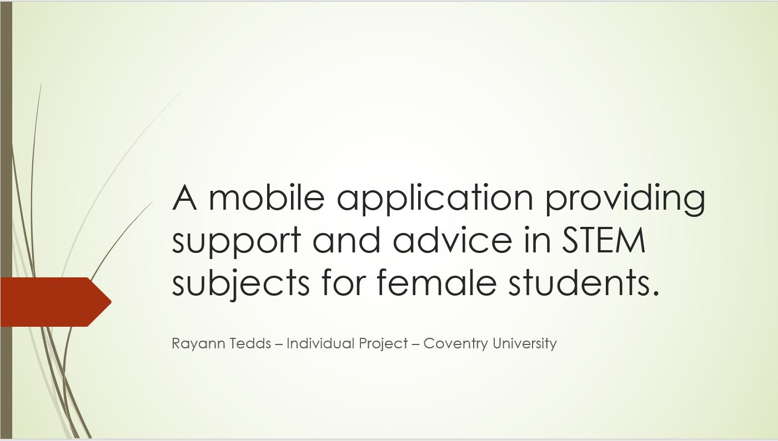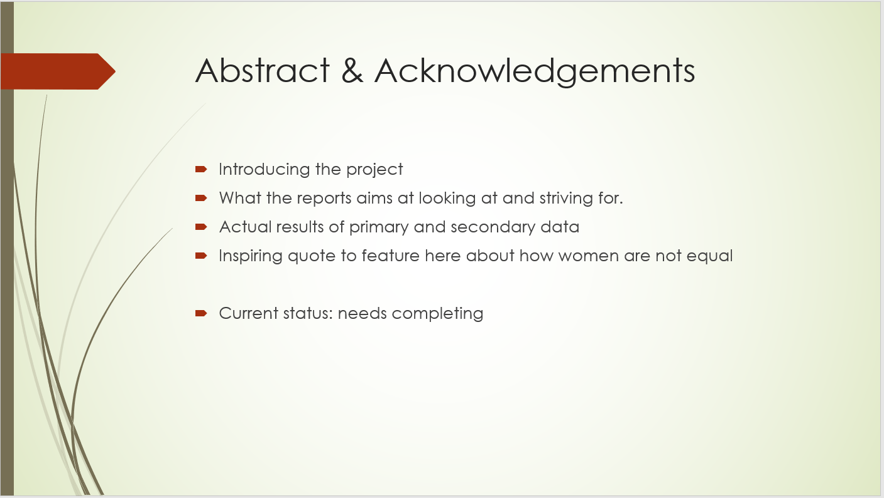

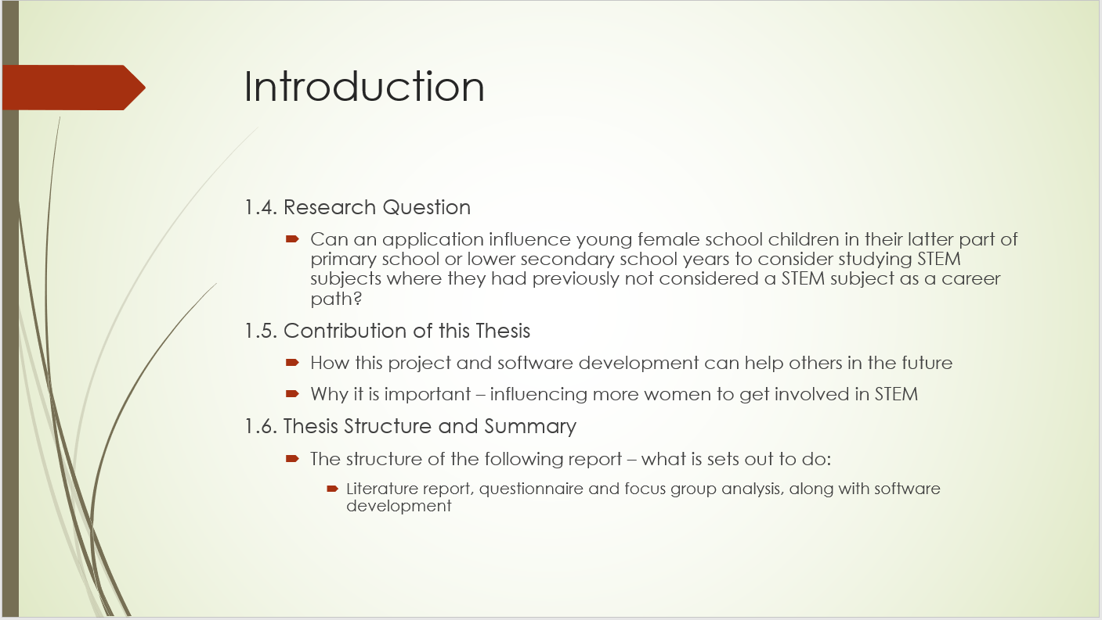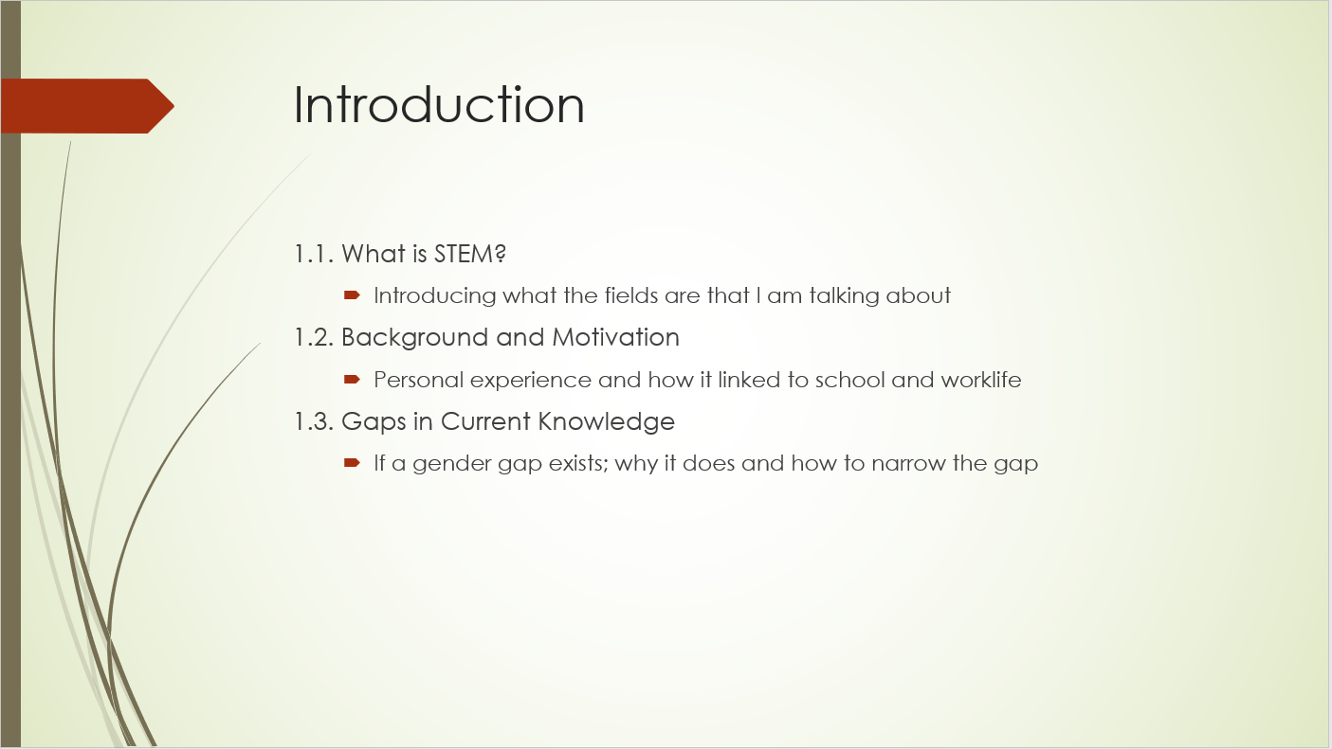

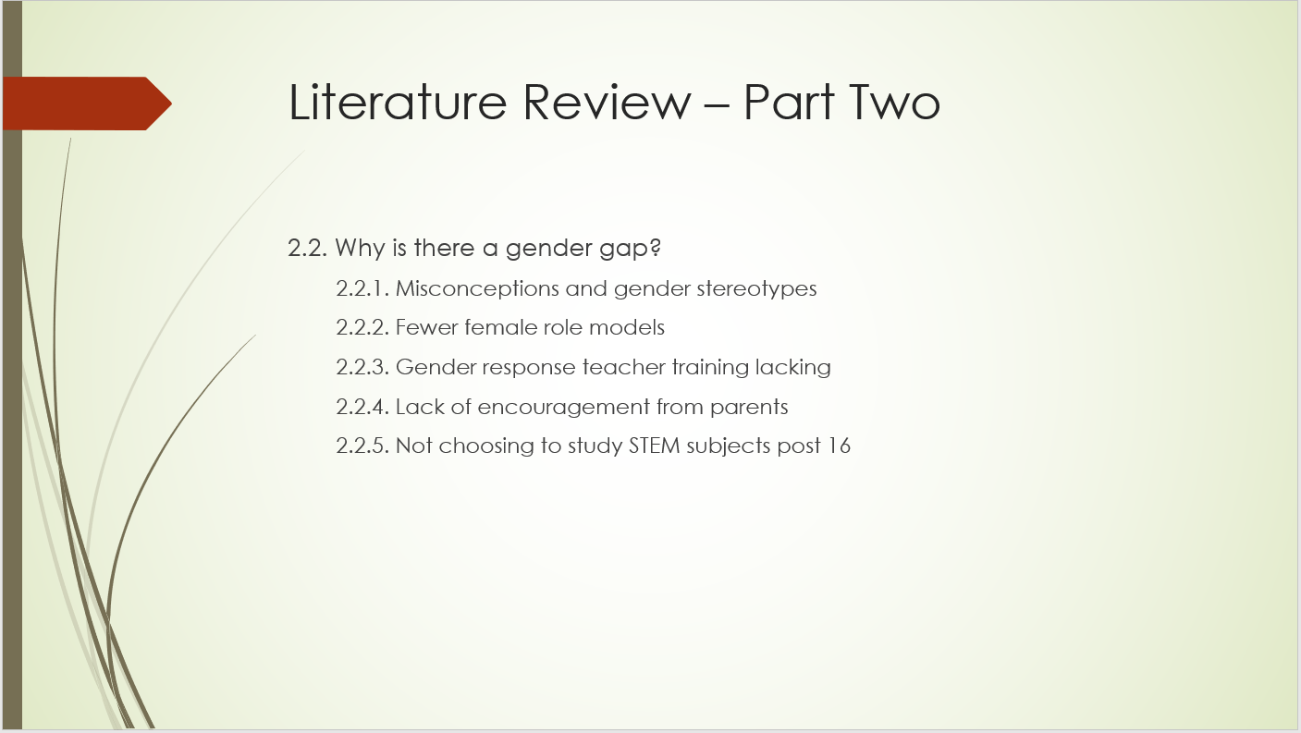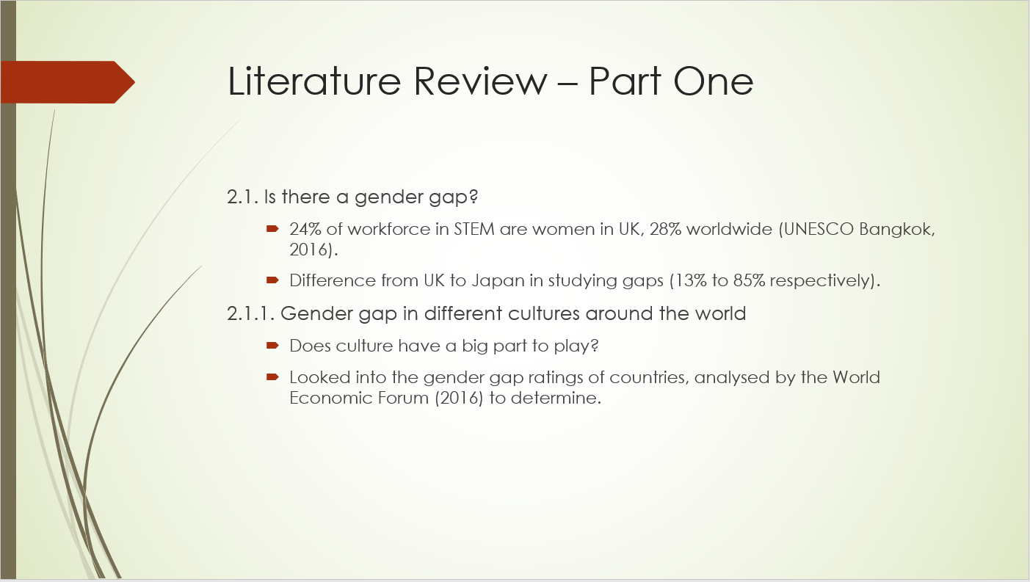

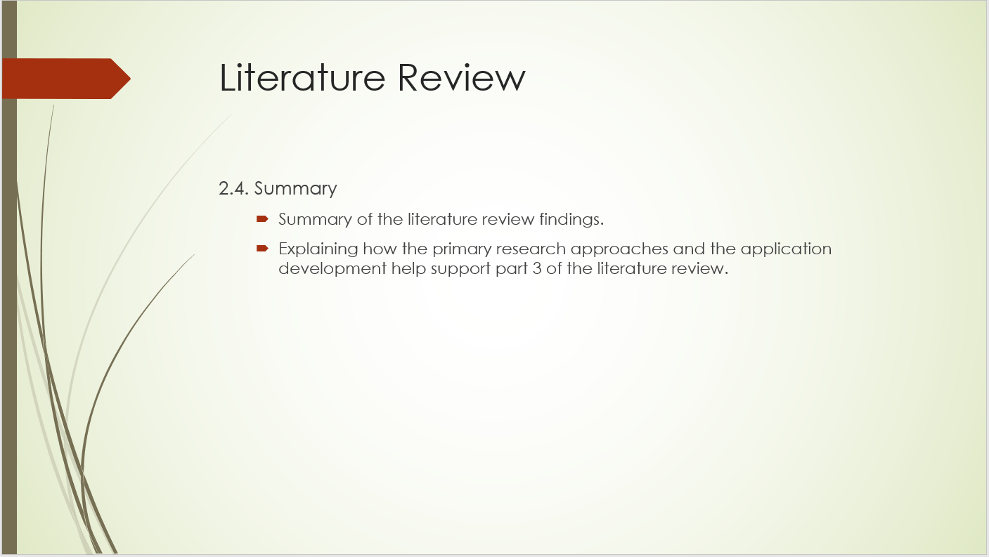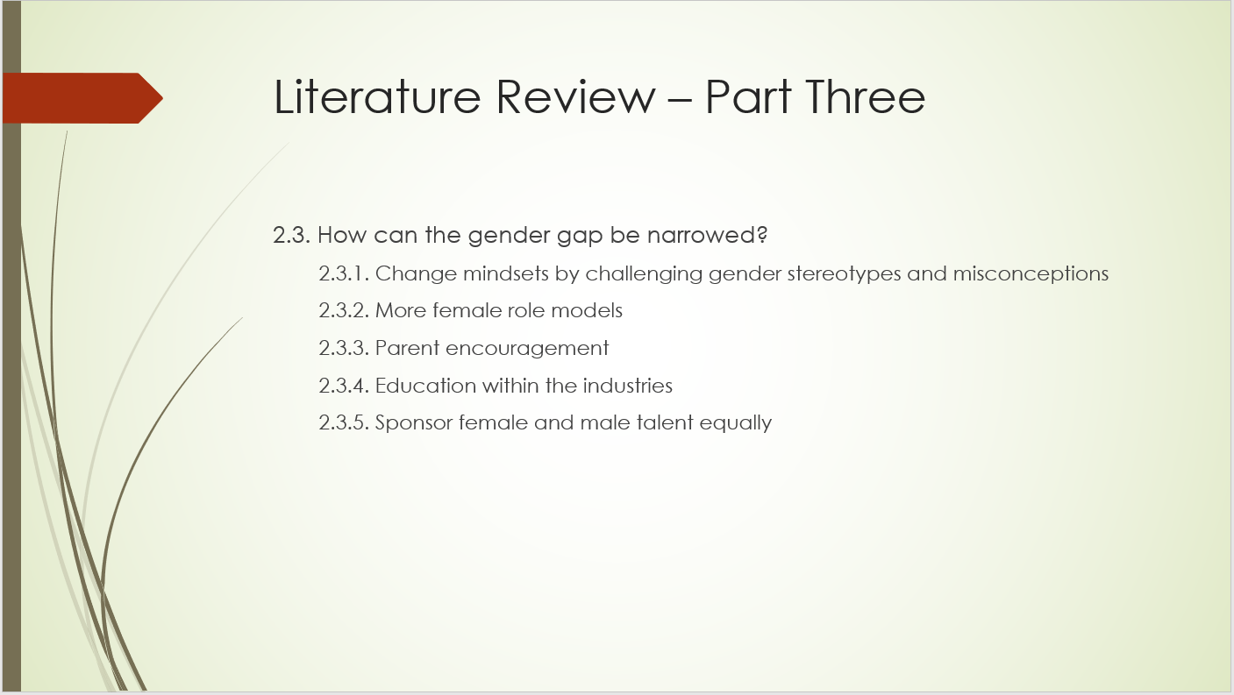

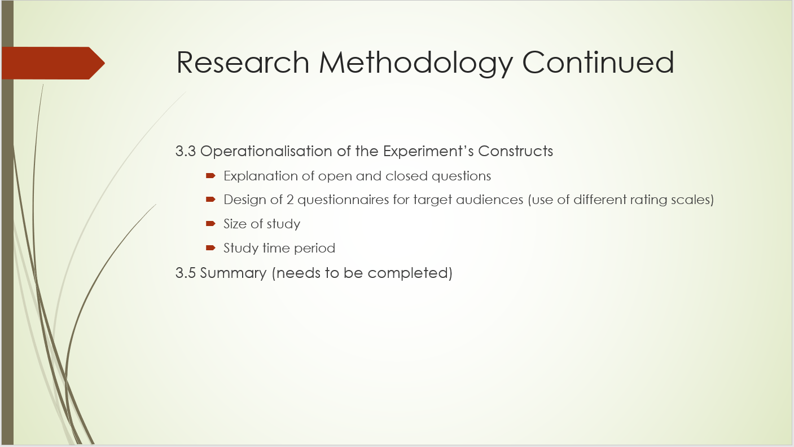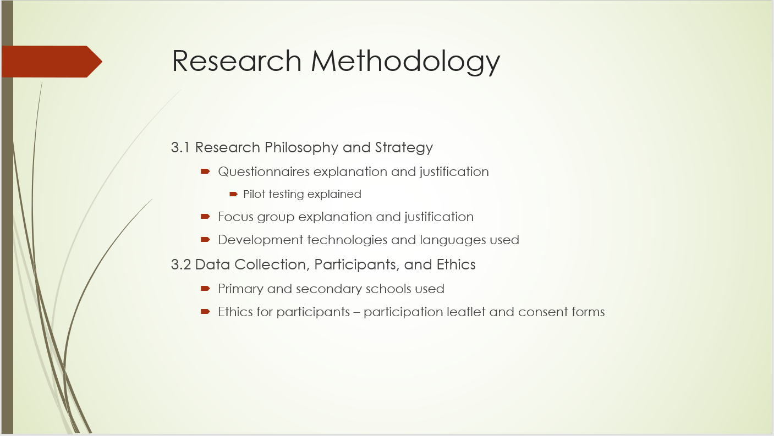

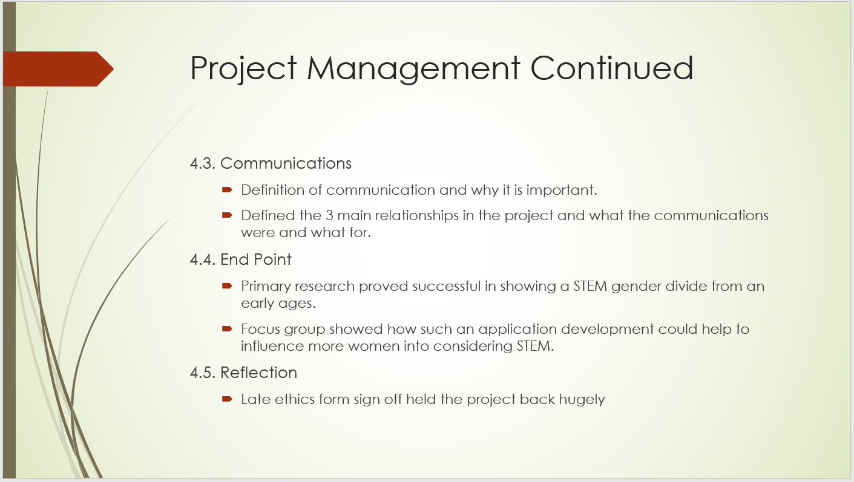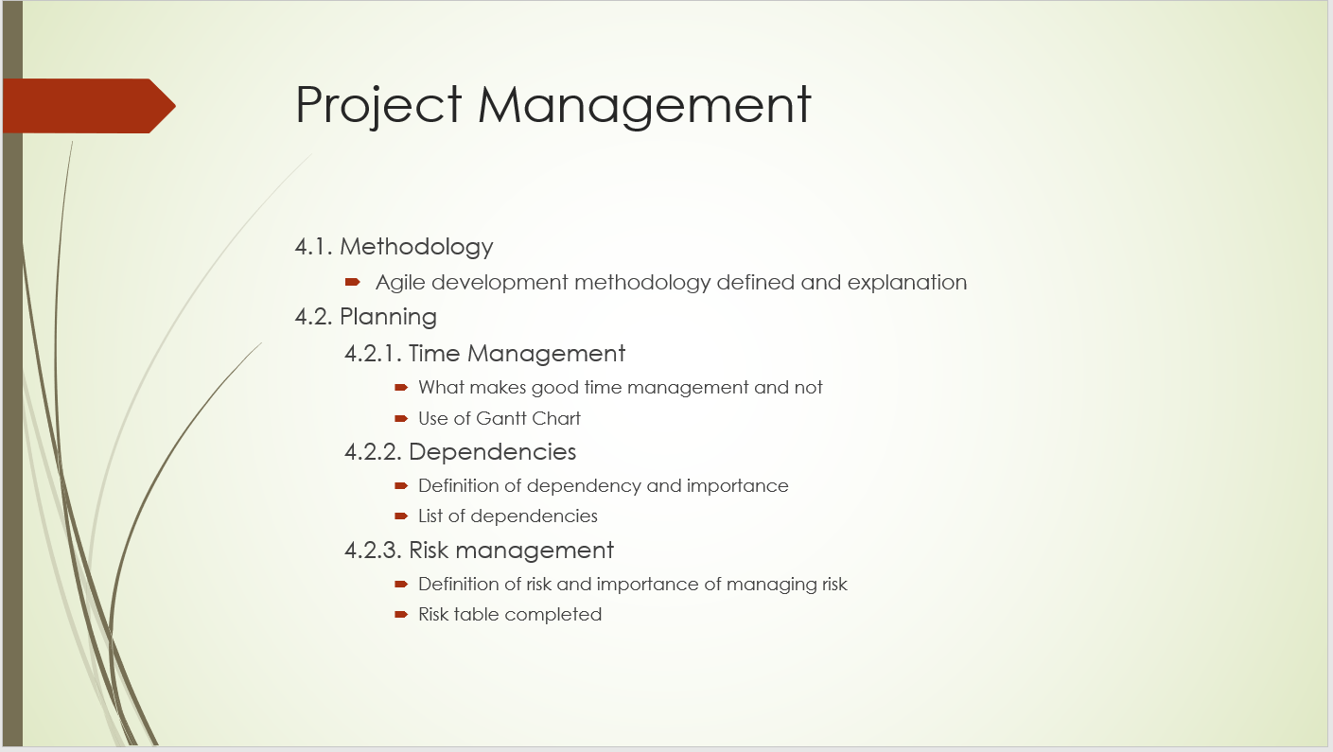

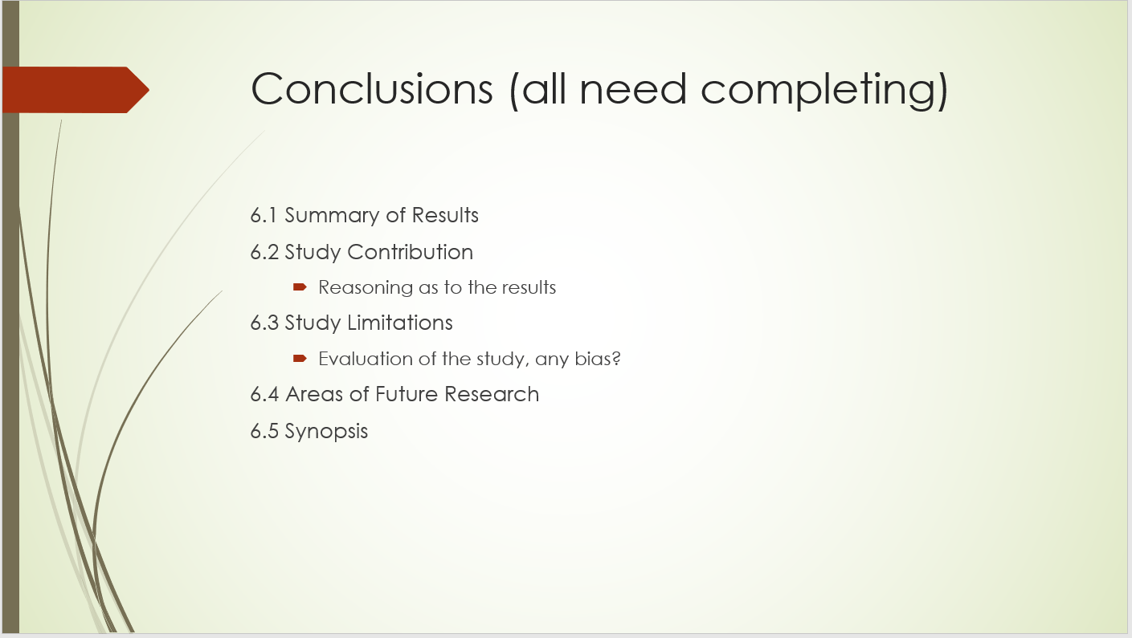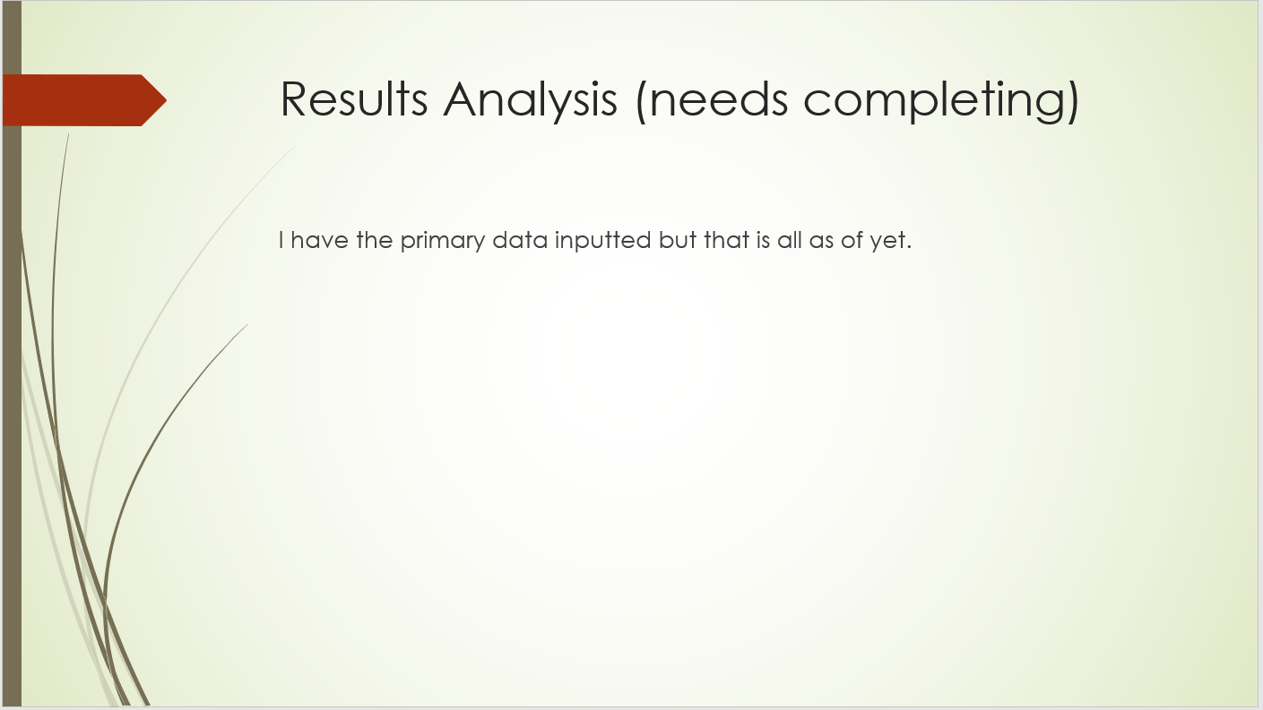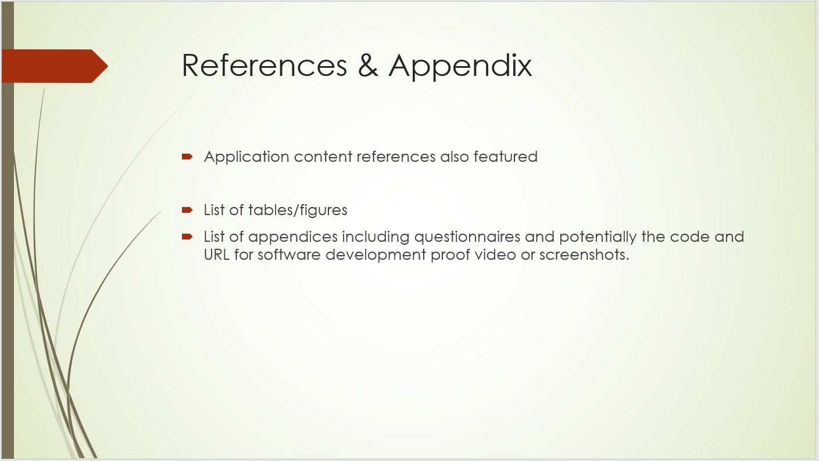

### Appendix G - Wireframes

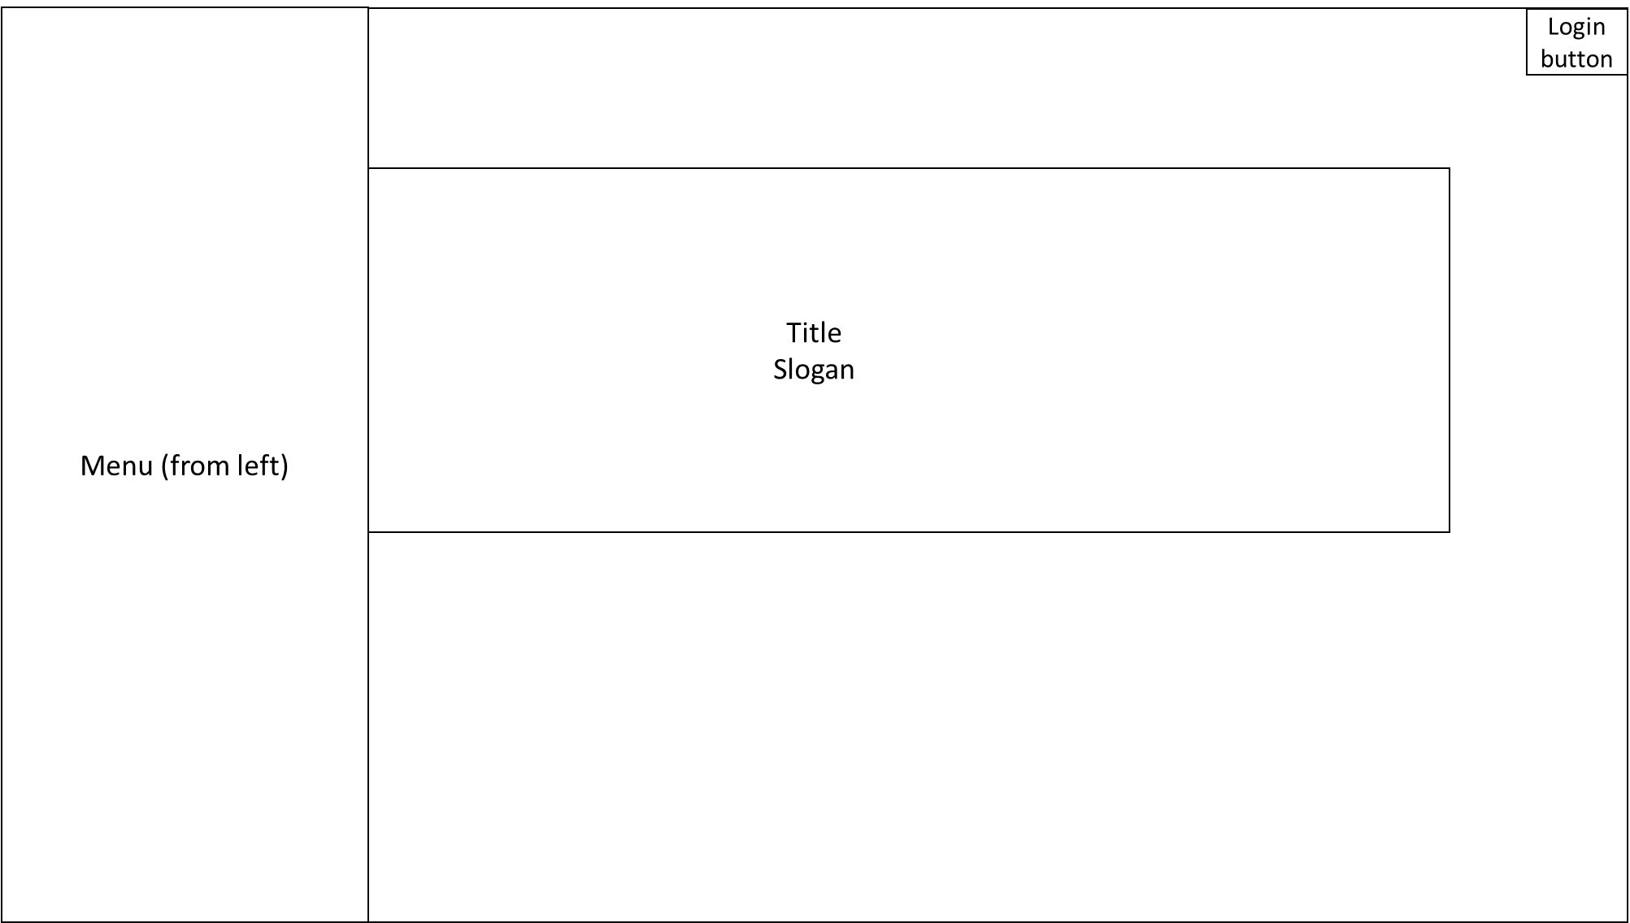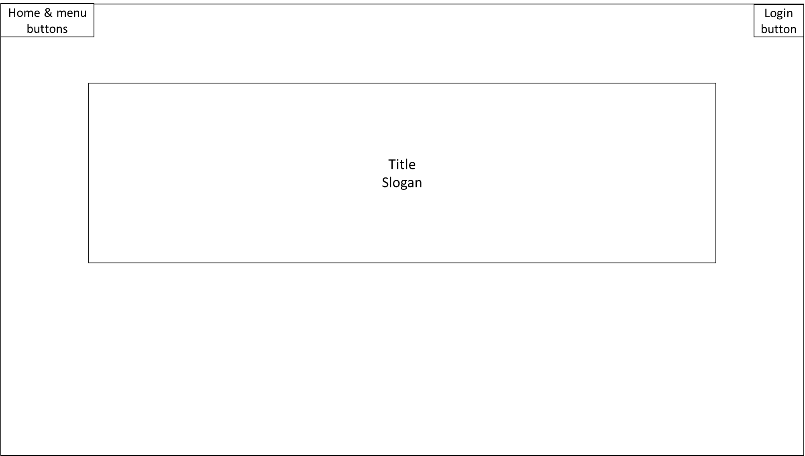

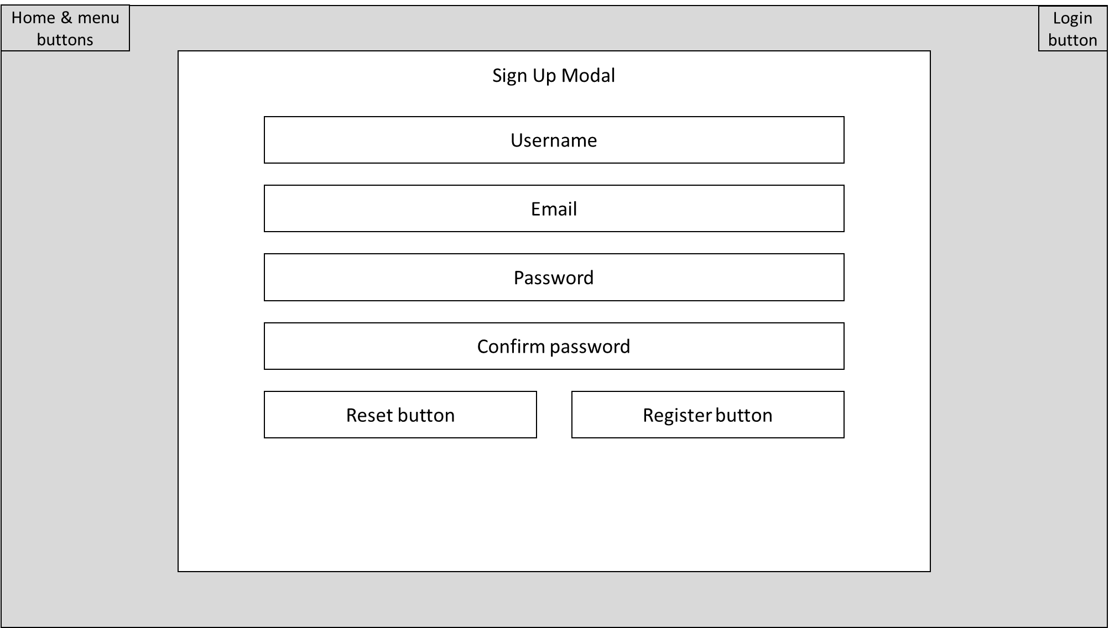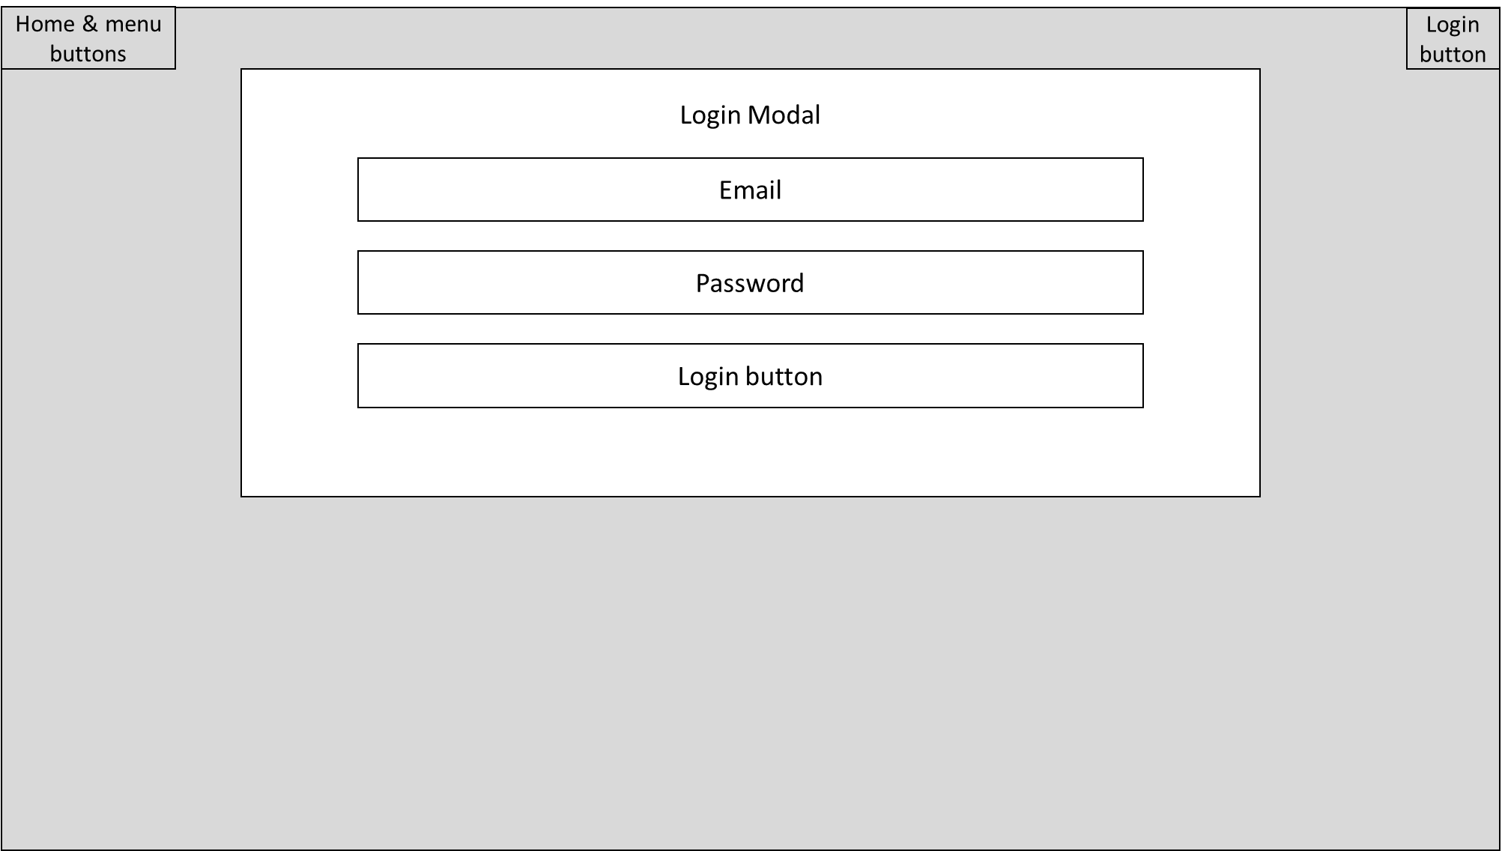

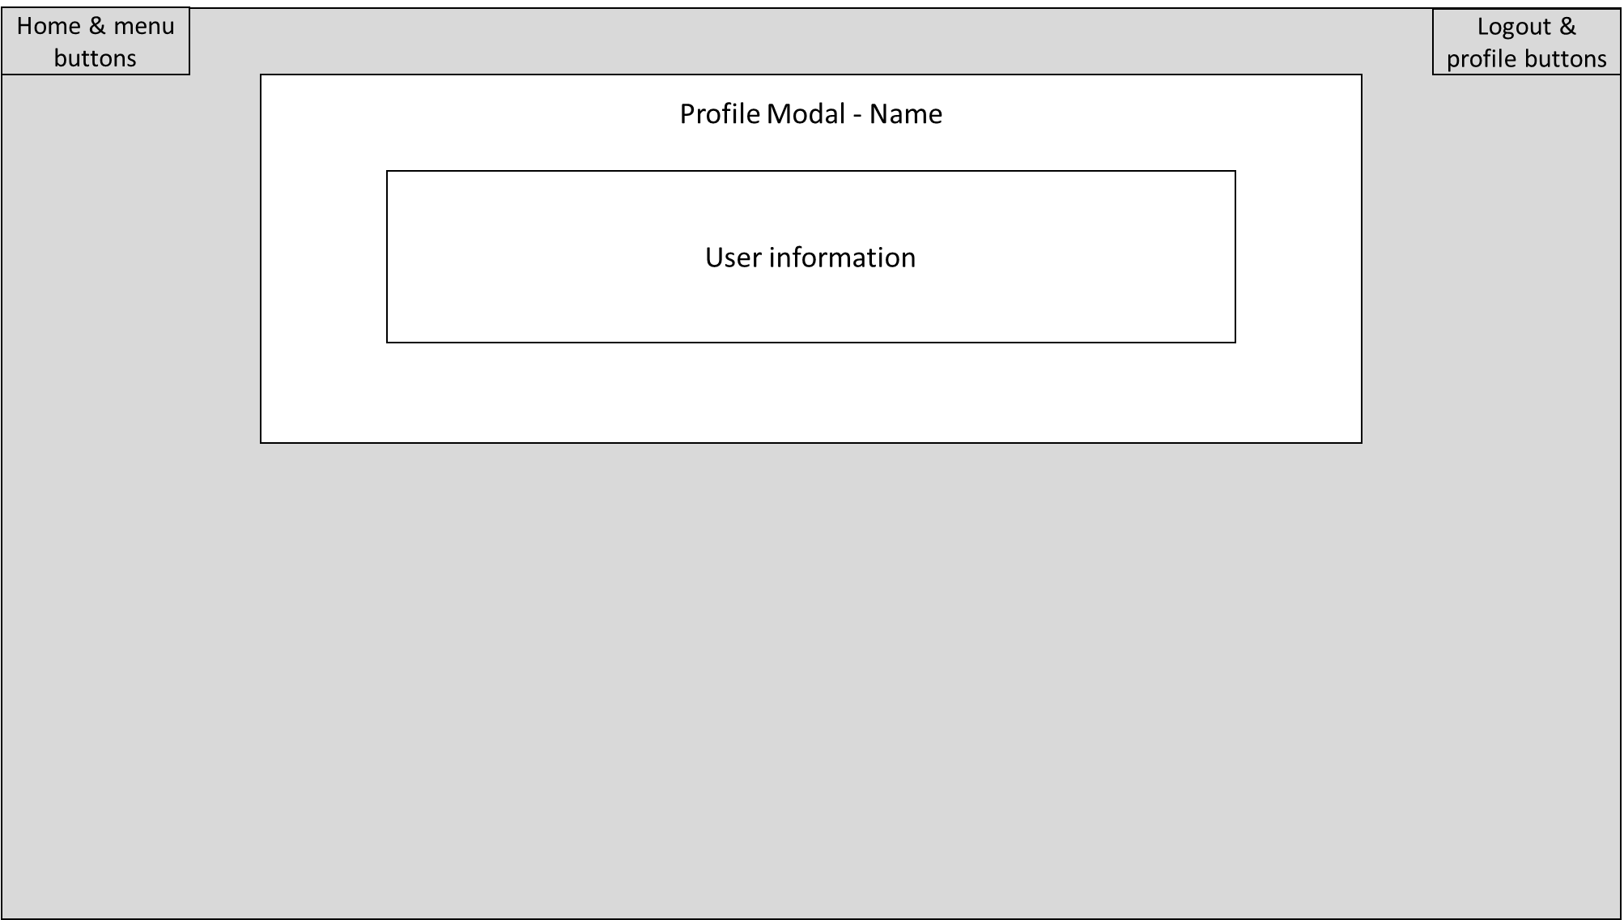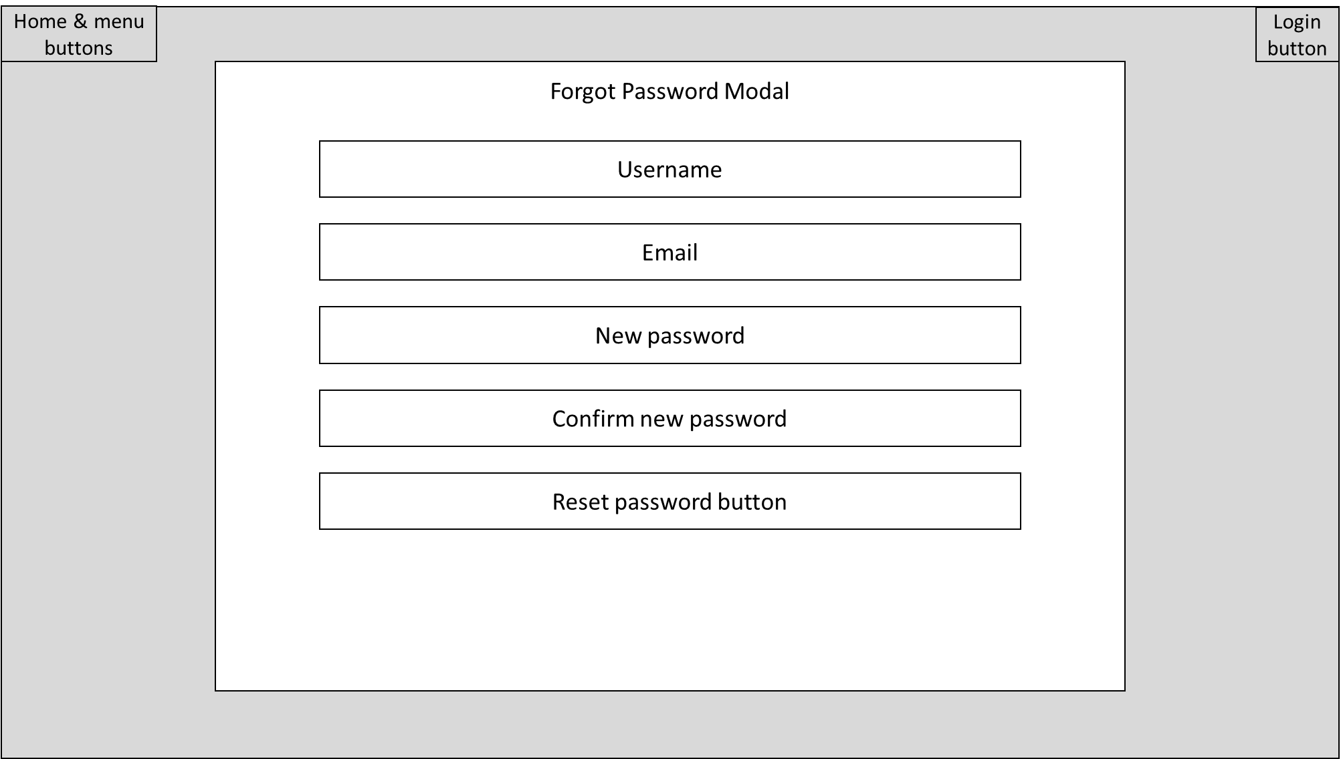

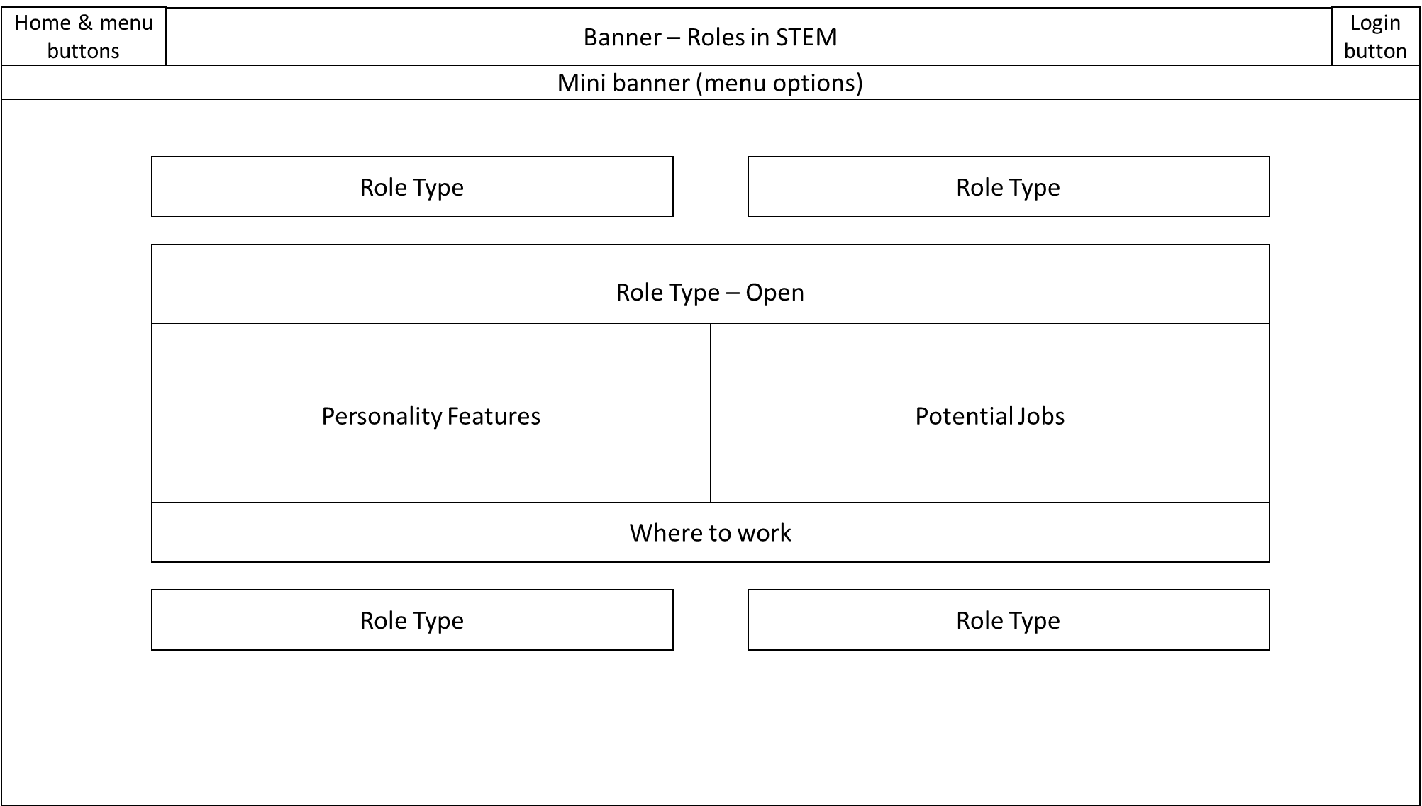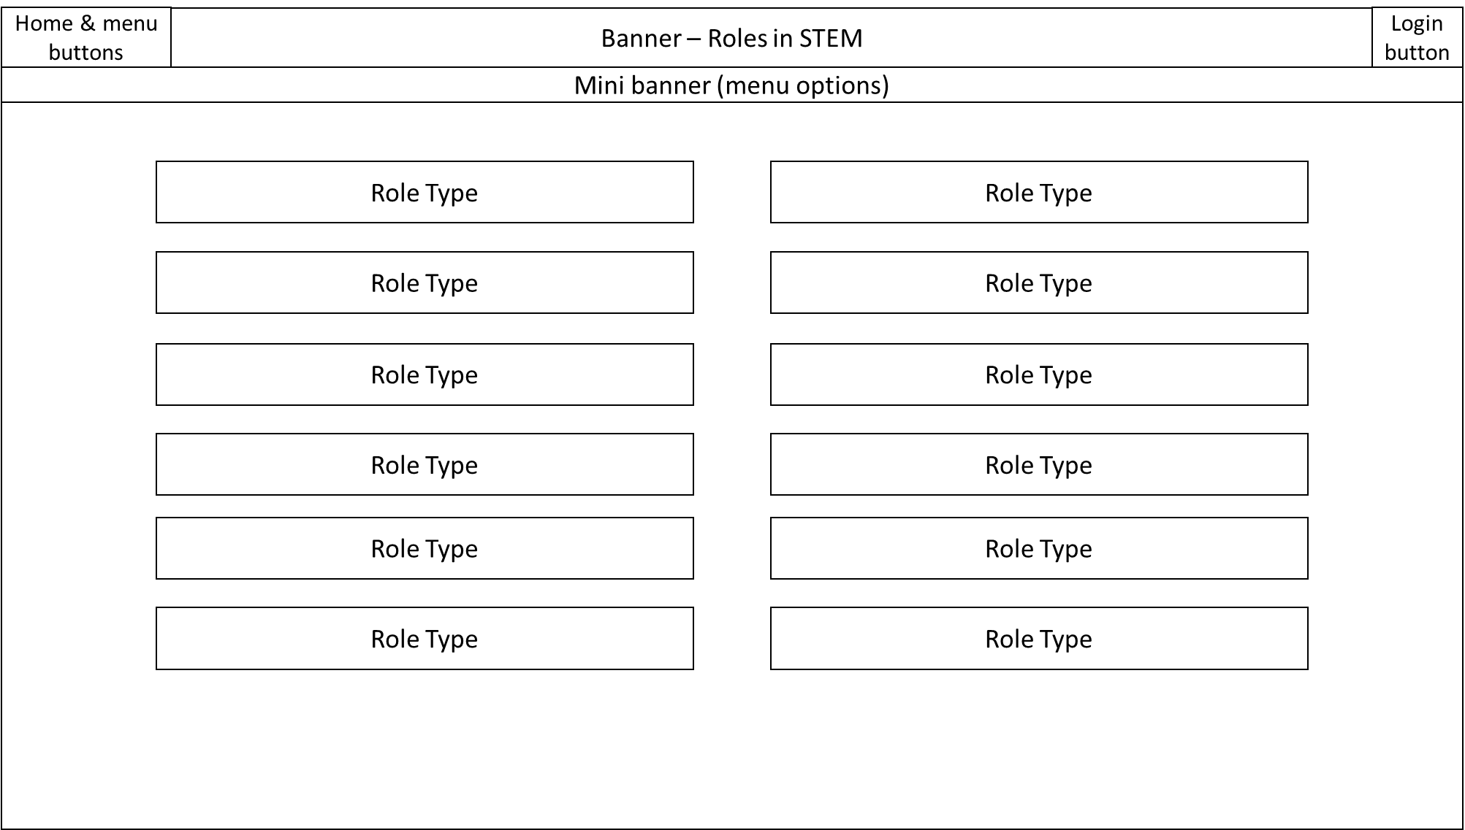

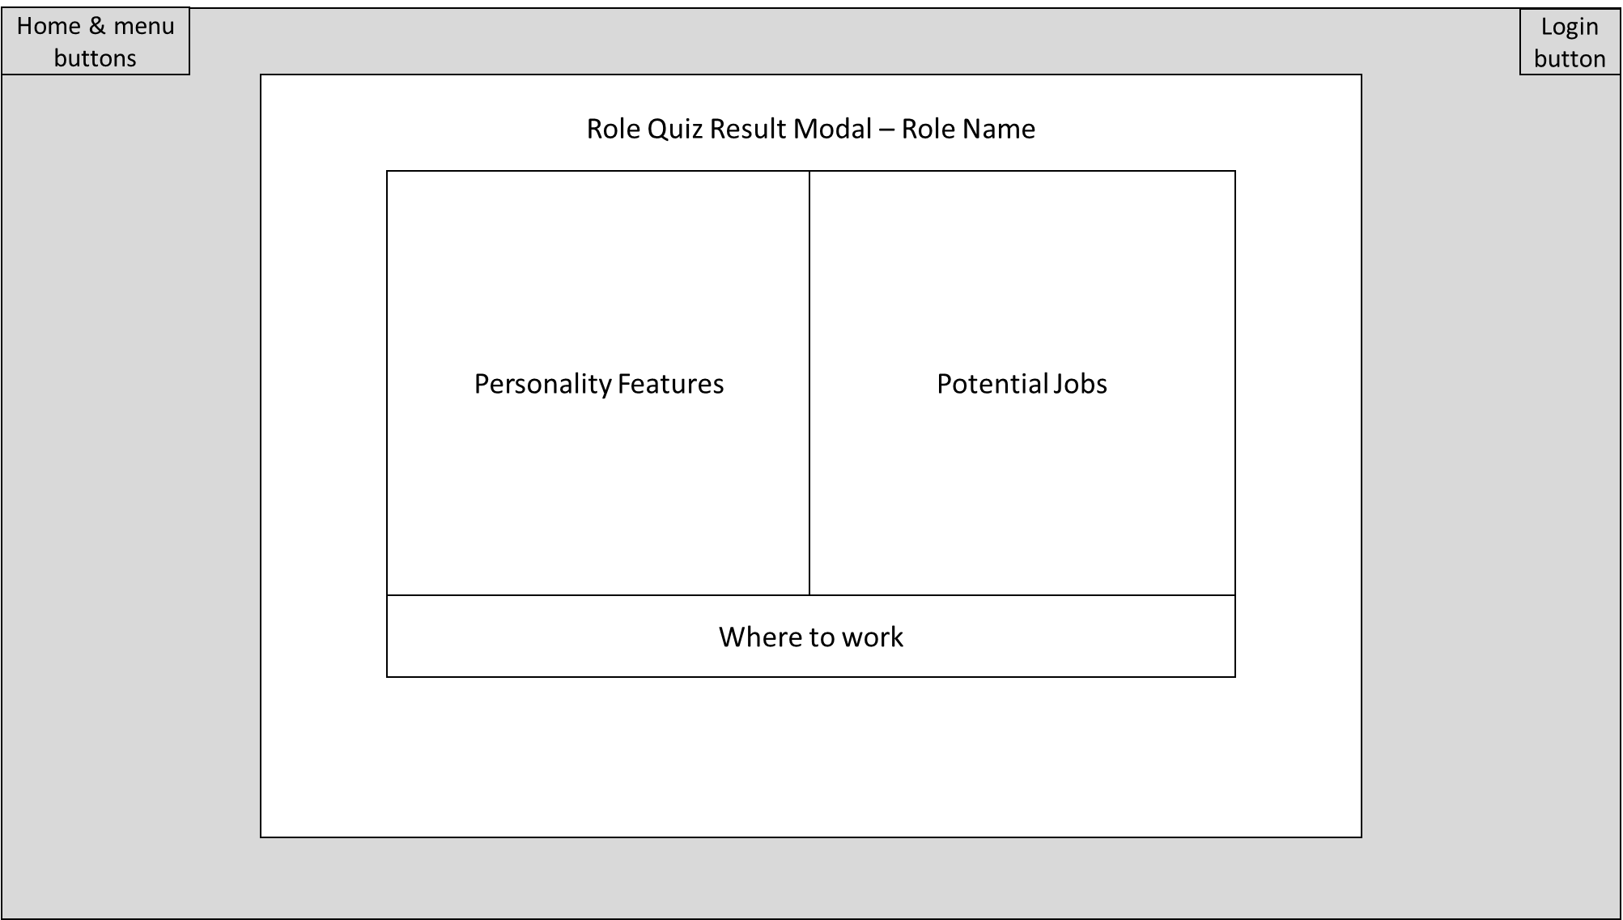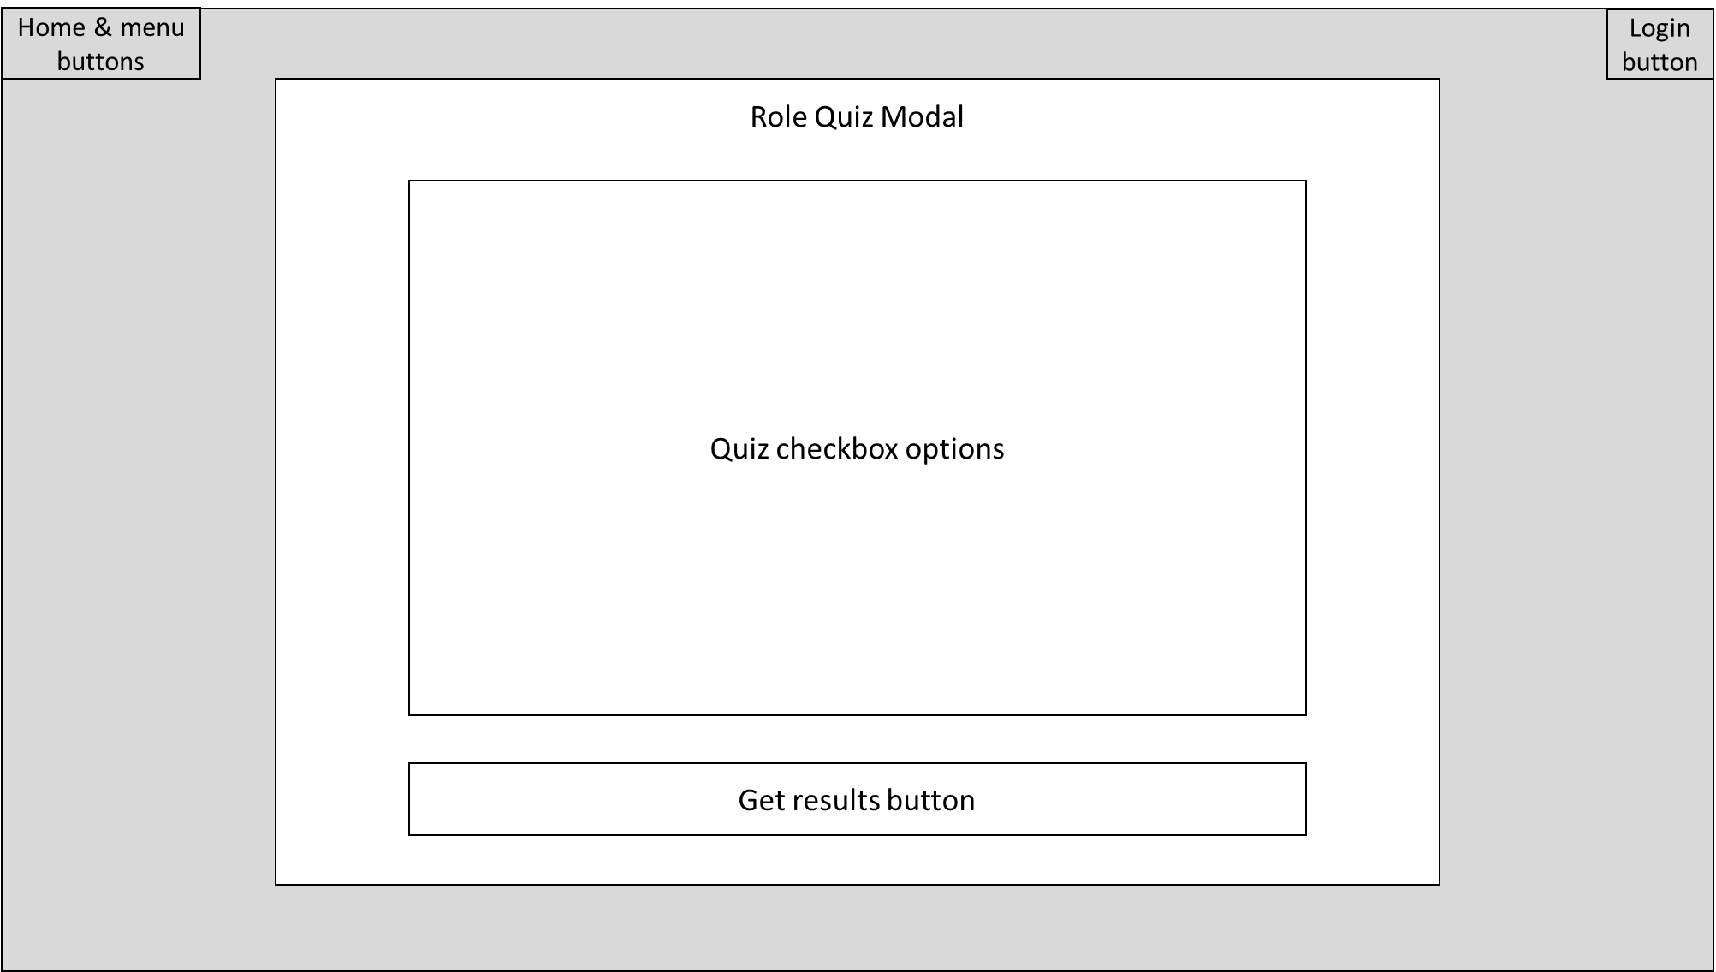

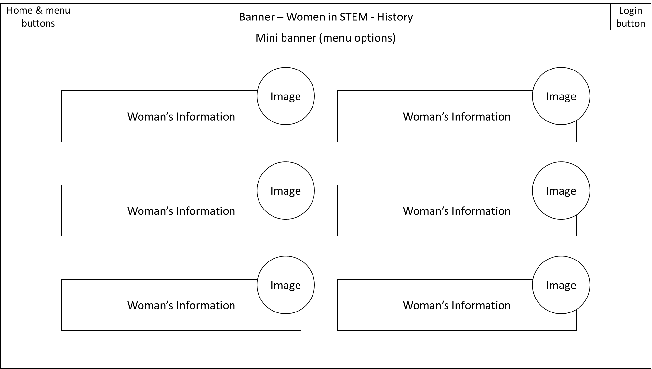

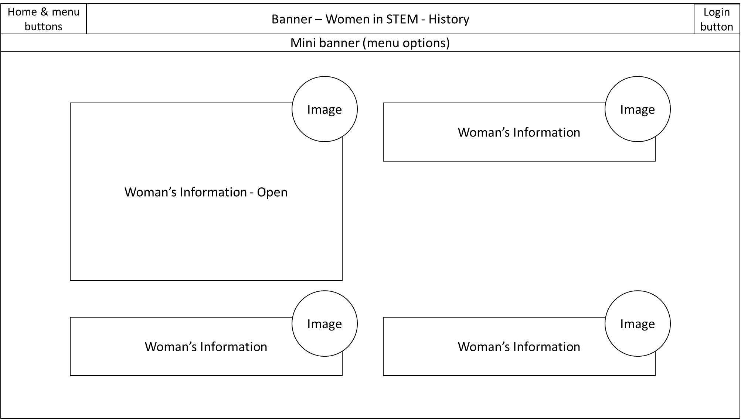

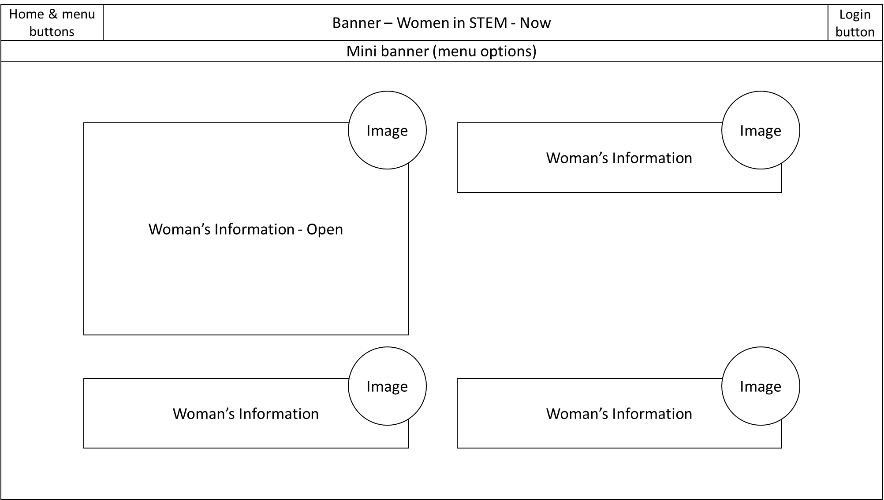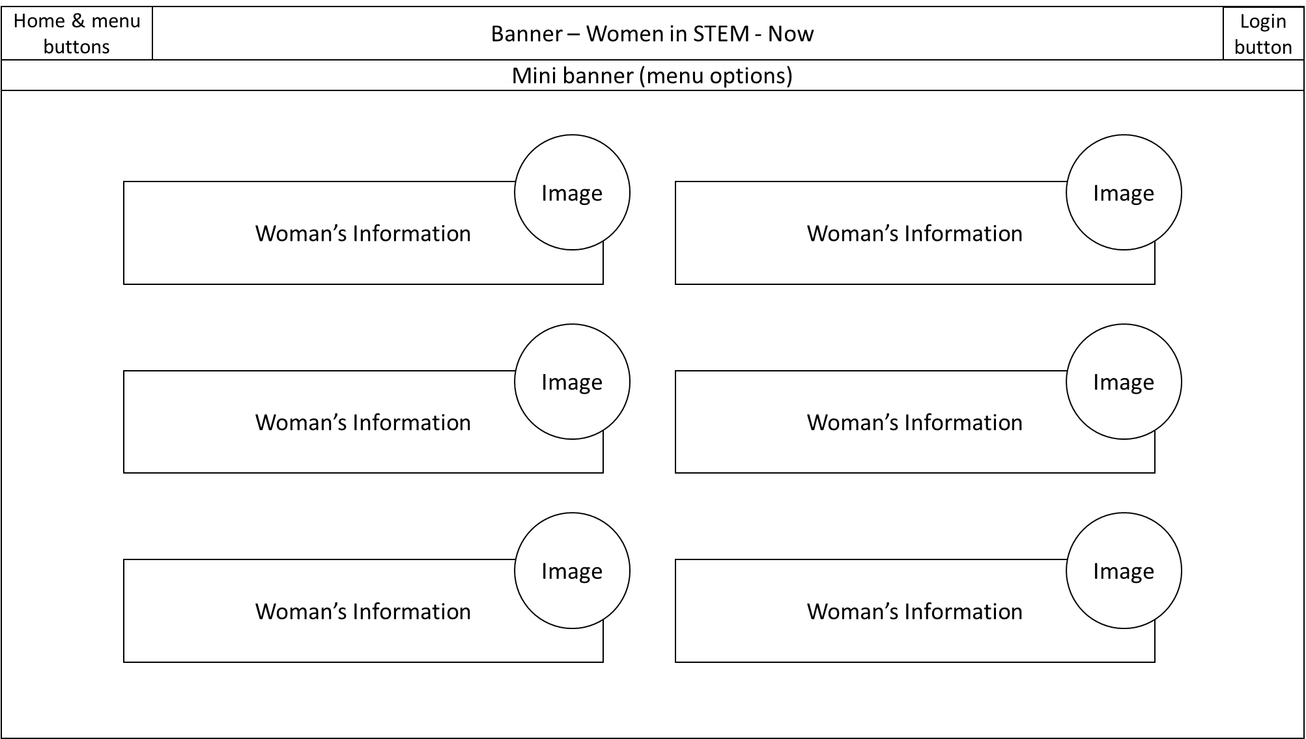

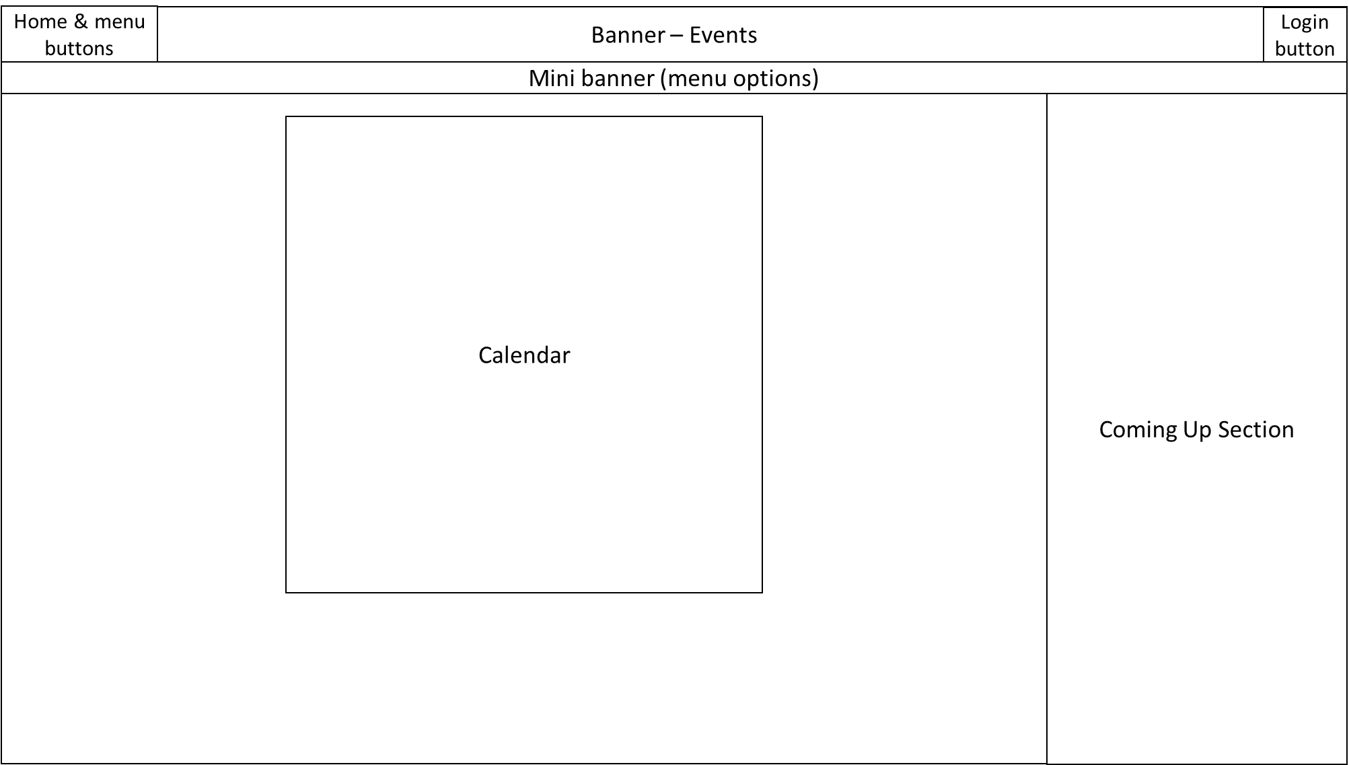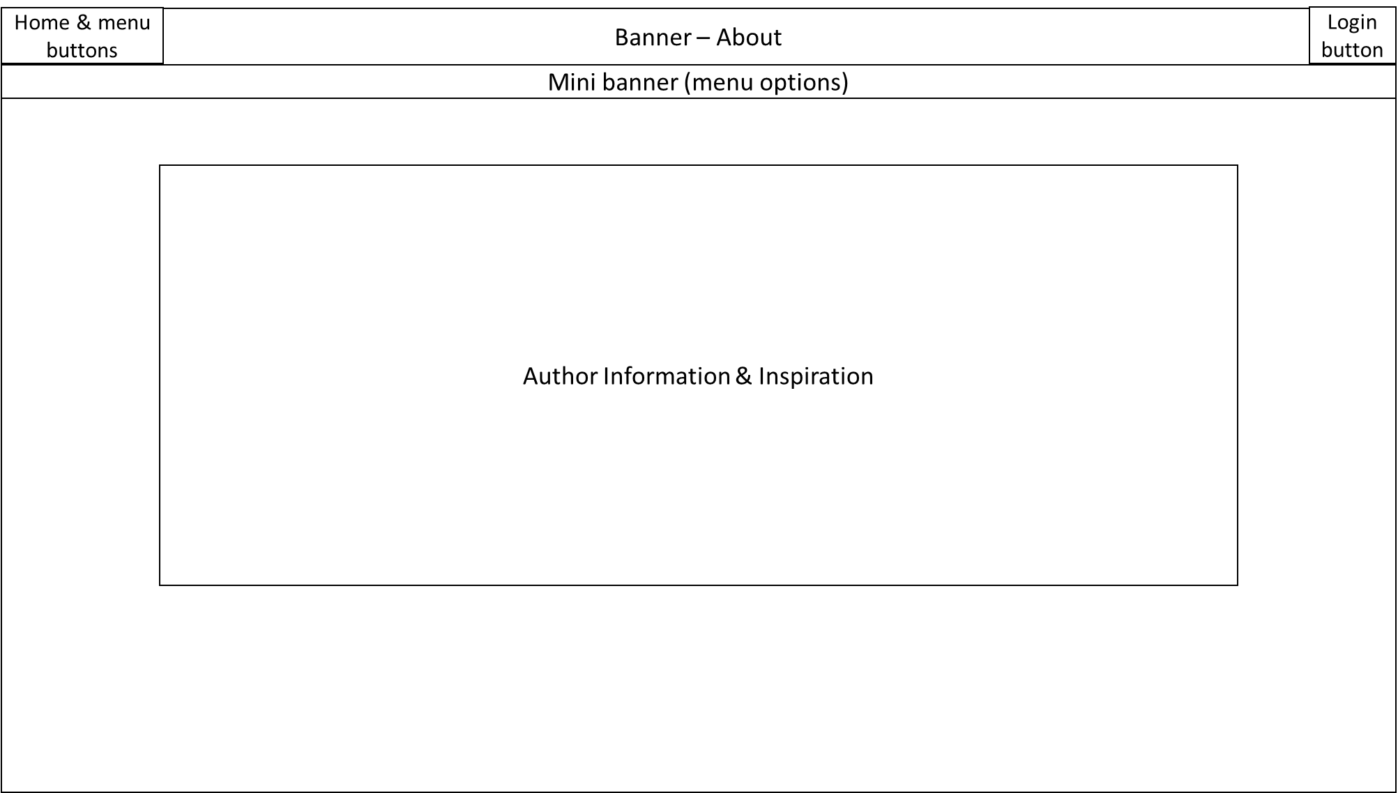

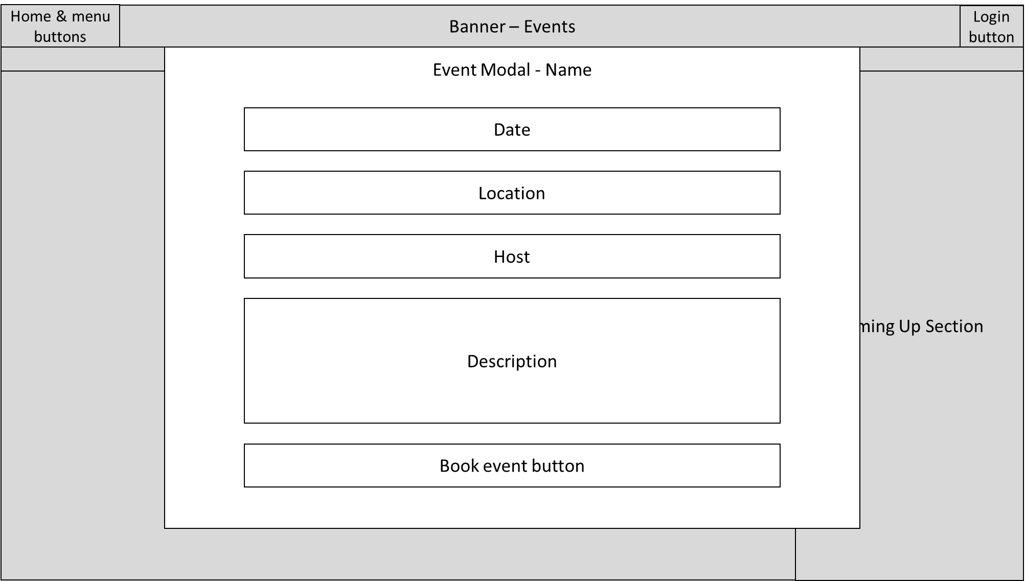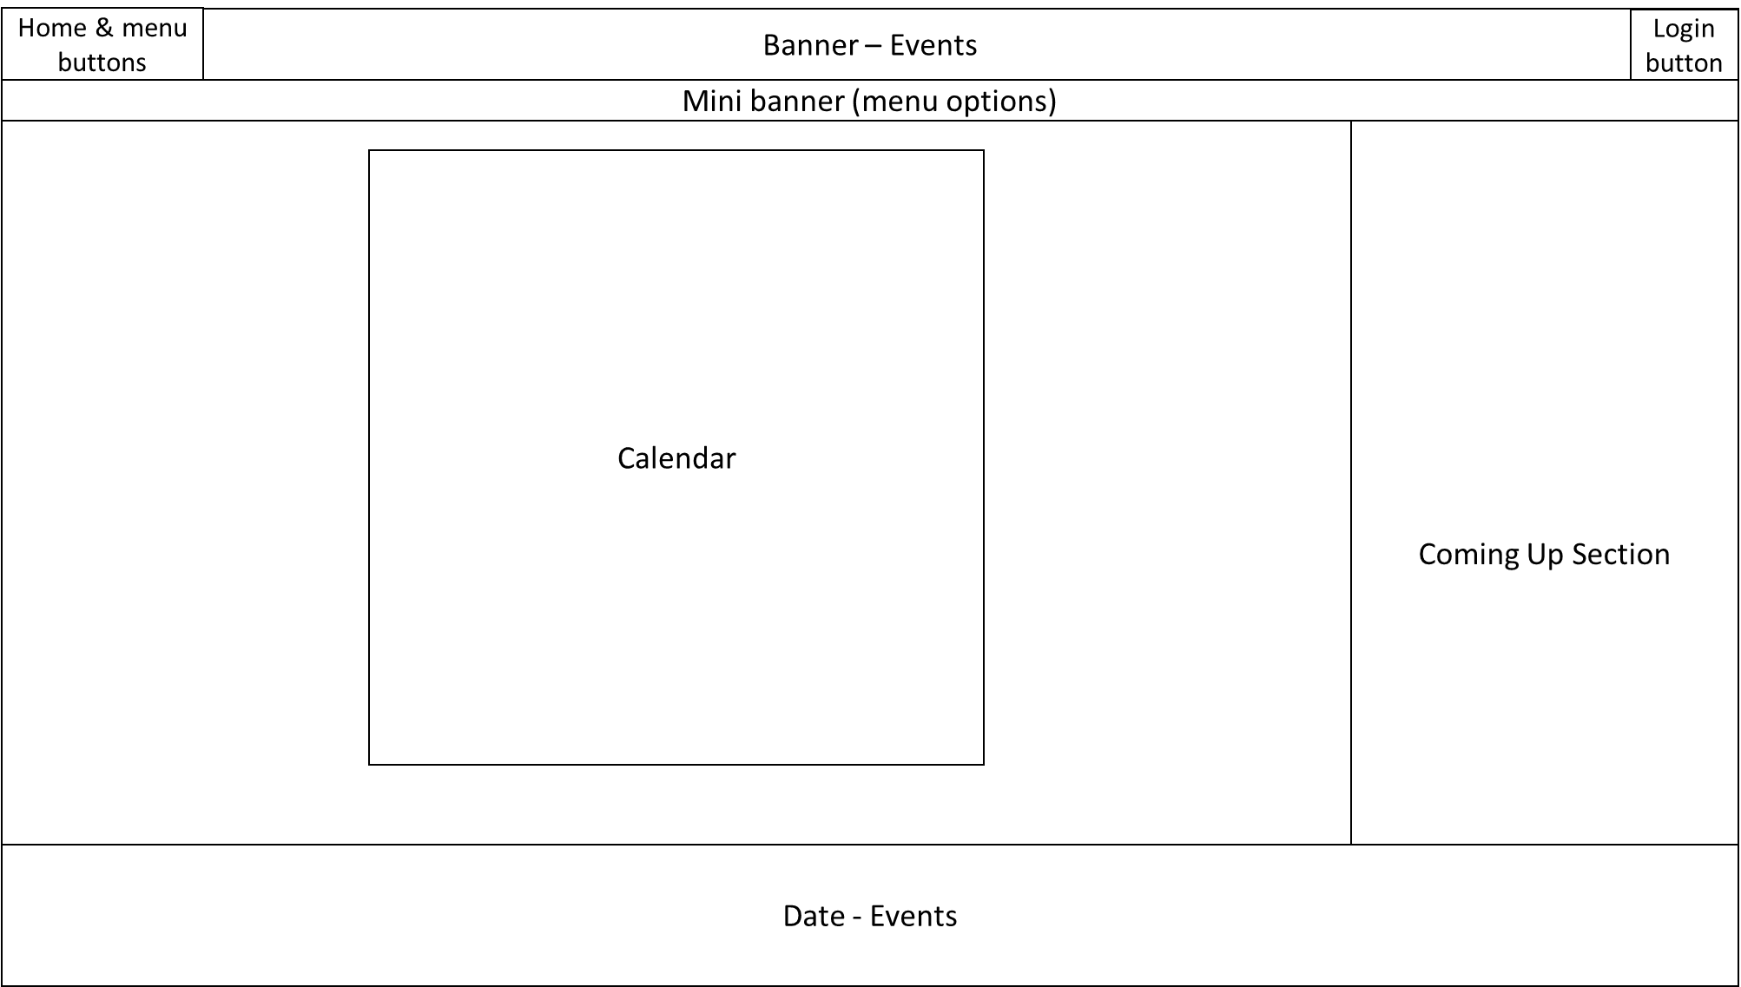

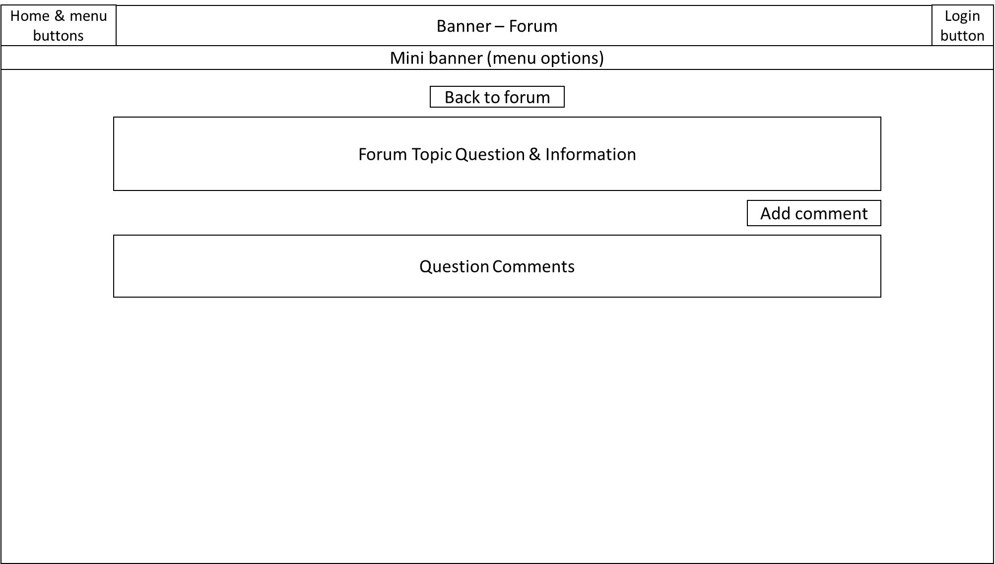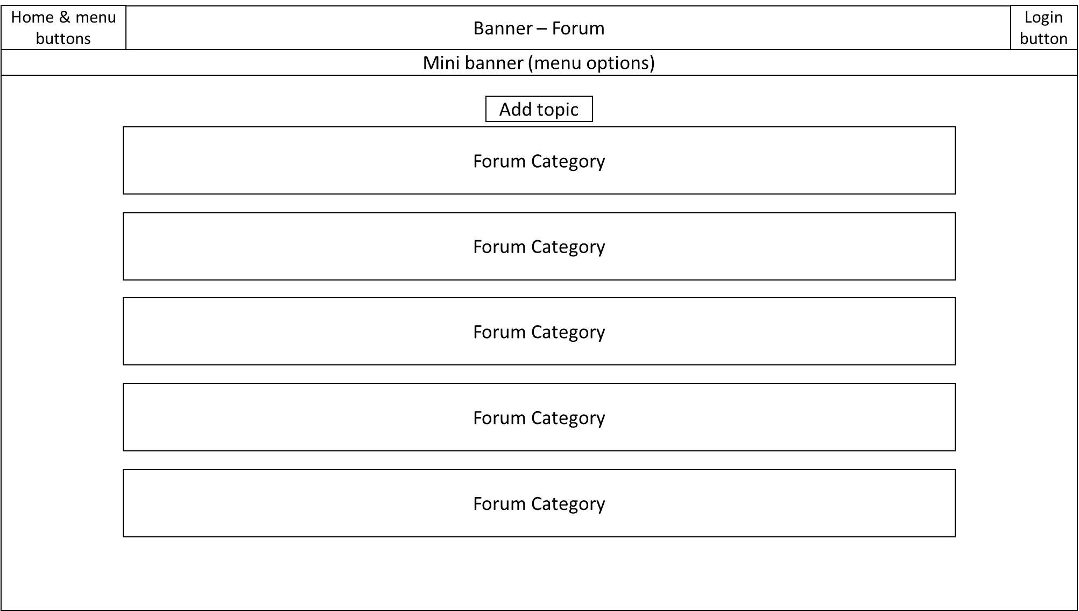

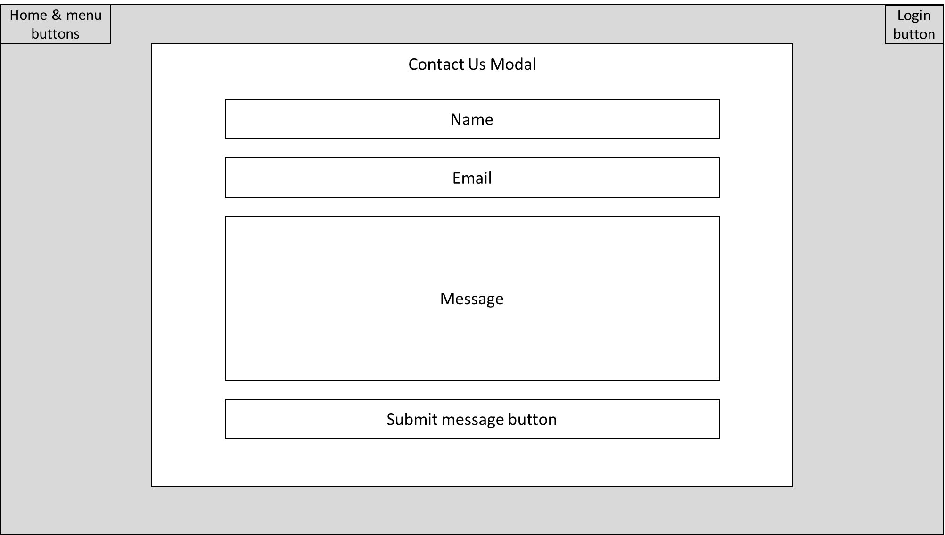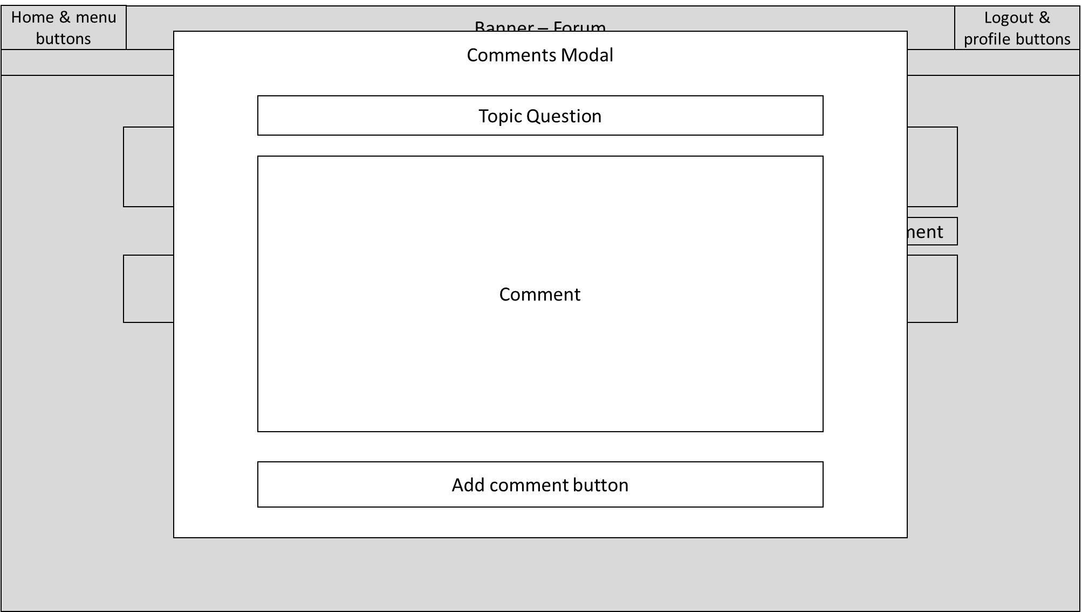

### Appendix H - Application Screenshots

Entire codebase can be found at: <https://github.com/RayannTedds/individualproject>



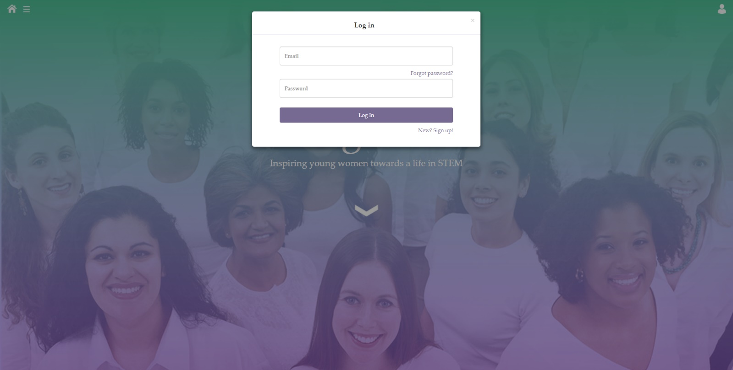



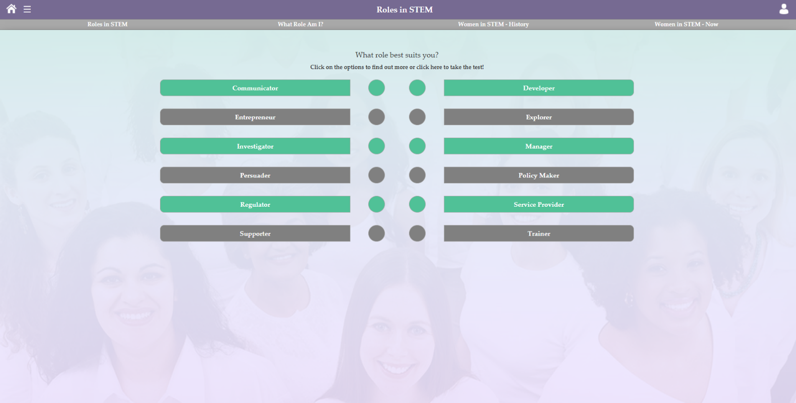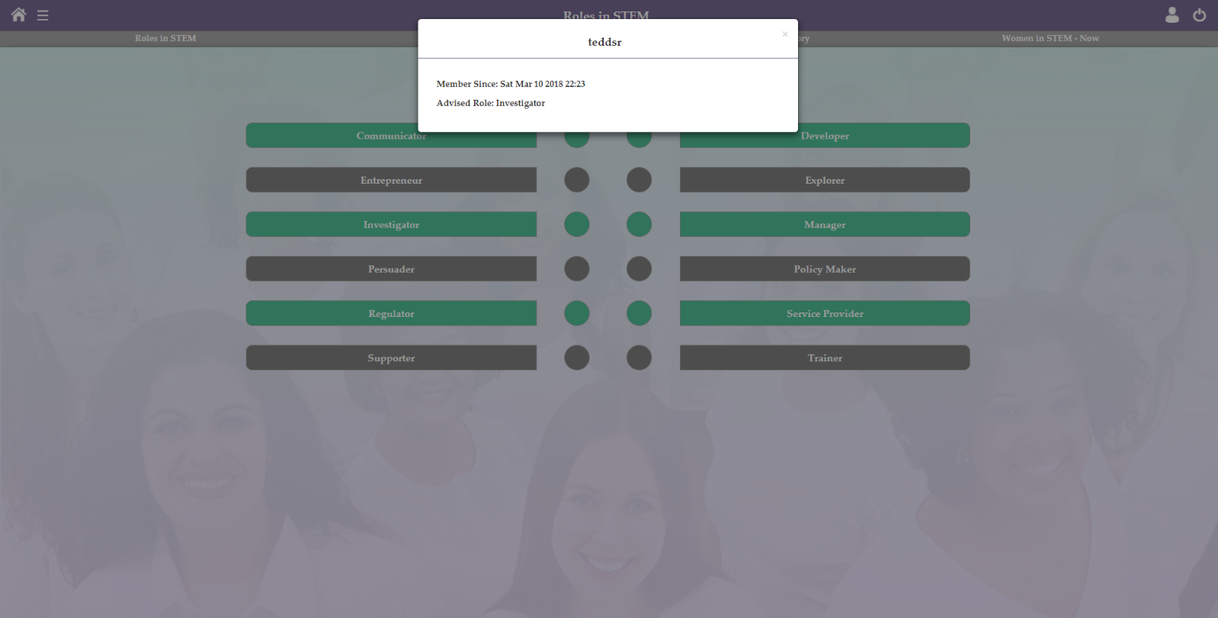

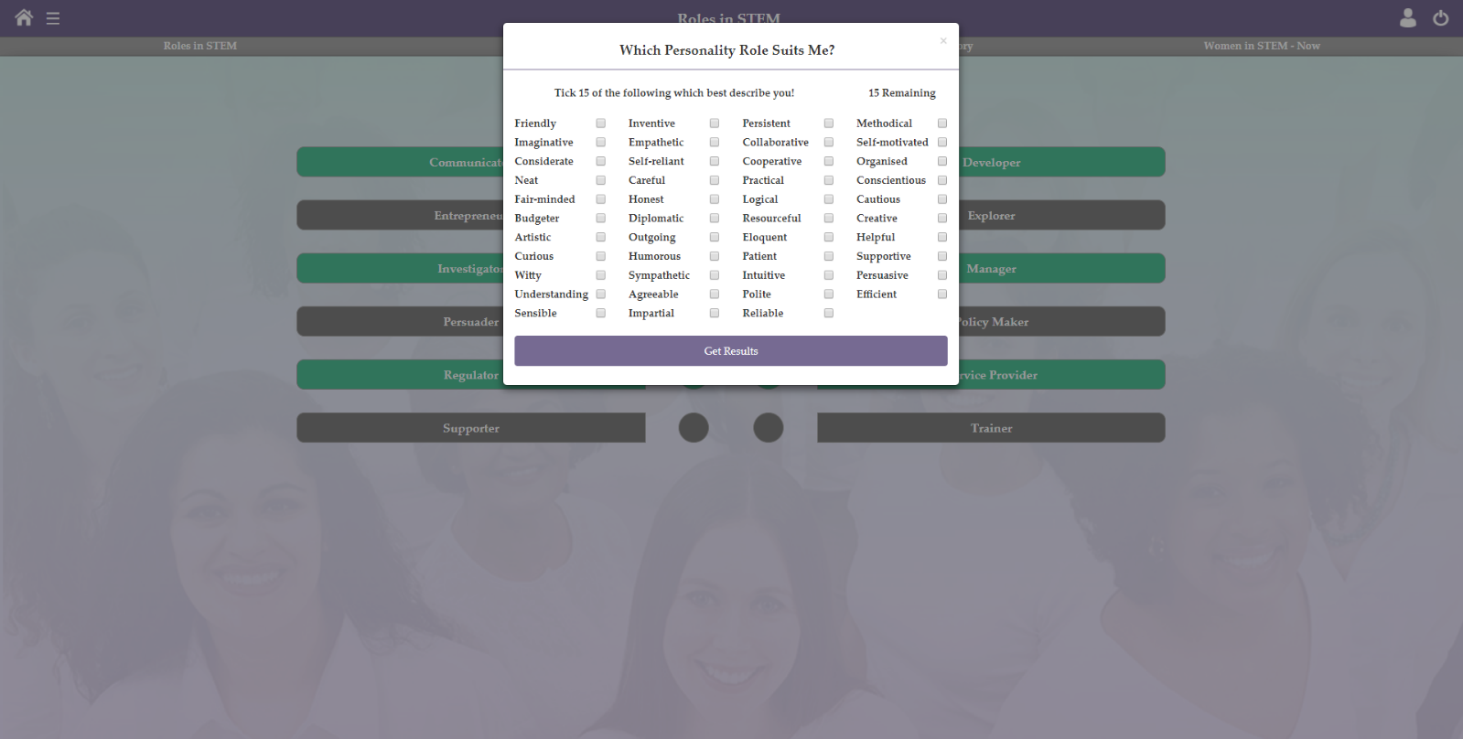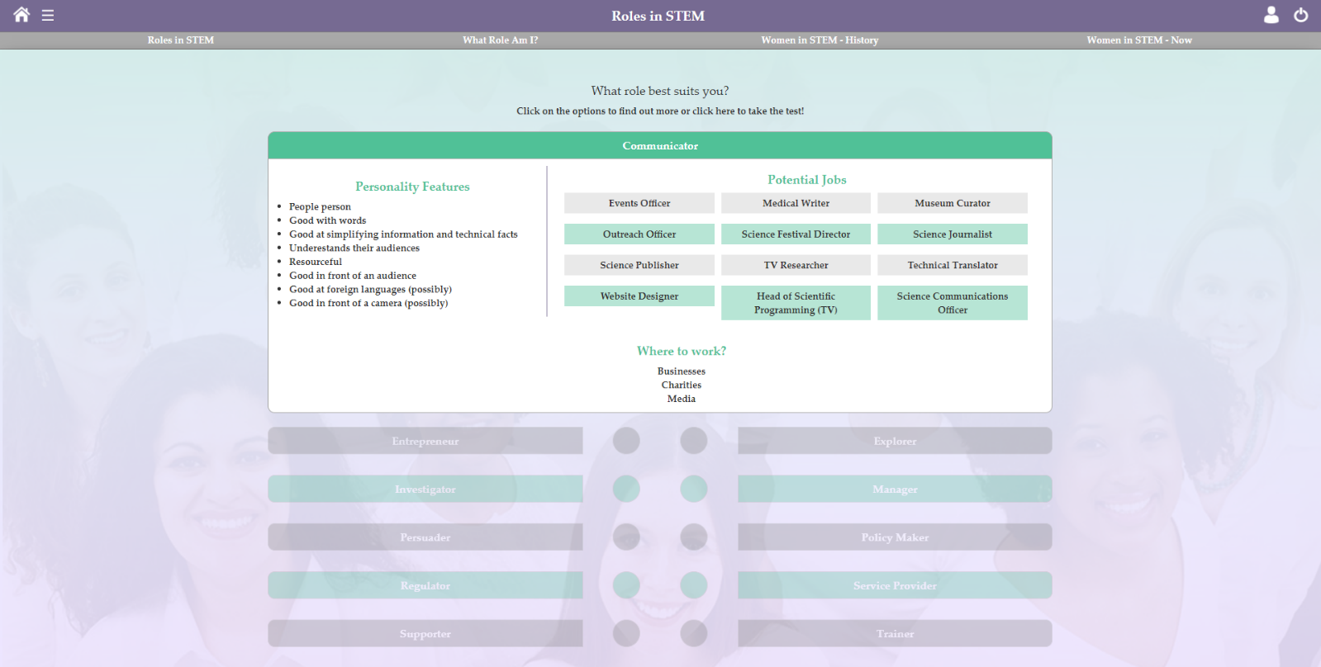

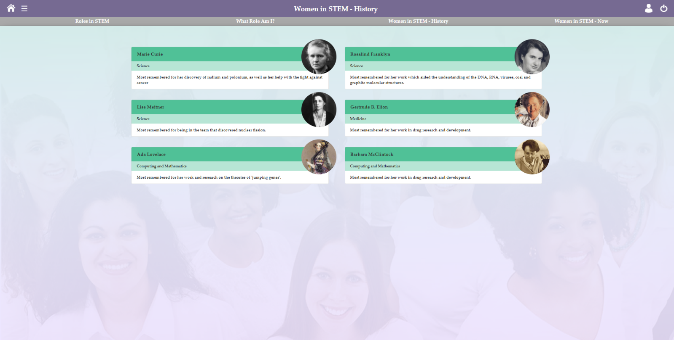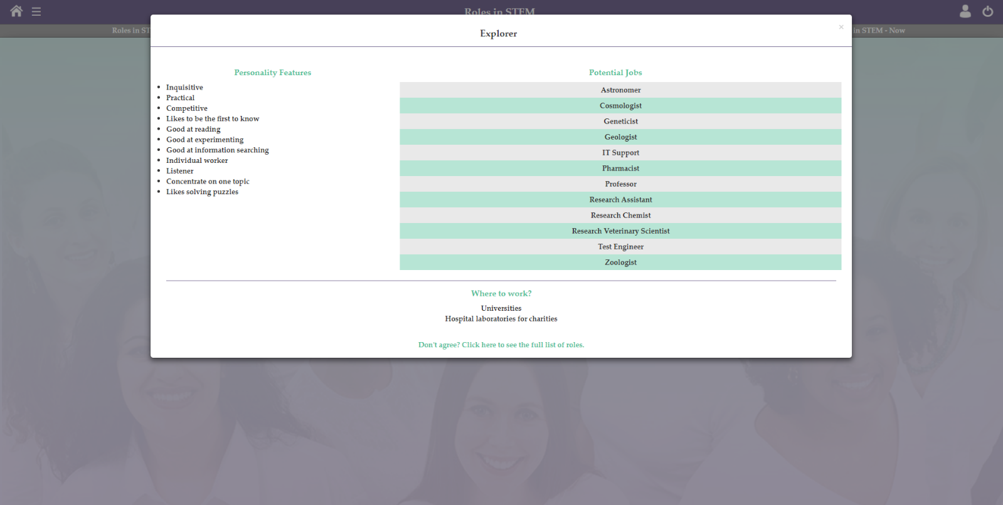

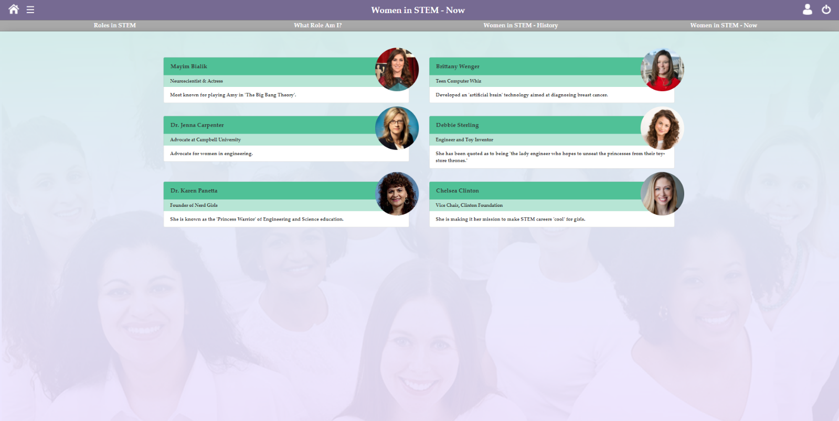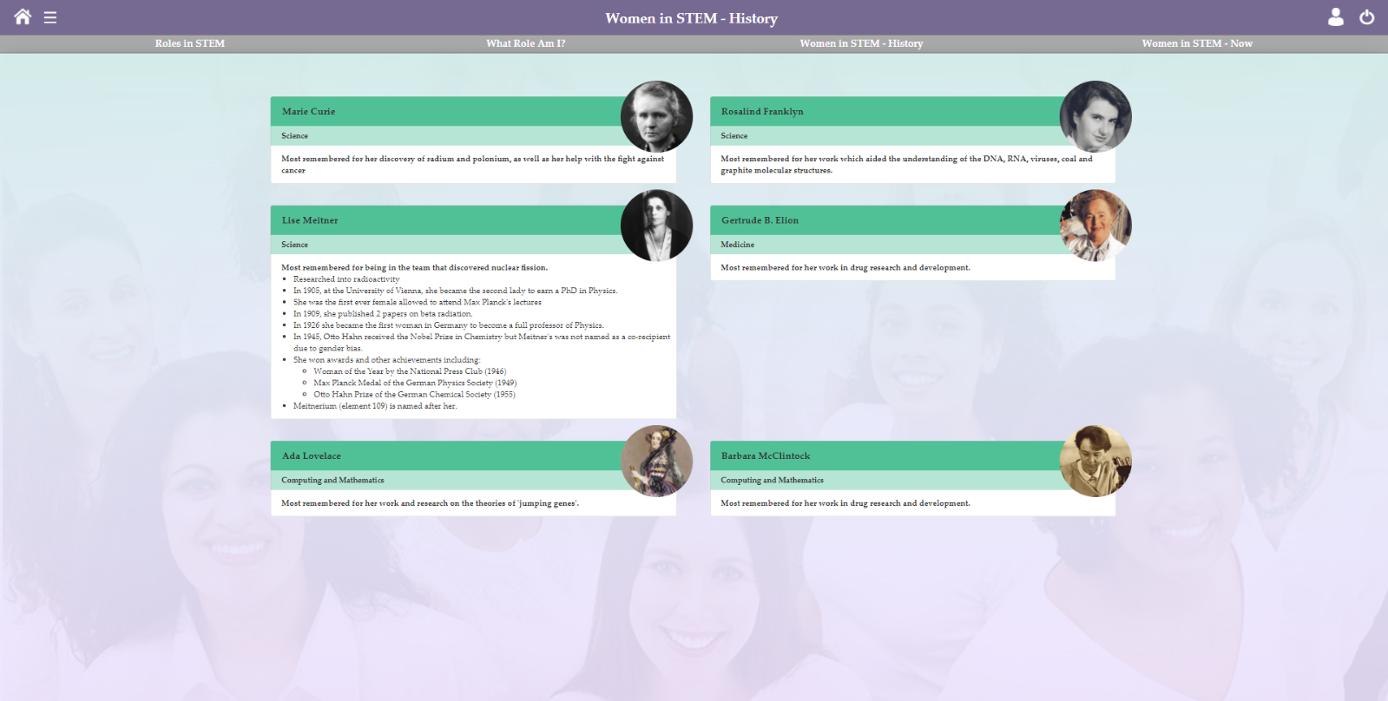

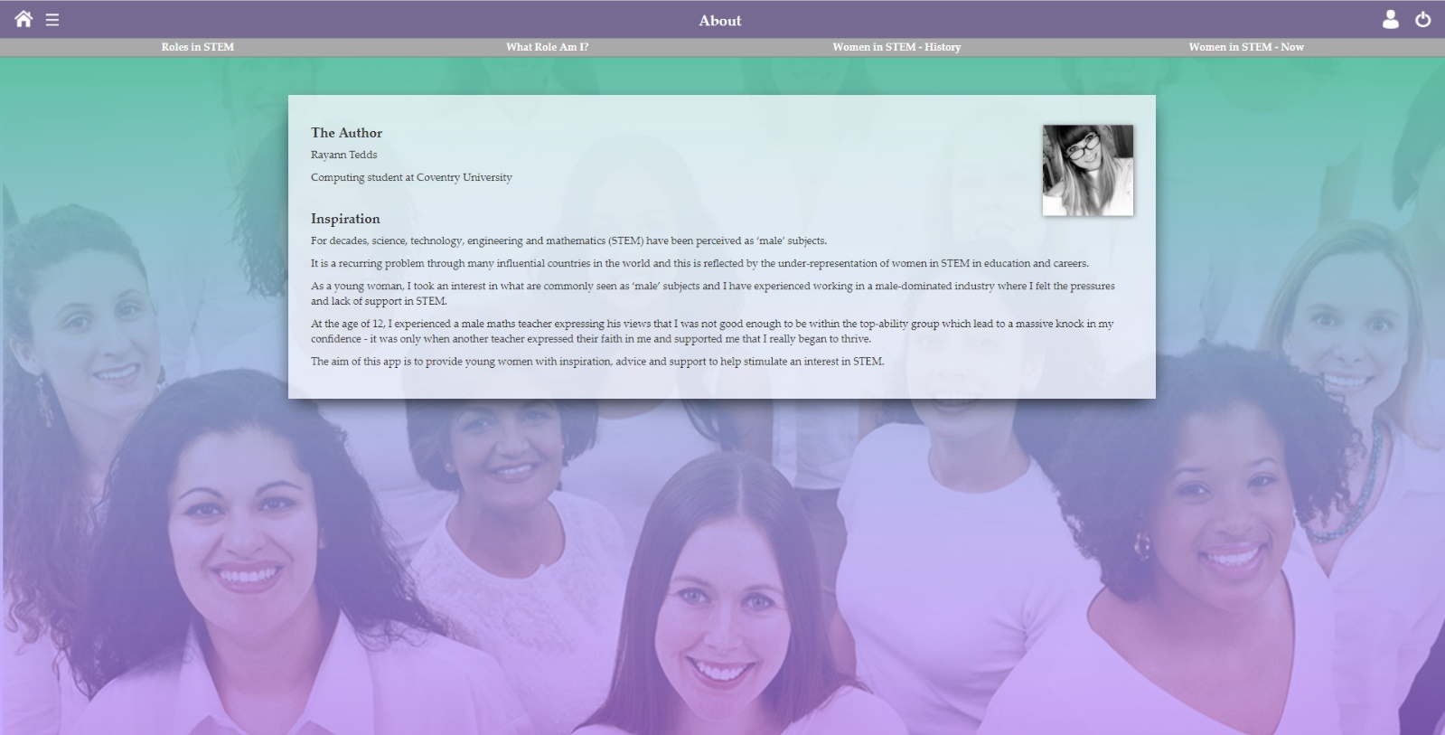

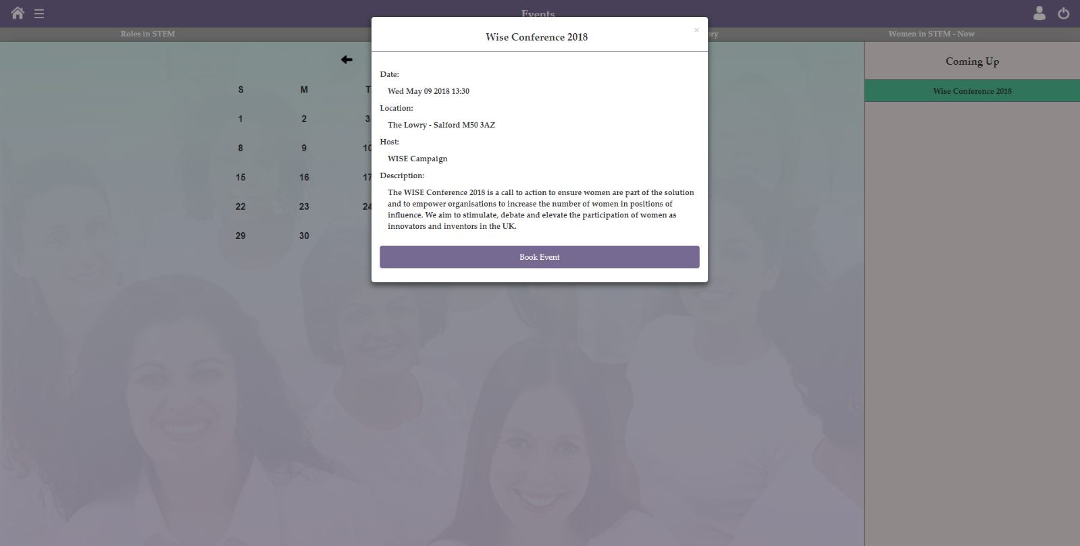

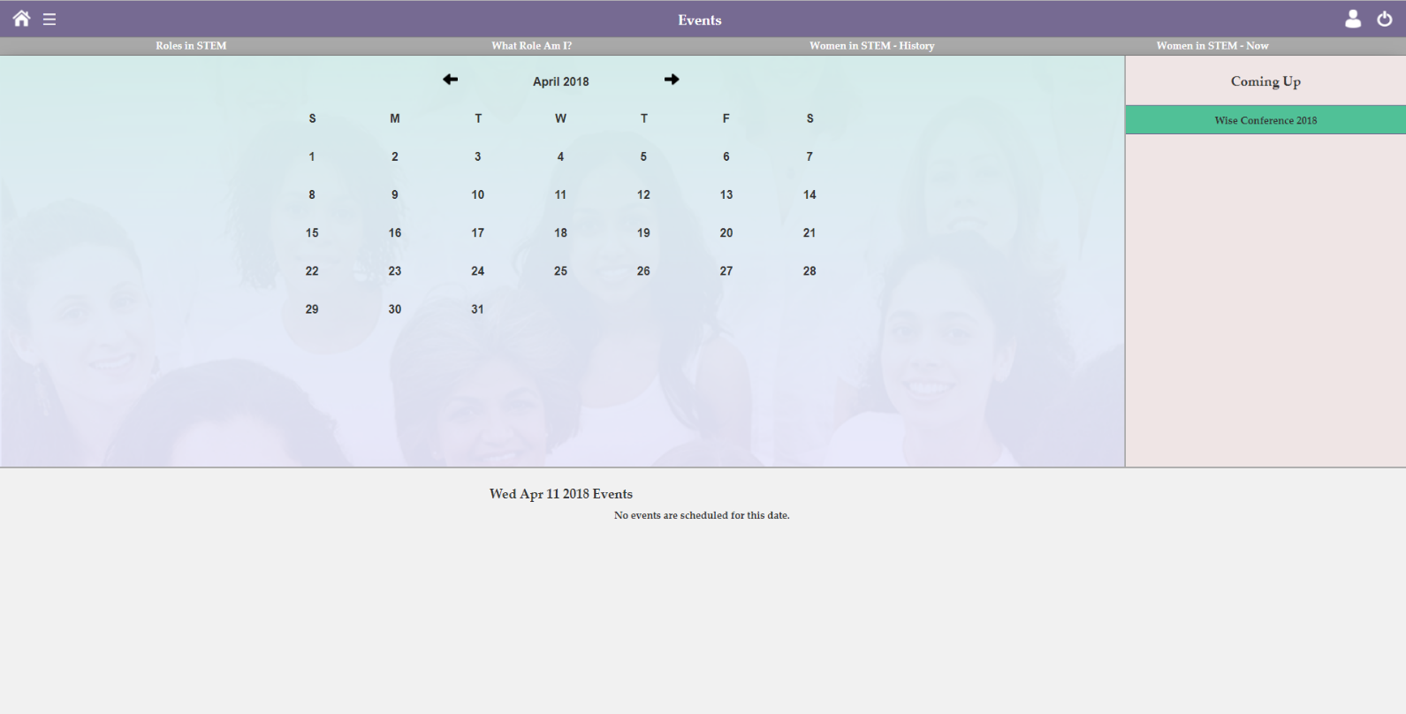

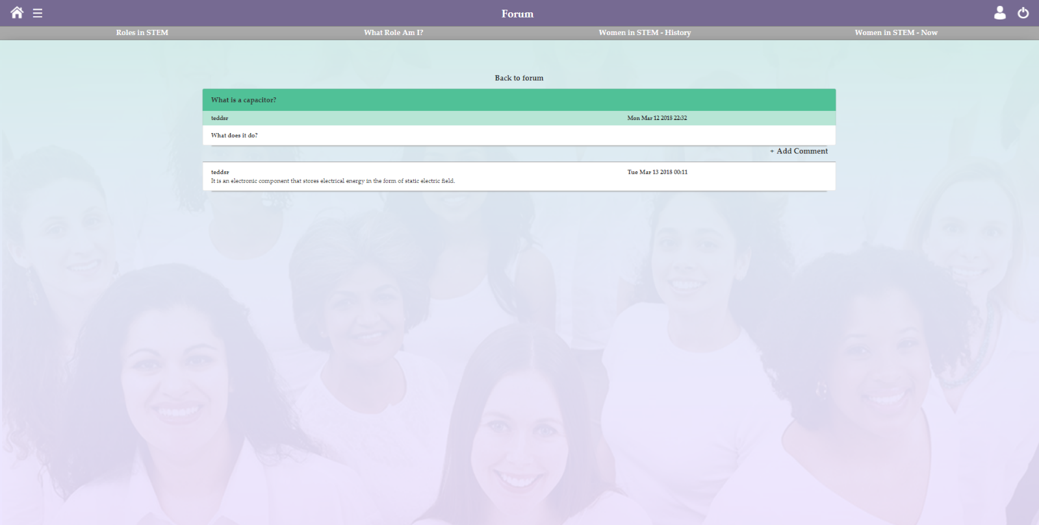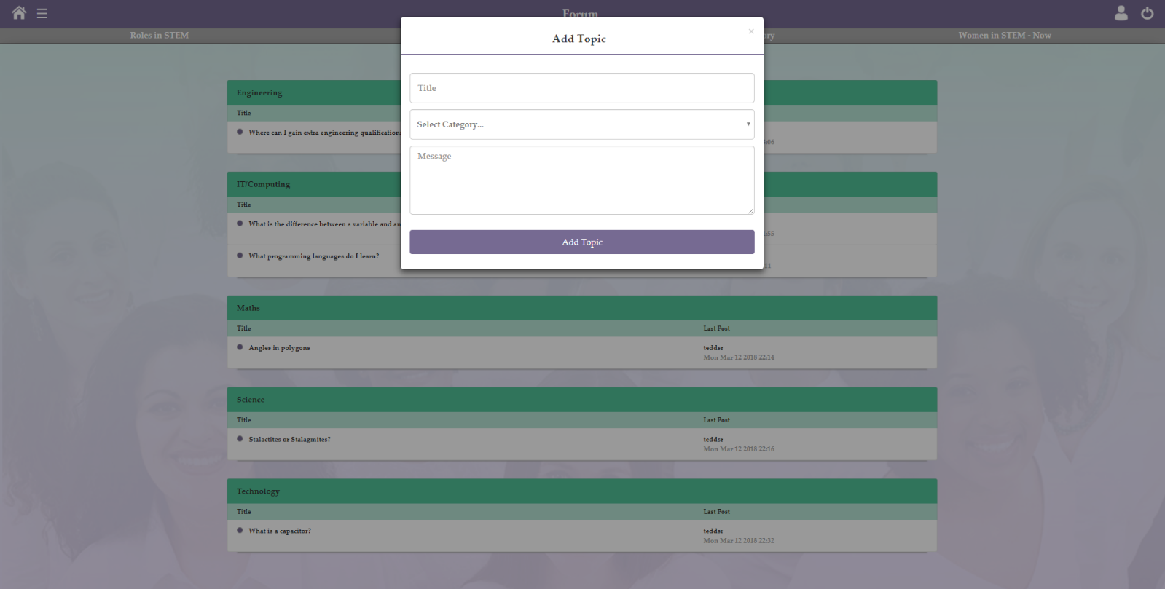

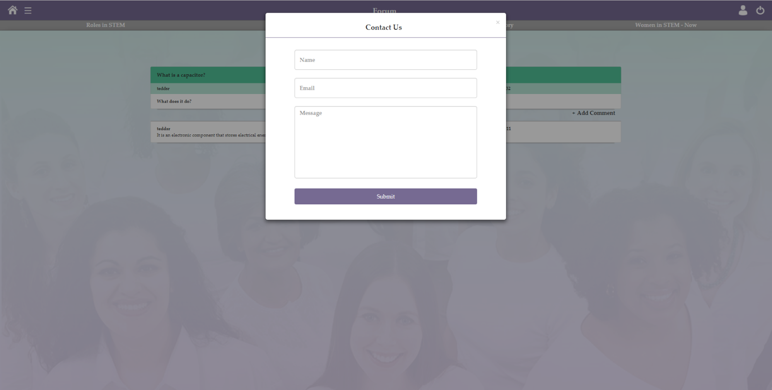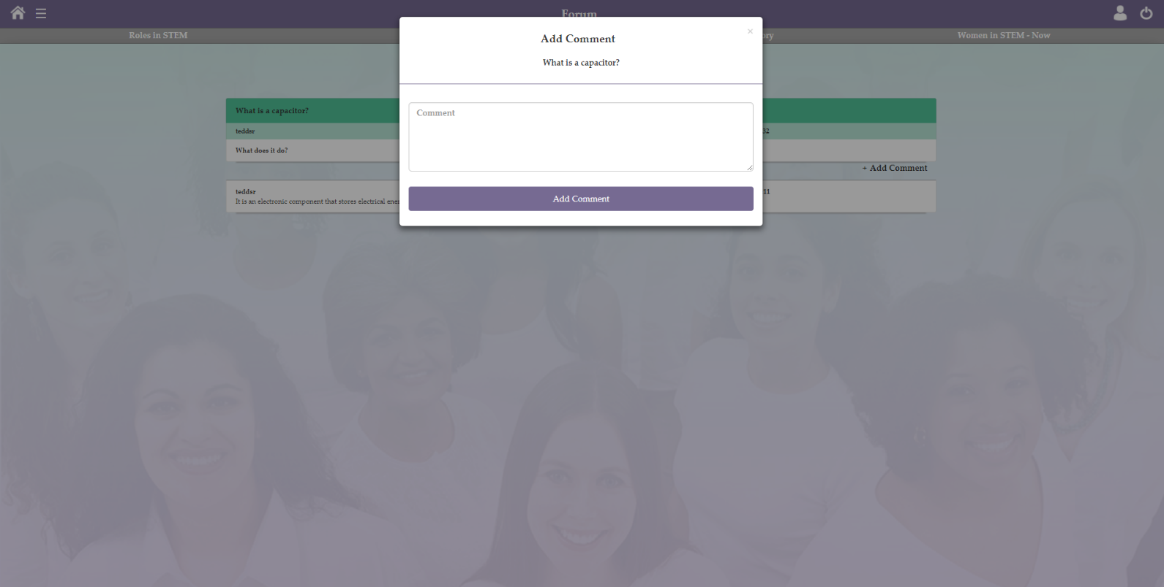

### Appendix I – Meeting Minutes

|  |  |  |
| --- | --- | --- |
| Date | Points Discussed | Action Points |
| 21/02/2018 | * Questionnaire checking and alterations. * Consent form checking * Update on application development process - pleased with the progress * Talking about presentation and how my project will evolve from that will give me more marks. | * 2 versions of the questionnaires - one for primary and the other for secondary as secondary school subjects go into more detail than the simple subjects at a primary school level. * Techniques to be used for the primary school questionnaire. (What they want to be when they grow up, I enjoy using computers at schools, when first exposed to technology and ages, earliest memory of using a computer etc). * Refer to IT (but as for IT/Computer Science, explain this at the start). * Page numbers need to be added the questionnaires. * Talked about pilot groups for the questionnaires - to get more marks (show the questionnaire to mum for primary school children and get advice). |
| 28/02/2018 | **Meeting cancelled due to snow day.** | |
| 07/03/2018 | * Rejection of ethics form concerns * Explanation of dissertation sections * Additions to be added to dissertation work * Explain of my progress with my literature review and the research methodology | * Need to add an introduction to the literature review; explaining what the intention of the review is and what it is going to achieve. Back this up with evidence. * Add an ‘application content’ reference section to the references, expressing that the information was taken from those sources – link this in the research methodology. * Add a ‘development’ section to the research methodology – what technologies and sources were used? Talk about the issues and problems. * Additions to the introduction sections now that I have an understanding of what needs to be included. |
| 14/03/2018 | * Literature review checking | * Literature review wasn’t check of yet, so application development work continued. |
| 21/03/2018 | * Literature review checking | * Literature review wasn’t check of yet, so application development work continued. |
| 28/03/2018 | * Presentation conducted * Identified areas to tweak in terms of structure * Identified missing sections that need to be included in dissertation | * Restructuring of introduction sections to ensure the flow of the dissertation * Literature review reasoning behind category selections – here I explained how I had come about the organising of the literature review section (via a spreadsheet) – this needed to be included in the work. * Search terms need to be included in the dissertation * Is a gender gap required to be narrowed? This needs to be added to the literature review – no point carrying in this research if it is not needed. * Analysis techniques and explanation needs completing * Development section needs adding as I have not talked about this in my report and it is a massive part of the project. * Future development addition |
| 04/04/2018 | **No meeting cancelled due to Easter holiday.** | |
| 11/04/2018 | **No meeting cancelled due to Easter holiday.** | |
| 18/04/2018 | * Dissertation extension needed | * Due to the ethics not being signed off quick enough, an extension request need to be applied for. |

### Appendix J – Gannt Chart

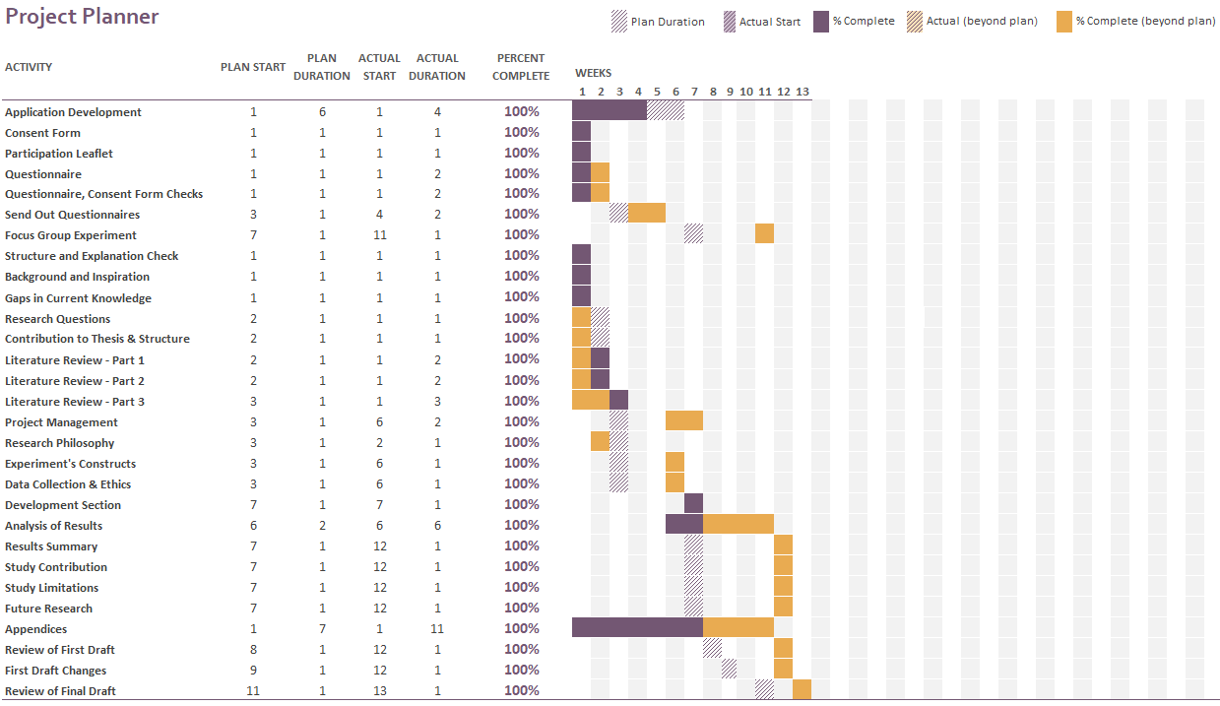

### Appendix K – Literature Review Resource Spreadsheet Example Screenshot

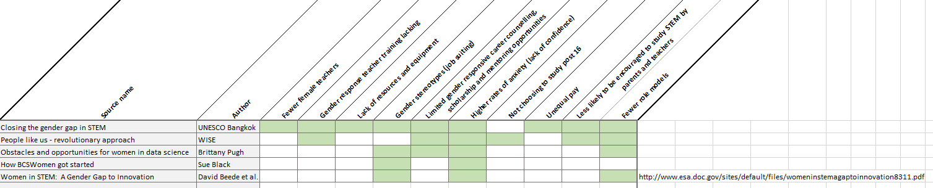

### Appendix L – Detailed Project Proposal

**300/303COM Detailed Project Proposal**

|  |  |
| --- | --- |
| First Name: | Rayann |
| Last Name: | Tedds |
| Student Number: | 5478330 |
| Supervisor: | Amanda Brooks |

## Section one: Defining your research Project

**1.1 Detailed research question**

**Help:** Your detailed research question is the statement of a problem within the computing domain which you will address in your project. Refining the research question involves narrowing down an initial question until it is answerable using a primary research method(s) that you will conduct during the time of your project. The refined research question must not be so general that it is answerable with a yes or no answer. It must not be so broad that you would be unable to achieve a solution during your project. The key to this is BEING SPECIFIC: Narrow down the method or technology you will use, narrow down the group that the question refers to (localize a general question) If the project is still ‘too big’, can you think of a way to work on a part of the problem? Avoid using words that cannot be measured, by you, without a huge research budget e.g. 'effects on society', 'effects on business'. *Example:* The initial question "Does cloud computing effect business" needs narrowing down *(for a start the answer is yes) W*hat is meant by cloud computing? Or 'effect'? Or 'business', in this question? Refining this first question will involve narrowing it down to something you, personally, can measure. A refined version of this question might be: "Does implementing a cloud based voting system improve the speed of decision making in a small company in Coventry?" This refined question is implementable: You can now identify a small company to work with, document their current decision making processes, implement a cloud based voting system, compare decision making speeds over a limited time period (say 1 month) and evaluate your findings. *A small piece of genuinely new knowledge is produced.*

|  |
| --- |
| Can an application influence a female primary school child to consider studying STEM subjects where they had previously not considered a STEM subject as a career path? |

**1.2 Keywords**

**Help:** Include up to 6 keywords separated by a semi-colon; what keywords are appropriate to describe your project in an online database like Google Scholar? Keywords should include the general research area and the specific technologies you will be working with. *Example.* A project that proposes a novel way of visualising large amounts of twitter feed data may have the keywords: Data visualisation; twitter; hashtags; database design; graphics libraries. For further help, take a look at the ACM keywords list http://www.computer.org/portal/web/publications/acmtaxonomy

|  |
| --- |
| STEM; networking and support; gender equality; education; careers; application. |

**1.3 Project title**

**Help:** The project title is a statement based on your detailed research question. For example, the research question *'to what extent does a mobile application reduce the number of errors made in class registers at Coventry University in comparison to current paper based registers'* may be stated in the project title*: "A Wi-Fi driven mobile application for large group registers using iBeacons".*

|  |
| --- |
| A mobile application providing support and advice in STEM subjects for female students. |

**1.4 Client, Audience and Motivation:**

**Help:** Why is this project important? To whom is this project important? A research project must address a research question that generates a small piece of new knowledge. This new knowledge must be important to a named group or to a specific client (such as a company, an academic audience, policy makers, people with disabilities) to make it worthwhile carrying out. This is the ***motivation*** for your project. In this section you should address who will benefit from your findings and how they will benefit. Example: If you intend to demonstrate that a mobile application that automates class registers at Coventry University will be more efficient than paper based registers - the group who would be interested in knowing/applying these findings would be both academic and administrative staff at Coventry University and they would benefit by time saved and a reduction in their administrative workload. If you are making a business case for an organization explain how the organisation will benefit from your findings.

|  |
| --- |
| As a young woman, I took an interest in what are commonly seen as ‘male’ subjects and I have experienced working in a male-dominated industry where I felt the pressures and lack of support in STEM. At the age of 12, I experienced a male maths teacher expressing his views that I was not good enough to be within the top-level group which lead to a massive knock in my confidence - it was only when another teacher expressed their faith in me and supported me that I really began to thrive.  My audience and motivation for this project is for women of all ages but predominately for young women in latter primary school years to women in university education. The main aim of the project and application is to inspire them to consider and choose a career in STEM subjects, particularly IT and computing through the use of tutorials and networking tools.  For younger girls, the project will provide advice on potential careers; opportunities to interact with female role models in the STEM field and tutorials in terms of computing. For those in higher and further education, the project’s application will be used as a networking and support resource whereby women can communication in order to help find solutions to their problems or worries and create a social networking tool, in general, for women looking into STEM subjects and careers.  Enhancing this, the app will provide a calendar and links to useful networking events, as well as providing a forum platform by which females can communicate and be inspired by other females within the field.  All in all, the project’s application will set out to provide a support network for existing and potential females in the STEM field. This could then help to inspire future masters of the science, technology, engineering and mathematics field and help to fill the roles in-demand within these sectors. |

**1.5 Primary Research Plan**

**Help:** This is the plan as to how you will go about answering your detailed research question - It must include a primary research method (an extended literature review is not an acceptable primary method). Think and plan logically. Primary methods may include experiments, applications or software demonstrators, process models, surveys, analysis of generated data …  
  
Example: In the class register example above "to what extent does a mobile application reduce the number of errors made in class registers at Coventry University in comparison to current paper based registers" - the research plan may involve: 1) Collecting and analysing paper based registers in a given class on five occasions. 2) Identifying the error rate average on these occasions 3) Designing and implementing a mobile application that automatically records attendance in class. 4) Deploying the application in the class on five occasions. 5) Identifying the error rate average of the mobile application on these occasions. 6) Comparison of data and summary of findings.

|  |
| --- |
| 1. Completing a literature review to gain an understanding of the gender gap within the STEM and begin to identify reasons as to why it exists, if it is proven to exist. 2. Conduct and analyse surveys and focus groups to gain an understanding of popular opinion when it comes to STEM subjects and careers. 3. Conduct interviews with current female teachers, lecturers and role models in STEM to help understand their opinions of the industries and what they believe can be done to help bridge this gender gap. 4. The design and implementing of a mobile application that helps the networking of females interested in STEM. 5. Deploying and conducting trials of the application to focus groups and potential users. 6. Analyse feedback and findings from the application and compare responses of focus groups and users. |

This is the end of section one.

## Section Two: abstract and Literature review

**2.1 Abstract**

**Help:** An abstract is a short summary of a research project that enables other researchers to know if your report or research paper is relevant to them without reading the whole report. It is usually written retrospectively so that it can include findings and results. It is fully expected that you will rewrite your abstract when you come to write your final paper. For now, you should write an abstract of about 250 words that define the project described in section one. Before writing your abstract you MUST read some abstracts from conference or journal papers on *Google Scholar* or from *portal.acm.org* (to understand their style) and then provide your own abstract that outlines what your question is and what you 'did' to answer it.

|  |
| --- |
| For decades, science, technology, engineering and mathematics (STEM) have been perceived as ‘male’ subjects and this is a stereotype that is still very much alive today as explained by Professor Bernhard Ertl (2017). It is a recurring problem through many influential countries in the world and this view is reflected by the under-representation of women in STEM in terms of education and future careers. This study will identify whether a gender gap exists in STEM industries and identifying key reasons for this divide if such does exist.  If identified, this report aims to set out ways in which a STEM gender gap can be narrowed by providing advice, general guidance and networking opportunities through the use of a mobile application as a potential key solution. The application’s goal is to provide a support network for women throughout their educational and professional lives within STEM subjects, enabling them to identify their potential and strive towards it.  Following findings from surveys, interviews, focus groups and the application development, this paper will discuss Black’s article (2015) on the important role networking and support plays in allowing women to thrive and flourish in such industries as women naturally tend to underestimate their abilities and talents from a young age compared to men.  Additionally, this paper reports its findings and suggests a framework of support and strategies that could be implemented to increase the uptake of STEM subjects by females, giving them an insight to roles that girls originally would have never thought would be suited to them. Finally, this paper provides recommendations as to further research opportunities and approaches that could be assessed and implemented by companies and educational organisations in order to bridge this gender gap further. |

**2.2 Initial/Mini Literature Review (500 words – 750 words)**

**Help:** A literature review is a select analysis of current existing research which is relevant to your topic, showing how it relates to your investigation. It explains and justifies how your investigation may help answer some of the questions or gaps in this area of research. A literature review is not a straightforward summary of everything you have read on the topic and it is not a chronological description of what was discovered in your field. Use your literature review to:

• compare and contrast different authors' views on an issue  
• criticise aspects of methodology, note areas in which authors are in disagreement  
• highlight exemplary studies  
• highlight gaps in research  
• show how your study relates to previous studies

|  |
| --- |
| Gender inequality within STEM industries has long been an area of discussion across the world. The ‘Women in STEM workforce 2017’ study conducted by WISE (2017) concluded that women make up only 24% of the workforce in STEM industries in the United Kingdom. A fact enhanced by the UNESCO Institute for Statistics which estimates that women make up 28% of scientific researchers worldwide (UNESCO Bangkok, 2016). This following report goes about exploring a range of sources and studies with the intention of discovering the reasons why this gap exists before coming to conclusions as to frameworks and approaches that need to be adopted if the gap is to ever be closed.  A Personality and Social Psychology study (Good, Rattan, and Dweck, 2009) tracked several hundred women studying mathematics for a semester at university. They found that women who found their studies to be taught with a fixed mindset approach didn’t achieve as much as others in a growth mindset environment. The reasoning included participants being quick to lose interest and ‘give in’ when challenges were tough due to lack of support of belief by others. Negative stereotypes of women in maths, combined with these reasons found that the participants of this study were less likely to pursue further education or a career in the given industry. The study found that within growth mindset promoting classrooms, women were found to be less susceptible to any negative stereotyping meaning that they were more likely to develop in this chosen area with a sense of determination and interest. High levels of anxiety and this lack of confidence amongst girls and woman around STEM has proven to be the dominate reason as to why there is such a gender gap within the industries. Negative gender stereotypes combined with fixed mindsets contribute to these low levels of self-belief within women.  A study by sociologist Correll (2004) found that the lack of appropriate gender-responsive training in the field can be identified as a failing factor in our education system which leads to girls not seeing their true potential in STEM. It found that within a group of students with the equivalent achievement history, girls perceived themselves to be a lower mathematical ability than the boys. The study also found that this self-assessment of students hindered and controlled the individual’s actual ability and in turn would make it less likely for said individual to choose to study a degree in science, maths or engineering (Correll, 2004).  Hill, Corbett and Rose (2010) strengthens this point and highlight that, as parents, educational representatives and a society, we should aim at developing growth mindsets whereby we praise children’s efforts and struggles, promoting that they can achieve and acquire any intellectual skills they require.  Influential women within STEM, including Black (2015) and Pugh (2016) have acknowledged the lack of female role model representation within the industries and how this can impact upon girls pursuing degrees and careers in STEM. This absence can even be traced back to the lack of female teachers in science, technology, mathematics and engineering within schools, as UNESCO highlights (2016). It has been proven that girls tend to need/want to know that their work has value and they need an understanding that STEM subjects will not be limiting their future and progression (WISE Campaign, 2017). Having female role models more accessible, through the use of social media or other means, to younger women will only create inspiration and create the sense of understanding the true potential of careers in science, technology, engineering and mathematics.  Young girls require appropriate career counselling and mentoring opportunities which will allow them to understand STEM industries further and discover their potential. This is factor that the WISE Campaign are trying to eradicate by the use of schemes such as ‘People Like Me’ which is deployed within schools. It is full of activities and presentations aimed at enabling girls to understand what roles there are within STEM and suggest how personalities traits can be reflected in certain job role which they may have never considered before (2015). The aim of WISE is to create that sense of belonging and passion which Hill, Corbett and Rose identify as lacking in the industries currently (2010).  From the research that has been undertaken it is evident that there is a lack of support and encouragement for young women to pursue STEM subjects. It consequently means that they do not realise their potential within STEM to want to pursue with such subjects post-16, meaning they are limiting themselves and abilities for their lives ahead. Even with the new ‘People Like Me’ scheme (WISE, 2015), UNESCO Bangkok (2016) identified that there is still a lack of stimulating resources and equipment for girls in STEM. This is the influencing factor as to why a mobile application is going to be developed with the intention of contributing to the ‘closing of the gender gap’. It intends to create a resource which is both educational and professional and can allow for the networking of women through different stages of their STEM lives before going onto assess its impact. |

**2.3 Bibliography (key texts for your literature review)**

**Help:** Please provide references, in correct Harvard style, for at least three key texts that have informed your literature review. If you are implementing an application, select texts which demonstrate how other researchers have tackled similar implementations? The references should be recent and sufficiently technical or academic. Your markers will be looking for you to identify technical reports, conference papers, journal papers, and recent text books. Avoid *Wikipedia* entries, newspaper reports that do not cite sources, and general or introductory texts.

|  |
| --- |
| Bernhard Ertl, Silke Luttenberger, Manuela Paechter. (2017) ‘The Impact of Gender Stereotypes on the Self-Concept of Female Students in STEM Subjects with an Under-Representation of Females’ *Frontiers in Psychology* [online] 8 DOI: 10.3389/fpsyg.2017.00703 [1 February 2018]  Black, S. (2015) *How BCSWomen got started* [online] available from <http://bcswomen.bcs.org/how-bcswomen-got-started/> [20 January 2018]  Correll, S. J. (2004). *Constraints into Preferences: Gender, Status, and Emerging Career Aspirations* [online] 69 (1), 95–110. available from <http://people.uncw.edu/maumem/soc500/Correll2004.pdf> [20 January 2018]  Good, C., Rattan, A., & Dweck, C. (2012) ‘Why Do Women Opt Out? Sense of Belonging and Women’s Representation in Mathematics’ *Journal of Personality and Social Psychology* [online] 102 (4), 701-714. DOI: 10.1037/a0026659 [20 January 2018]  Hill, C. Corbett, C. & Rose, A. (2010) *Why So Few? Women in Science, Technology, Engineering, and Mathematics* [online] available from <https://www.aauw.org/aauw_check/pdf_download/show_pdf.php?file=why-so-few-research> [20 January 2018]  Pugh, B. (2016) *Obstacles and Opportunities for Women in Data Science* [online] available from <https://www.elderresearch.com/company/blog/obstacles-and-opportunities-for-women-in-data-science> [20 January 2018]  UNESCO Bangkok. (2016) *Closing the gender gap in STEM: Drawing more girls and women into Science, Technology, Engineering and Mathematics* [online] available from <http://unesdoc.unesco.org/images/0024/002457/245717e.pdf> [19 January 2018]  Wisecampaign.org.uk (2015) *People Like Me: Why this revolutionary approach to attract girls into science, technology and engineering will make a difference* [online] available from <https://www.wisecampaign.org.uk/uploads/wise/files/6pp_NFPLM_SUMMARY_v31.pdf> [20 January 2018]  Wisecampaign.org.uk (2017) *Resources | Women in STEM workforce 2017* [online] available from <https://www.wisecampaign.org.uk/resources/2017/10/women-in-stem-workforce-2017> [18 January 2018] |

This is the end of SECTION TWO